
Provider Portal Guide Part 2
-
Funded Early Education Entitlement (FEEE) Funding



A Guide for Private, Voluntary, Independent Providers and Maintained Schools

Section | Contents | Page Numbers
1 | Introduction to the Training Guide | 3
2 | Portal Login and Changing Passwords | 4 - 7
3 | Forms Library | 8
3.1 | Fill in Forms | 8
3.2 | View Forms | 8
4 | Submitting Estimate Claims for 9 months to 4-year-olds | 9 – 11
5 | Submitting Actual Claims – Universal Entitlement | 12 - 21
5.1 | Opening Actuals Screen | 12
5.2 | Updating an Existing Child Record | 13 – 17
5.3 | Deleting a Child Record | 17 – 18
5.4 | Adding a New Child Record | 18 – 21
6 | Working Parent Entitlement | 22 - 29
6.1 | Validating a Working Parent Voucher Code | 22 – 23
6.2 | Claiming Extended Entitlement for 3- & 4-year-olds | 24 – 26
6.3 | Claiming Expanded Entitlement for 2-year-olds | 26 – 28
6.4 | Claiming Expanded Entitlement for 9–23-month-olds | 28 – 29
7 | Flying Start for 2-year-old Entitlement. | 30 – 34
7.1 | Claiming for a Child Living in Derby City | 30 -32
7.2 | Claiming for a Child Living Outside Derby City | 32 -34
8 | Early Years Pupil Premium (EYPP) | 35 – 36
8.1 | Submitting EYPP Claims to be checked under Economic Criteria | 35
8.2 | Submitting EYPP Claims to be checked under LAC or SEND | 36
9 | Disability Access Funding (DAF) | 37 - 38
9.1 | Claiming Disability Access Funding | 37 - 38
10 | Stretched Funding | 39 - 40
10.1 | Setting Up to Deliver Stretched Funding | 39
10.2 | Claiming Stretched Funding | 39 - 40
11 | Submitting Adjustment Claims | 41 - 45
12 | Summary Page – Viewing Payments and Previous Claims | 46
13 | Registered Interests | 47 – 48

Contents

Section 1: Introduction to the Training Guide

The Families Information Service (FIS) Funding Portal is a self-service tool for childcare providers within Derby City to submit termly Funded Early Education Entitlement (FEEE) submissions.

The FIS Funding Portal is monitored and maintained by Derby City Council Families Information Service (FIS). If you have any questions about using or accessing the FIS Funding Portal, or you want to talk to us regarding your funding claims you can contact us on:

Families Information Service
Derby City Council
The Council House
Corporation Street
Derby
DE1 2FS
Telephone: 01332 640758
Email: earlyyearsfunding@derby.gov.uk

This training guide is designed to help anyone who is using the FIS Funding Portal to:

- Submit termly Funded Early Education Entitlement (FEEE) submissions for 9 months to 4-year-old children.
- Submit Early Years Pupil Premium (EYPP) claims for 9 months to 4-year-old children.
- Submit Disability Access Funding (DAF) claims for 9 months to 4-year-old children.
- Validate and Process Children’s Voucher Codes
- Reconcile and Review FEEE payments due to your setting.

This guide has a section on each of the uses shown above, and it will guide you through how to use the Funding Portal in each situation and try to answer any questions you have.

Section 2: Portal Login and Changing Passwords

To access the FIS Funding Portal please visit section 3 of the Funded Early Education Entitlement (FEEE) Webpage for childcare providers on Derby City Council's website by following the link below:

Funded Early Education Entitlement (FEEE) - Derby City Council

The FEEE webpage for childcare providers has a lot of useful support information for childcare providers, and we regularly update this page with key documents. Please take the time to look at the page, it may answer any queries you have on the funding and support you to successfully submit your updates and funding claims.

Click on the green button worded ‘Claim Funding Online’ to access the 'provider portal' if you click on this you will be taken to the FIS portal login page below:

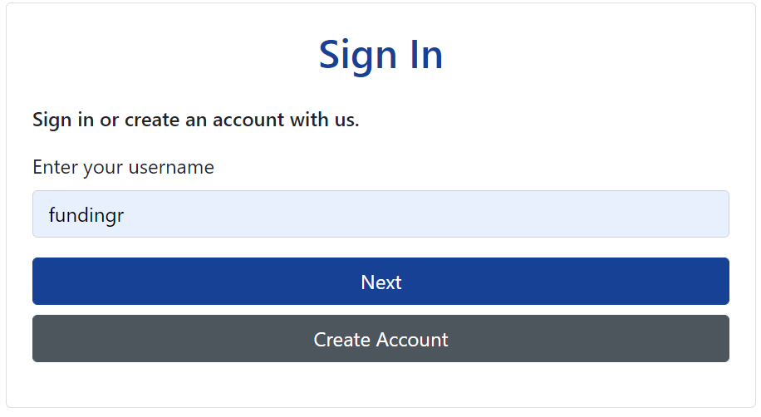

Enter the login details provided by FIS, the username is usually some or all your provider’s name and the password is usually ‘child’ followed by two capital letters and two numbers i.e., childAV10. Please do not enter your email address to login or request a token if you have forgot your password as this will not work, always use the username provided by FIS.

Once you have logged in the A-Z search Options page should appear as in the print screen below.

Once you have logged in, please select ‘Modules’ which is highlighted with an arrow in the top left-hand corner of the page below and select 'Childcare / Service Provider' from the drop-down menu.

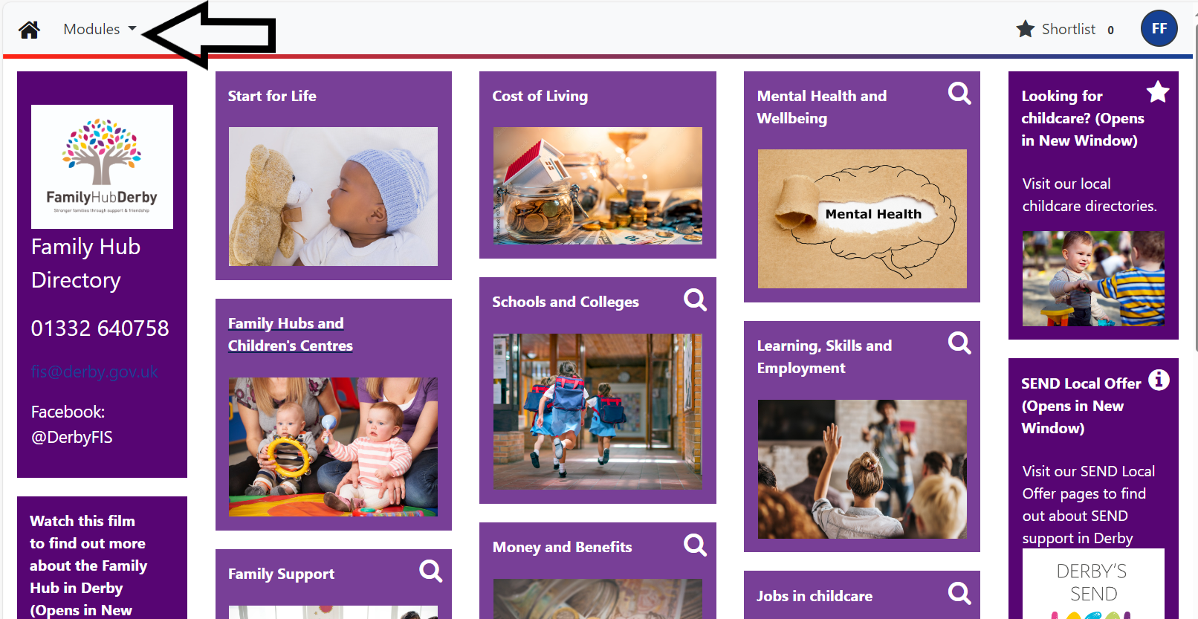

You will then be taken to the screen below to select organisation, if you have more than one organisation type for example, nursery provision and out of school provision. You must select the organisation where your FEEE funding is being delivered and click the blue proceed button.

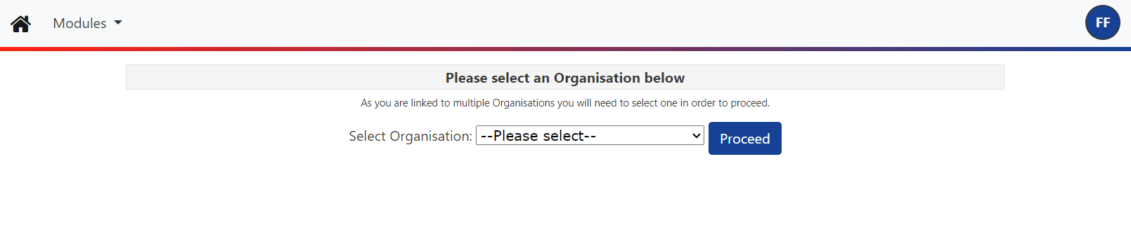
You will then be taken to the FIS Provider Portal home screen shown below, to change your password go to the circle at the top right-hand corner of the screen as shown below and select ‘Account Management’ from the drop-down menu and select ‘change password’.

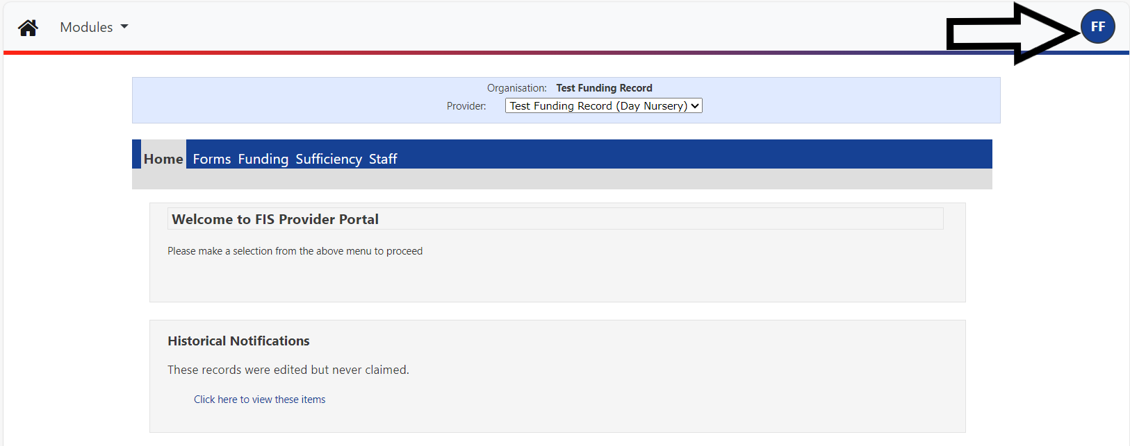

This will take you to the ‘Account Security’ tab shown below to change your login details when accessing the portal, this page will also let you know when you last updated your password. Please click on the ‘Change Password’ button to change your password.

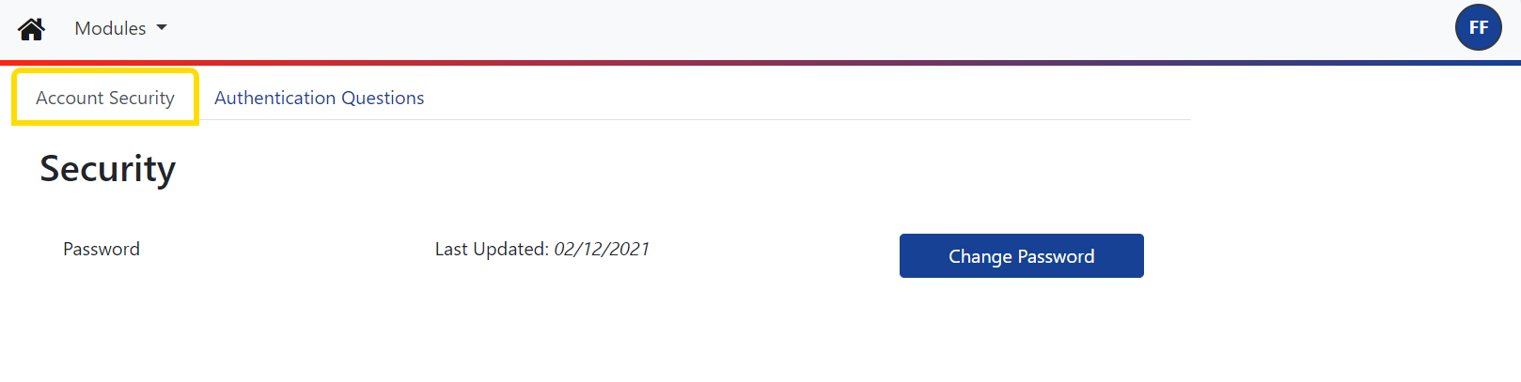You will then be taken to the page below, please enter your password provided by FIS, if you do not know or have forgotten your password, please contact FIS on 01332 640758 to reset your password and click ‘Next’.

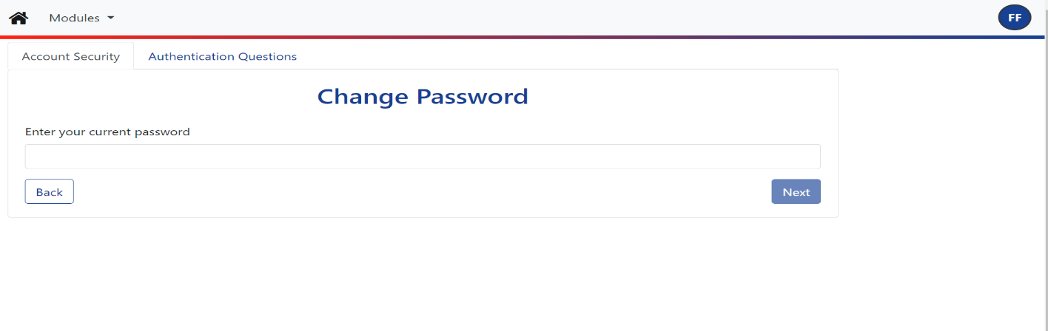

You will then be taken to the page below to enter and confirm your new answer. Please note passwords are case sensitive, however usernames are not.

Password security standards – your password should be a minimum of 8 characters, made up of a combination of letters numbers, symbols, upper case and lower case, the more complex the better! Please remember this portal contains personal data about children and families.

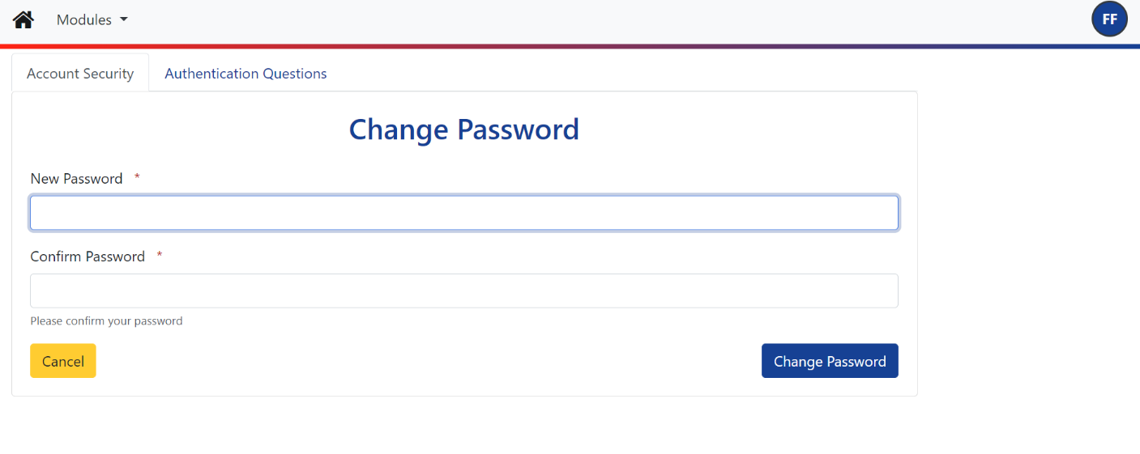

Once you have entered and confirmed your new password and clicked the ‘Change Password’ button the following message will appear on screen to state you have successfully changed your password, then you can click the ‘Finish’ button:

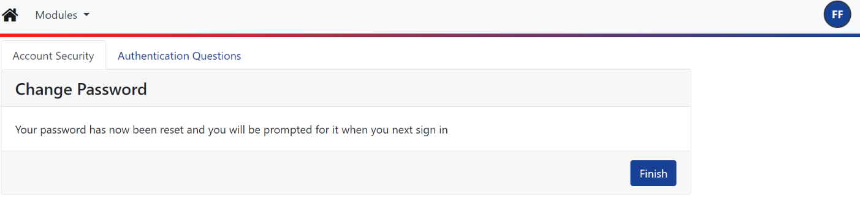

Once you have reset your portal login, you will then need to reset your ‘Authentication Questions’ to access the funding portal.

Before you input your old and new answer, please ensure the ‘Authentication answer (Provider)’ is highlighted in grey first, if not click on this once to highlight as shown below. You can then enter your ‘Old Answer’ which will be ‘Fisofd’. Your new answer must be at least 3 characters long A-Z (no numbers or symbols). Once you have entered your new answer and confirmed this click the ‘Save’ button.
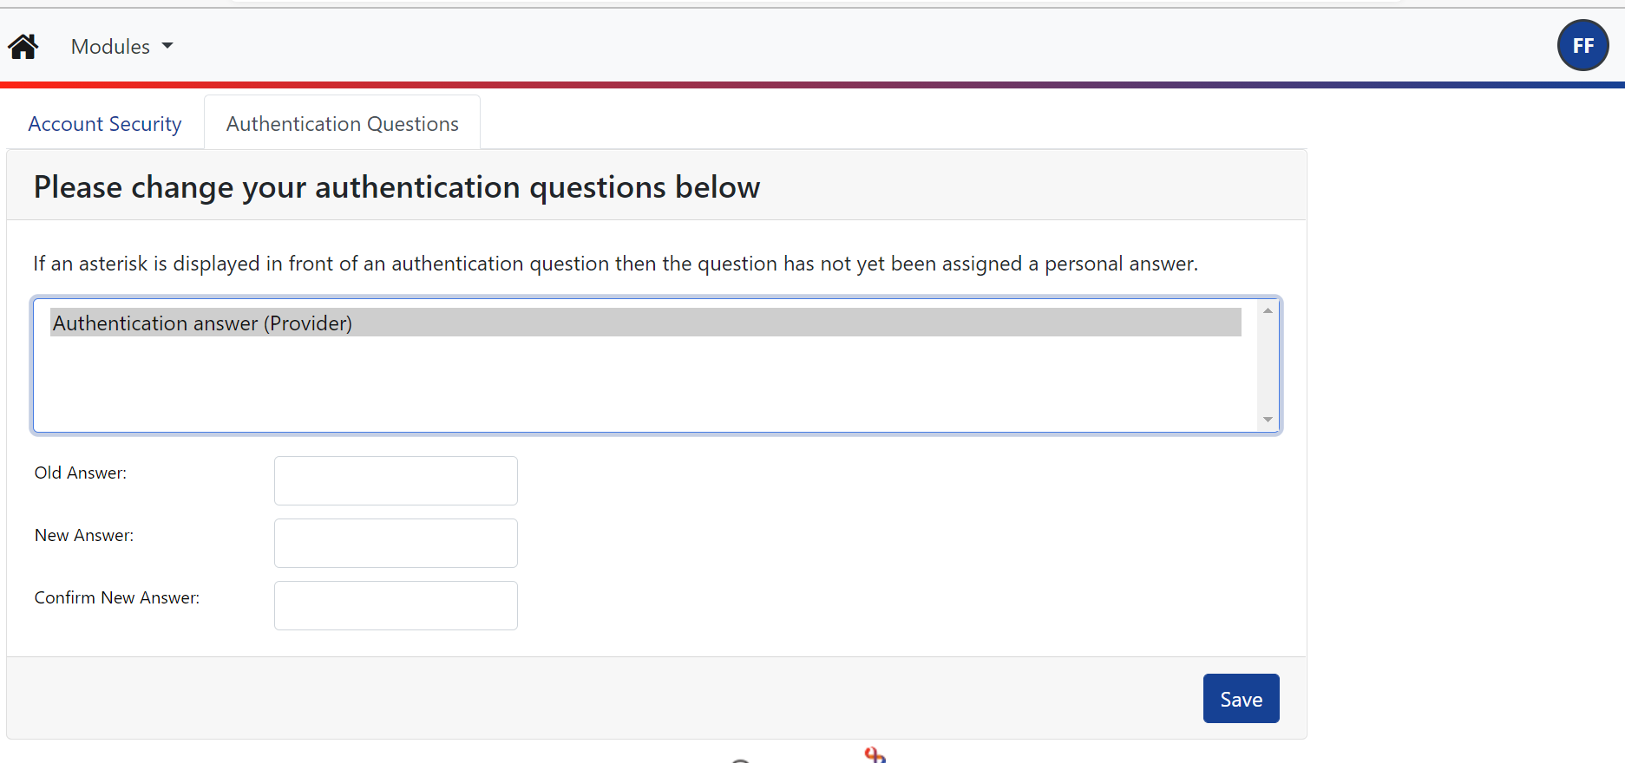

You will then get the following message to confirm you have successfully changed your authentication answer:

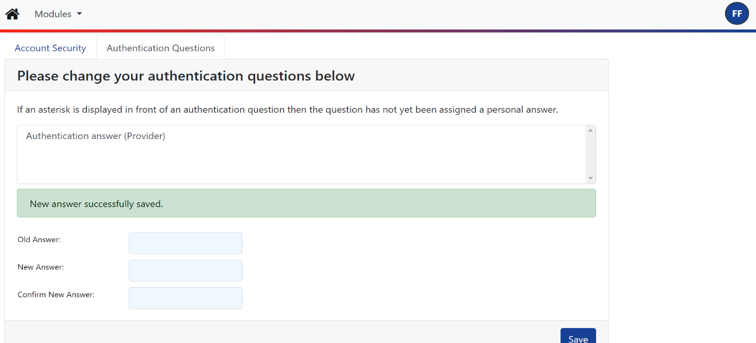

If you want to access your ‘FUNDING’ tab you will always be asked to give 3 characters from your authentication answer, as shown below.

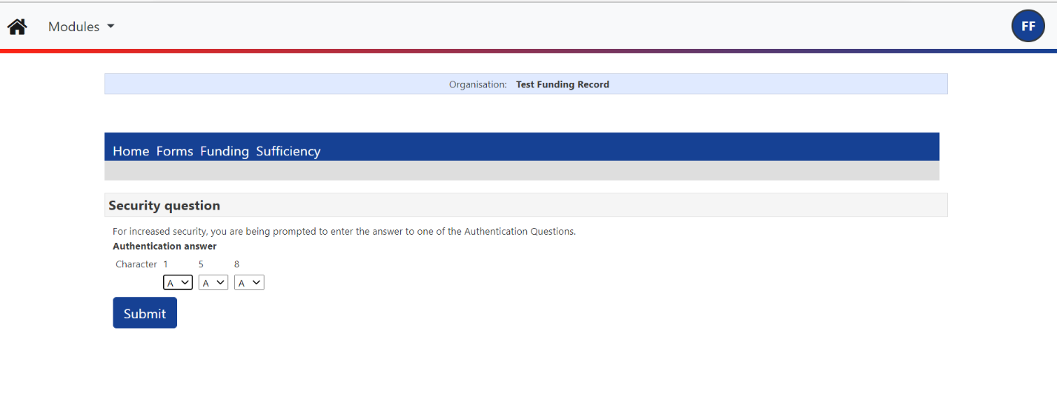

Section 3: Forms Library

3.1. Fill In Forms

To access the forms - select ‘FORMS’ and ‘Fill in Forms’ as shown below, select a form by double clicking. Please ensure you fully complete the form; some forms have more than one page and you will need to click ‘Next Page’. Once the form is fully completed you can then click on ‘Submit Form’, you should see a green successful submission bar appear at the top of the screen to confirm you have successfully submitted a form.
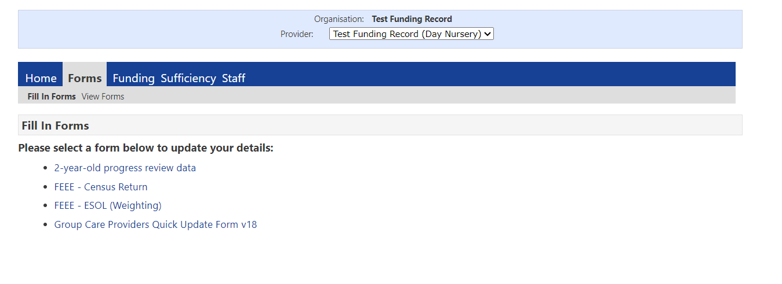
Please see below the purpose of each form that needs to be completed with FEEE claims and when the form needs to be completed:

FEEE – Census Return
This form will need to be submitted each term as part of your termly actual submission, this data is sent to the Department of Education (DfE) and contributes to the calculation of the Council’s annual budget for FEEE so is very important and must be completed and submitted by the actual submission deadline each term which is stipulated on the funding timetable.

FEEE – ESOL (Weighting)
This form needs to be completed when a funded 3- and 4-year child’s first language is not English and may need extra support. It should only be completed each term for new children and be submitted by the Actuals submissions deadline stipulated on the funding timetable. This data is required to determine whether your provision is allocated any additional funding. If a child’s first language is not English, your provision will be allocated an extra 0.20p per hour for each universal and/or extended hour the child is funded.

3.2. View Forms

You can view forms you have previously submitting and check the status of each form by selecting the ‘FORMS’ tab and then ‘View Forms’ the forms will have a status at the end to say if they have been Authorised, Denied or are still Pending. Forms are usually Denied if they have been submitted more than once, or there is an error on the form, but we will contact you to discuss any errors that we cannot resolve.

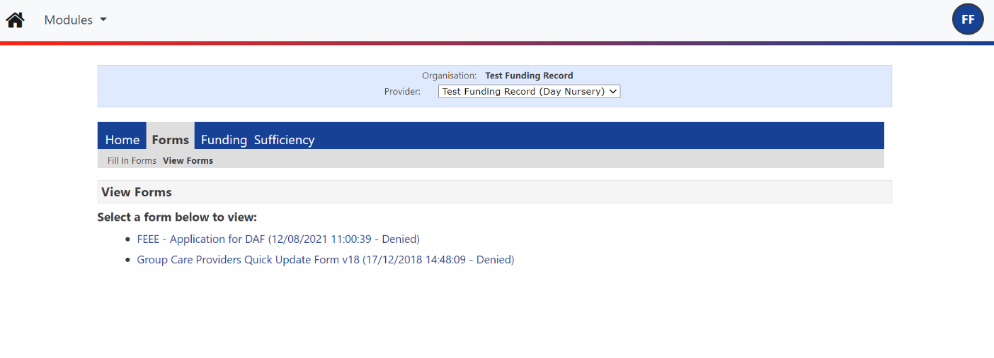

Section 4: Submitting Estimate Claims for 9 months to 4-Year Olds

Estimate claims must be submitted via the FIS Portal by the estimate submission dates supplied on the funding timetable for each term. To submit your estimate hours, you will need to calculate the total weekly number of funded hours inclusive of any universal, additional support, extended or expanded entitlement. You will need to submit your 3- & 4-year-old funding, 2-year-old funding and 9–23-month-old funding separately.
If you do not submit your estimates by the deadline stipulated on the funding timetable you will not be paid an upfront 70% estimate payment amount and you will have to wait for your actual payment based on actuals and this will be paid at 100%.

If you do not have any funded children for the term for a particular age group you will need to submit zero hours estimate, so we know you have not got any funded children for the term.

Estimate claims need to be a true reflection of anticipated participation of funded hours for the following term. Providers must be aware that over-claiming estimate amounts will result in an overall minus payment at actual stage and funding will be recouped. If a provider is identified as continually over-claiming, the estimate funding may be withdrawn, and you will only be able to submit details at the ‘Actual’ headcount stage. You will need to refer to the number of funded weeks in each term on your funding timetable to calculate the estimated claim.

Example of calculating hours in a 14 funded week term for estimate submission:
Provider has 4 children in the same age group, 2 claiming 15 hours universal per week and 2 claiming 15 hours extended or expanded entitlement per week:

2 x 15 hours = 30 hours
2 x 15 hours = 30 hours

Provider enters 60 weekly hours onto the FIS Funding Portal.
The FIS Portal will multiply the weekly hours you have entered by 14 weeks when you click on the ‘calculate’ button the termly hours will appear, which in this example will be 840 termly hours, you then click on ‘send claim’ and the weekly hours you have entered will be submitted to Derby City Council.

Stretched funding Estimate weekly hours can be recorded on the FIS Portal as term time weekly hours.

Example 1 - if a child is taking a stretched model of 22 hours per week over 52 weeks they will need to be included in your estimate as 30 hours.

Example 2 - if a child is taking a stretched model of 11 hours per week over 52 weeks, they will need to be included in you estimate as 15 hours.

Example of calculating estimate as term time in a 14 week term including stretched funding:
Provider has 4 children in the same age group, 2 claiming 15 hours per week, 1 child taking stretch funding claiming 12 universal hours per week over 47.5 weeks of the year, you will calculate as follows:

2 x 15 hours = 30 hours
1 x 15 hours = 15 hours

Provider enters 45 weekly hours onto the FIS Portal.
The FIS Portal will multiply the weekly hours you have entered by 14 weeks, when you click on the ‘calculate’ button the termly hours will appear, which in this example will be 630 termly hours. You then click on ‘send claim’ and the weekly hours you have entered will be submitted to Derby City Council.

Alternatively to get a more accurate estimate figure you can use the following calculation to total the overall stretched hours you want to claim and add this to the the total amount of term time weekly hours:

Stretched number total stretched term time number
of children total X weekly hours / of funded weeks

Example of calculating estimate in a 14 week term including stretched funding:
Provider has 4 children in the same age group, 2 claiming 15 hours per week, 2 children on a 52 week stretch taking 10.96 hours for 17 weeks in autumn, you will calculate as follows:

2 x 15 hours = 30 hours
2 x 10.96 x 17 weeks / 14 weeks = 26.6 hours

Provider enters 56.6 weekly hours onto the FIS Portal
The FIS Portal will multiply the weekly hours you have entred by 14 weeks, when you click on the ‘calculate’ button the termly ours will appear, which in this example will be 792.4 termly hours. You then click on ‘send claim’ and the weekly hours you have entered will be submitted to Derby City Council.

To Claim Estimate Funding:

- Select ‘FUNDING’

- Select ‘Estimates’

- Select the academic year and term you want to enter estimates for and then on the right-hand side select the funding type you want to submit your estimates for; 9-23 months old funding, 2-year-old funding or 3- & 4-year-old funding.
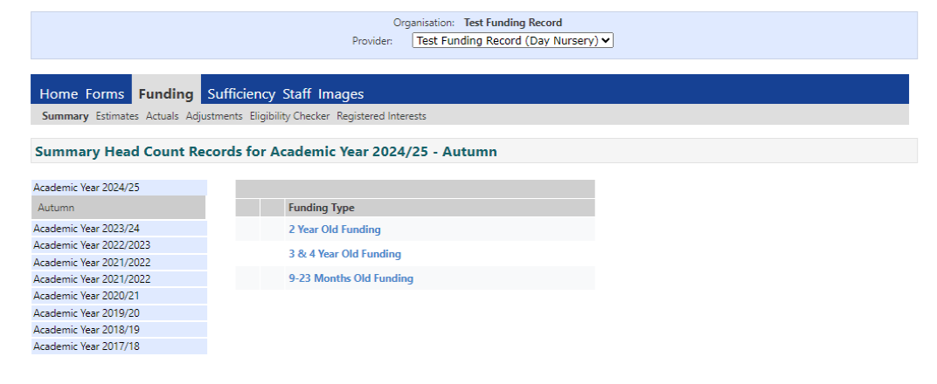
- Once you open a term and funding type the screen will look as below:

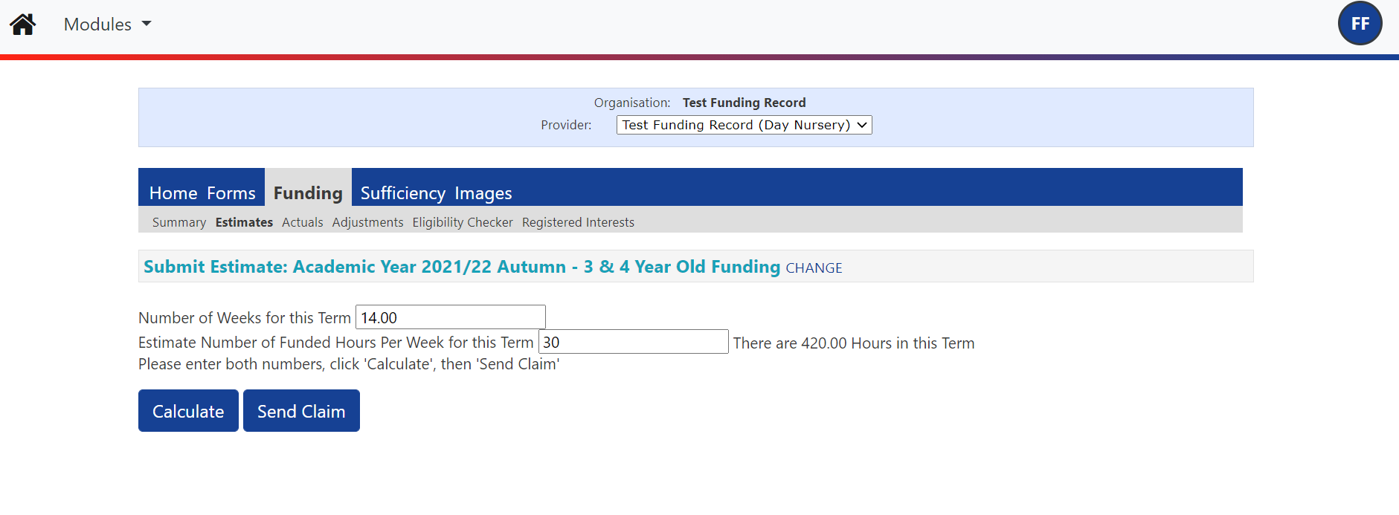

- Input the number of weeks you would like to claim for the term, this is always stipulated on the second row of your funding timetable for each term titled ‘Number of weeks funded by LA’. If you will be providing less than 38 weeks a year you should input the exact number of funded weeks that you are going to be providing each term.

- Input your total estimate number of funded hours per week for the term and select ‘Calculate’, the total number of hours for the term will then calculate and appear at the side of the funded weekly hours you have entered. The screen above gives an example estimate claim for two children claiming 15 hours of funding a week.

- Click on ‘Send Claim’ and this will be sent to FIS.

- A green box will appear at the top of the screen to confirm you have successfully submitted your claim to FIS. If you do not see this, please contact FIS on 01332 640758 or email earlyyearsfunding@derby.gov.uk to check your claim has successfully sent.

Please Note: If your estimates change you can resend new data anytime up until the final deadline date for estimate submissions your previous estimate will be overwritten. Please also be aware if you over-estimate your claim at this point funding will be reclaimed at actuals stage. Continual over claims will be investigated and Derby City Council reserves the right to withdraw estimate funding and only pay on actuals.
Section 5: Submitting Actual Claims Universal Entitlement

Actual claim records must be submitted by the actual submission date stipulated on the FEEE Funding timetable which can be found on the Childcare Provider Webpage. Once FIS has carried forward children from the previous term we will email out to all providers to let you know you can start submitting your claims for the current term. Please remember as soon as a term is opened on the FIS portal you can start to submit claims. You can do this in multiple visits as the system saves unsent information until it is submitted. If you send your claim and need to add something or correct it, you can add or alter the informaton and re-submit it up until the deadline date stipulated on the funding timetable. If you have the information available early please submit this to us as this helps us sort out any queries with data and double funding and process claims in time to make payments.

5.1. Opening Actuals Screen

- Go to Funding > Actuals > select the relevant term and funding type.

- To enter your claim details select the funding type 3&4 year old

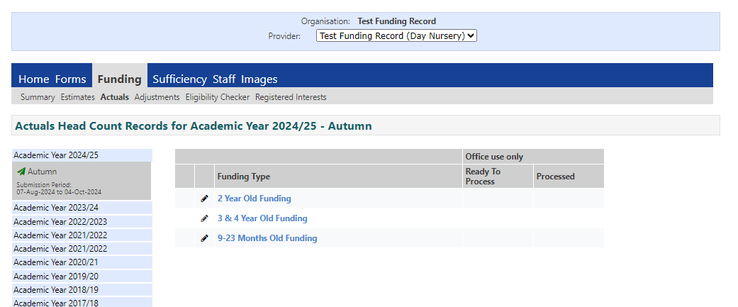

- Eligible children from the previous term will show, as in the screen below, however if it is your first term claiming no child data will appear. All funded hours are put back to zero so you must go in and update hours for each child carried forward each term.

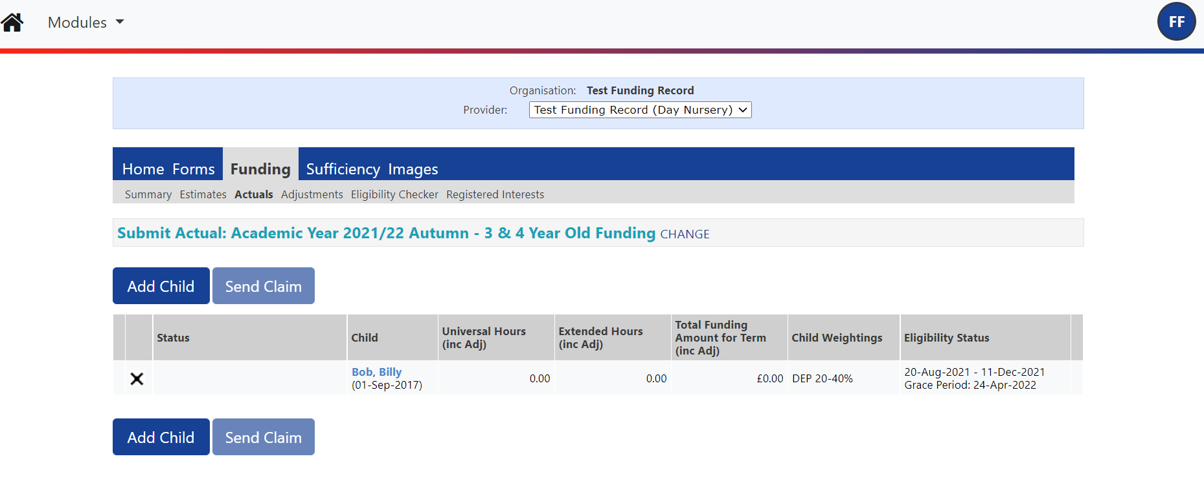

5.2. Updating an Existing Child Record

- It is important that you check that all the details of the children who have been carried forward are correct (i.e. full legal name of child is included and spelt correctly and the hours you are claiming are correct).
- When children are carried forward into the next term all funded hours are set back to zero you must update funded hours for all children or you will not receive any funding for them this includes EYPP and weighting funding.
- You must also make sure in autumn term all 4 year old children that have gone up to school are removed from your autumn term claim.

- To amend an existing child's record select the child’s name that is written in blue, the screen will open up to the ‘summary’ tab as below. Once all details have been submitted and processed by Derby City Council you can check your child summary to see what payment you will receive for the child.

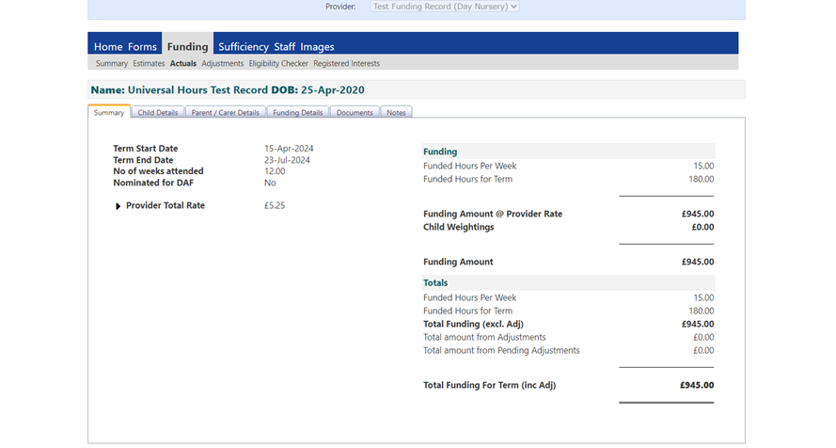

- Select the ‘child details’ tab to check all child details are correct and update as required:

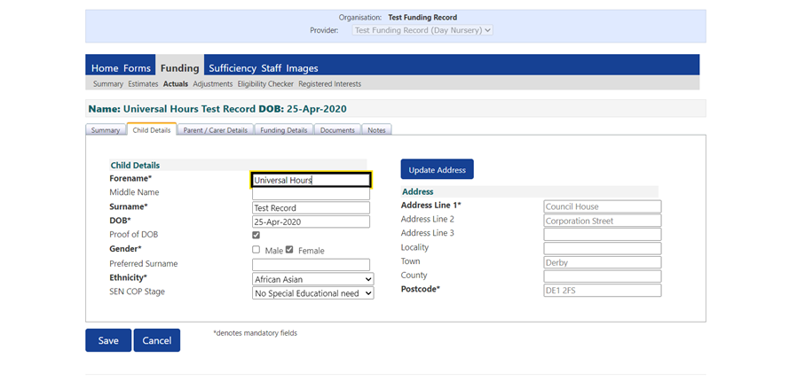

- If you think a child will meet the economic criteria to receive EYPP you will need to add parent/carer details, as shown in the screen below, the parents name, national insuarance number, date of birth and the child’s date of birth will be used to perform an EYPP check under the economic criteria. Please ensure parents have given consent for an EYPP check to be performed on their child’s parental contract before ticking the box below to give consent for an EYPP check to be performed:

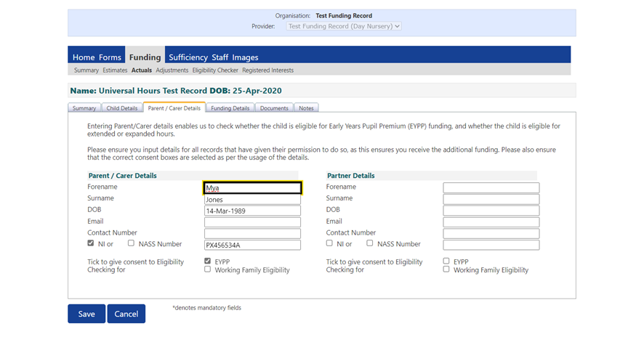

- If a child meets the EYPP Criteria as they are in reciept of Disability Living Allowance (DLA) or they are a Looked Ater Child (LAC), have left care through through Adoption, Special Guardianship or Residence Order you will need to send a copy of the child’s DLA or Adoption, Guardianship or Residence Order to us using the document download tab for an EYPP funding to be applied.

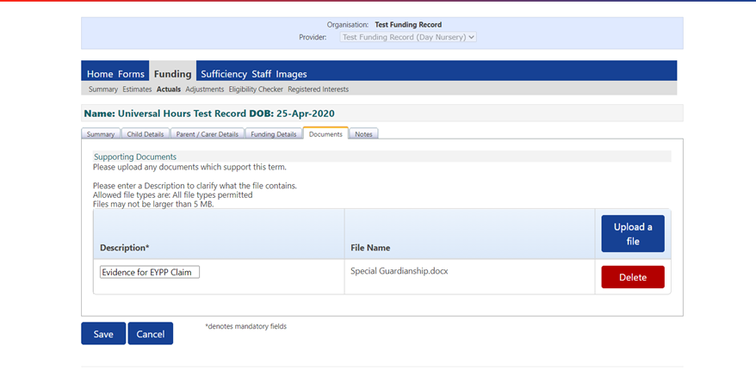

- As shown in the screen below, select ‘Funding Details’ all details from the previous term should have carried forward into the new term to be checked and amended if needed, however the child’s funded hours will have been set back to zero so you will need update funded hours for all children, failure to update funded hours will result in a nil claim and you will not receive any funding for the child.

Please note term start and end dates are automatically populated and are set much wider than the actual term dates for term time children to accommodate stretched funding. Please adjust the term start and end date to reflect the child’s actual attendance, funding term dates can be found on the funding timetable.

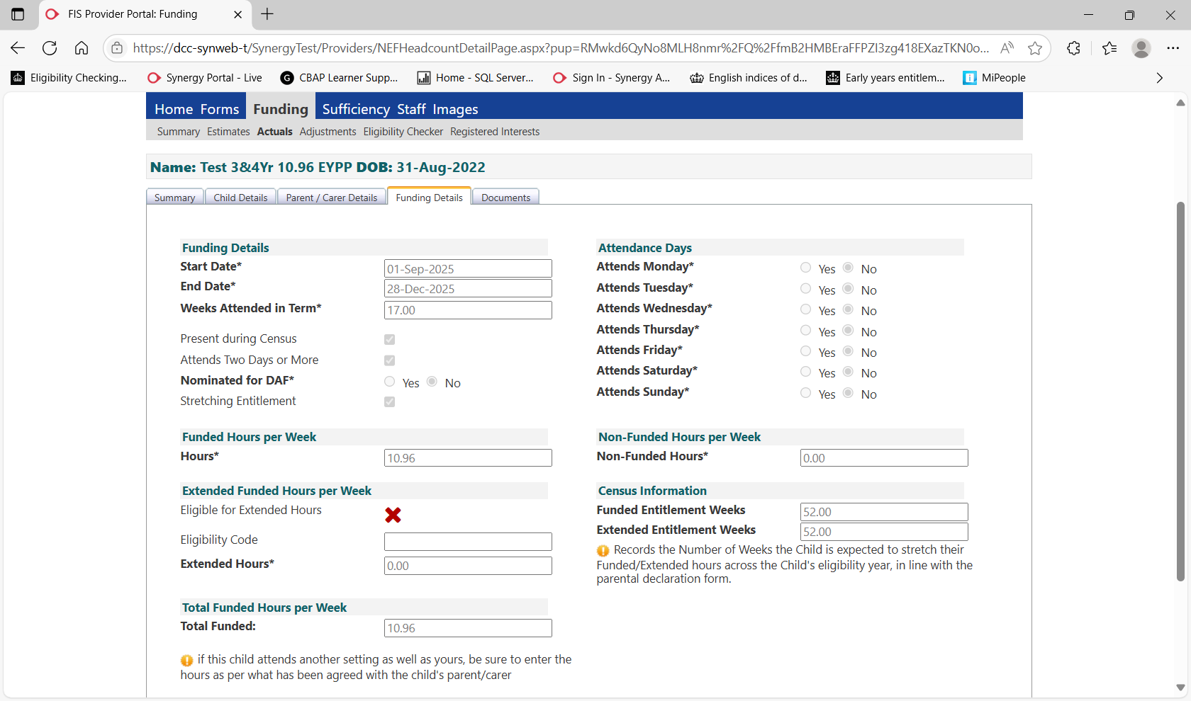

- Click on 'Save' and as shown below the status of the child record will change to ‘Unsubmitted Claim' and there will be an exclamation mark to indicate the claim has not been submitted.

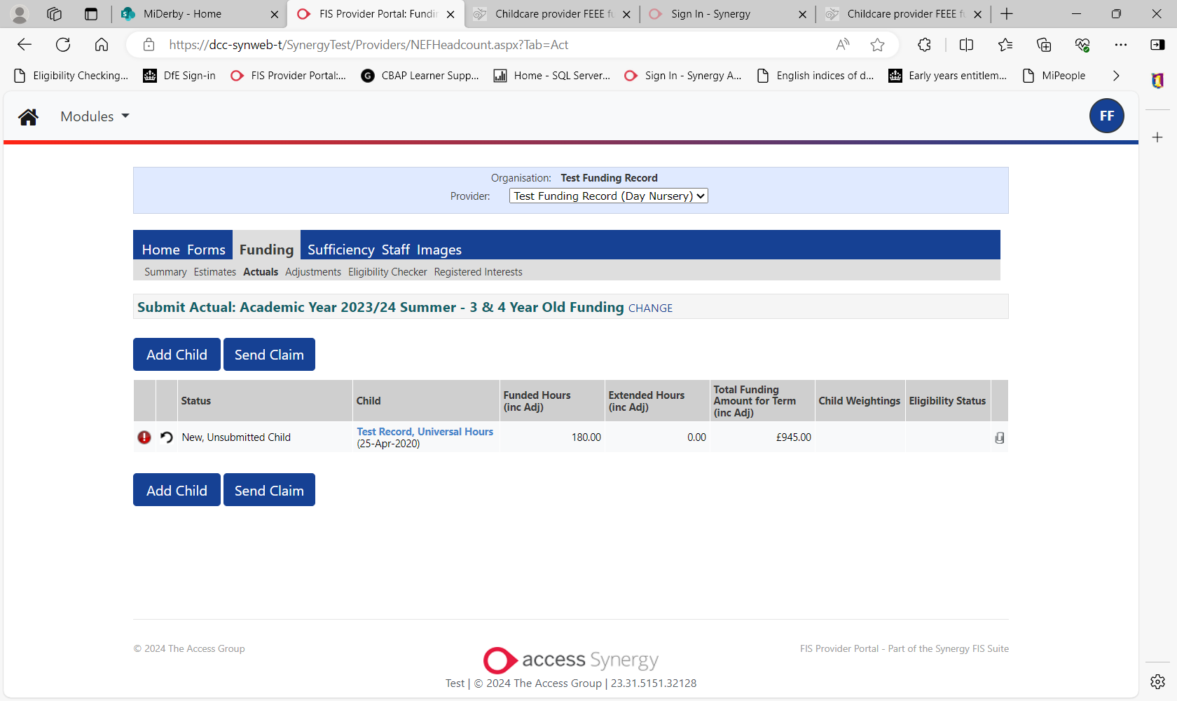

- Once you click on ‘Send Claim’ as shown below you will get a green box at the top of the screen to state the record has been submitted successfully and the status of the child record will change to ‘Awaiting LA Download’

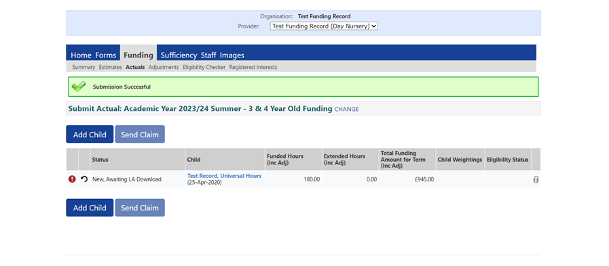

- Once FIS has processed the child record the status of the record will be blank as shown below:

- If you decide not to send your amendments straight away using the 'Send Claim' button, the next time you log onto the FIS Portal you will see the message below on your Home screen under Notifications. This message is to remind you that you have made changes which have not been submitted. If you see this message after the submission deadline please contact FIS on 01332 640758.

You can submit individual child claims to Derby City Council you do not need to wait until you have completed all child claims to submit as a whole, you can update and re-submit child claims as many times as you need to before the final Actuals deadline.

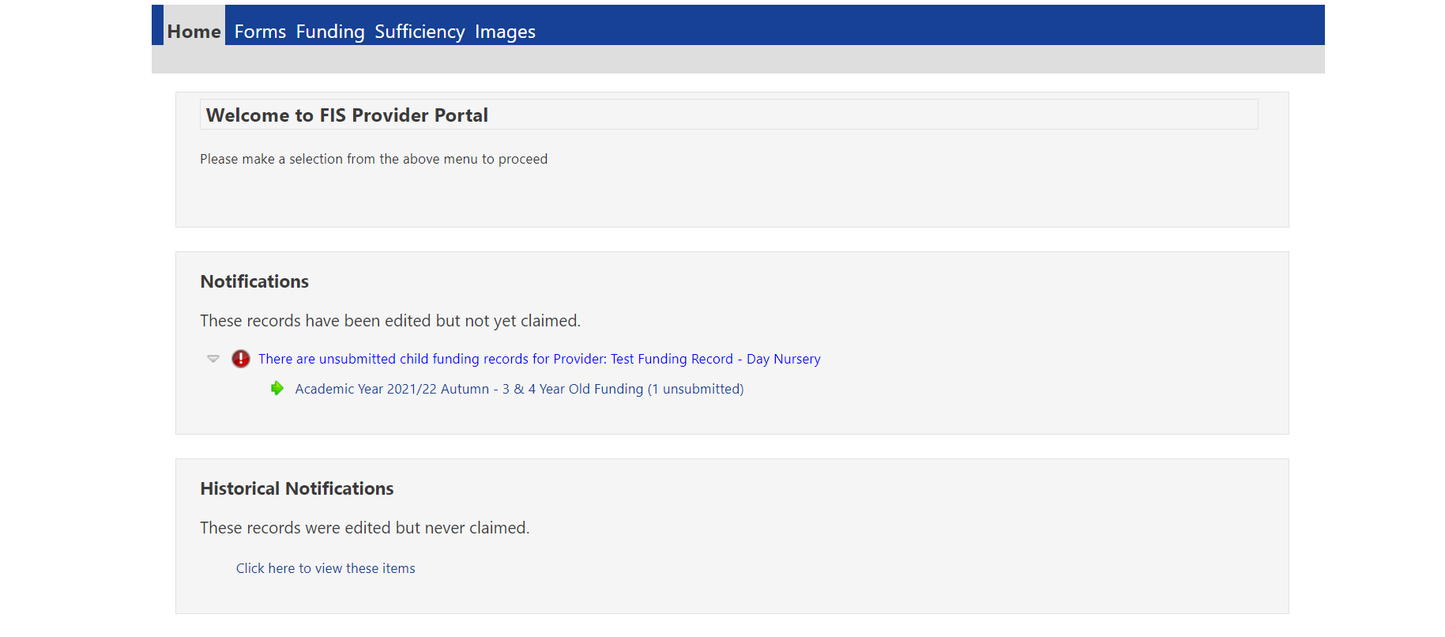

- If you have made changes but not submitted the child record and you want to undo the changes, you can click on the undo edit icon highlighted below and this will undo any changes you have made.

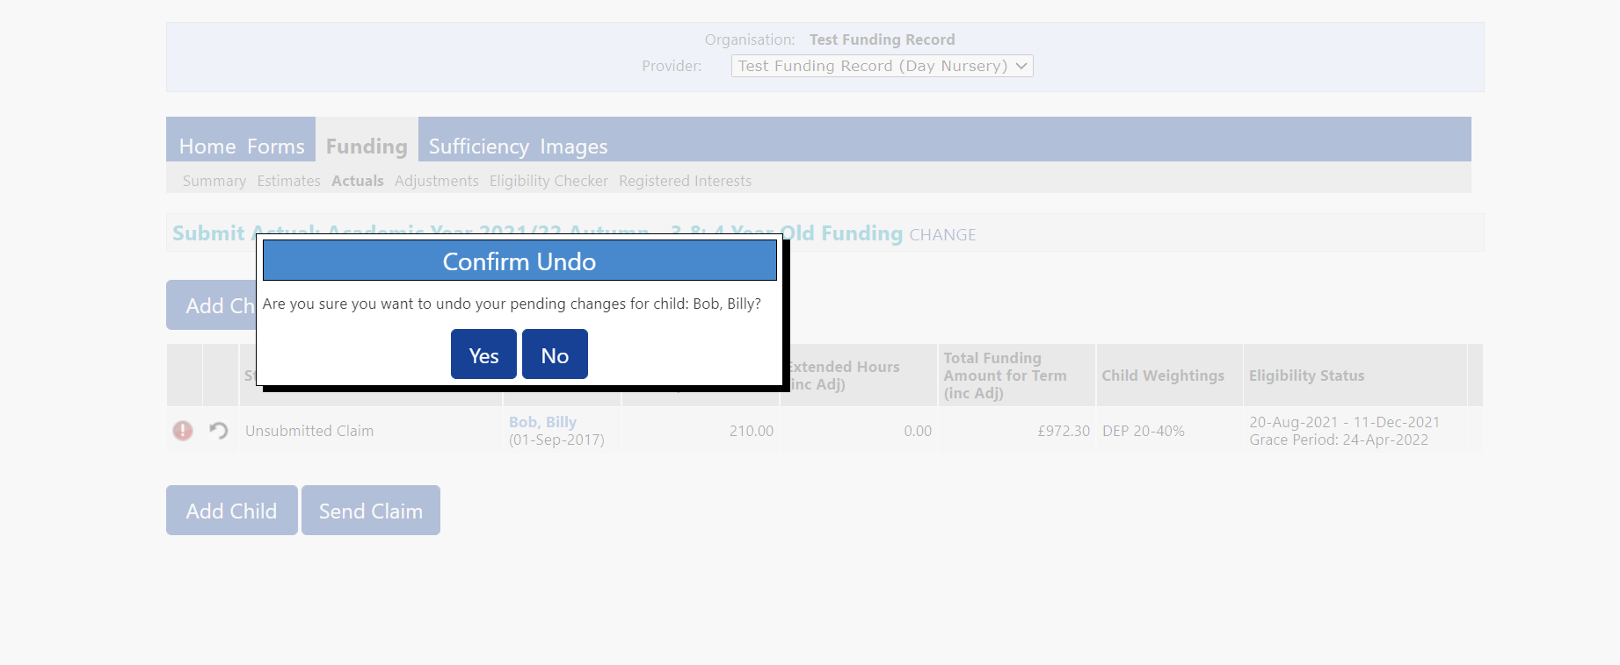

5.3. Deleting a Child Record

- Click on the cross icon highlighted below to 'Request Delete' child record, the screen will show as below, select ‘Yes’ to remove the child from your submission.

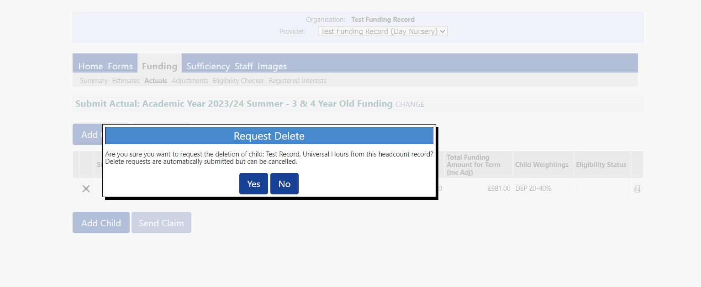

- The status of the record will change to ‘Awaiting LA Deletion’ once FIS have approved the change the child will be removed from from your actuals for the term.

- Please note once you select Yes to requests delete, the deltion is automatically submitted even if you do not click on the 'Send Claim' button. It is still possible to cancel the delete by clicking on the undo icon at this stage providing FIS have not accepted the deletion.

- Once we have accepted the deletion the child will dissapear completely from your portal screen within the term you have deleted. If at this stage you realise you have deleted a child in error you will need to add the child back on as a new child.

5.4. Adding a New Child Record

- Go to Funding – Actuals – Select Year/Term and Type and then Select ‘Add Child’ to input new children, the screen will open to ‘child details tab’ as shown on the screen below

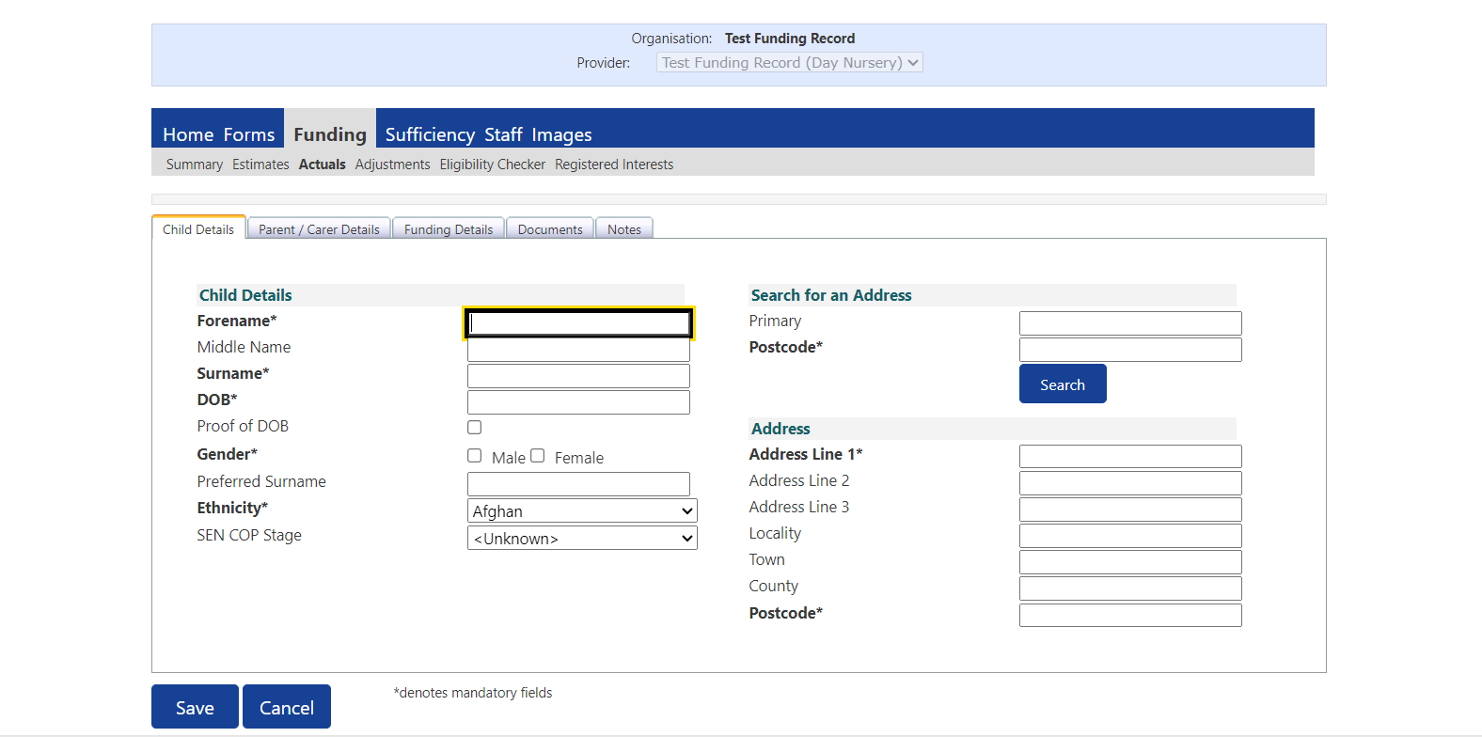

- Complete the Child Details, this section asks for all details that are on the Parental Contract, as a minimum you must ensure you fill out all fields marked with * as mandatory to move to the next page.
However you must also ensure you tick the box to state you have seen the child’s I.D to prove their DOB, and it is very important that you complete the ‘SEN COP stage’ box to let us know if the child has any Special Education Needs, this data is required for the termly Early Years Census and must be completed in line with the FEEE Provider Agreement.

You can search for the child’s address using their postcode and house number, once you click the search button you will then be able to find the full address from the drop down list, if the full address can not be found you can add the address manually by selecting ‘Enter Manually’ and then manually entering the full address.

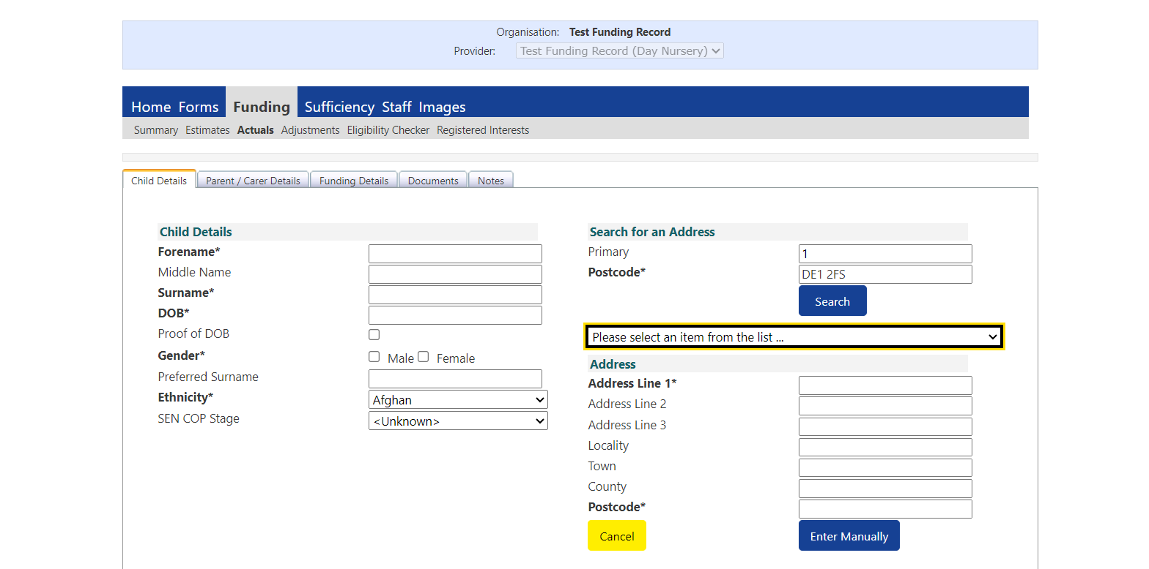

- Next click on the ‘Parent/Carer Details’ tab.

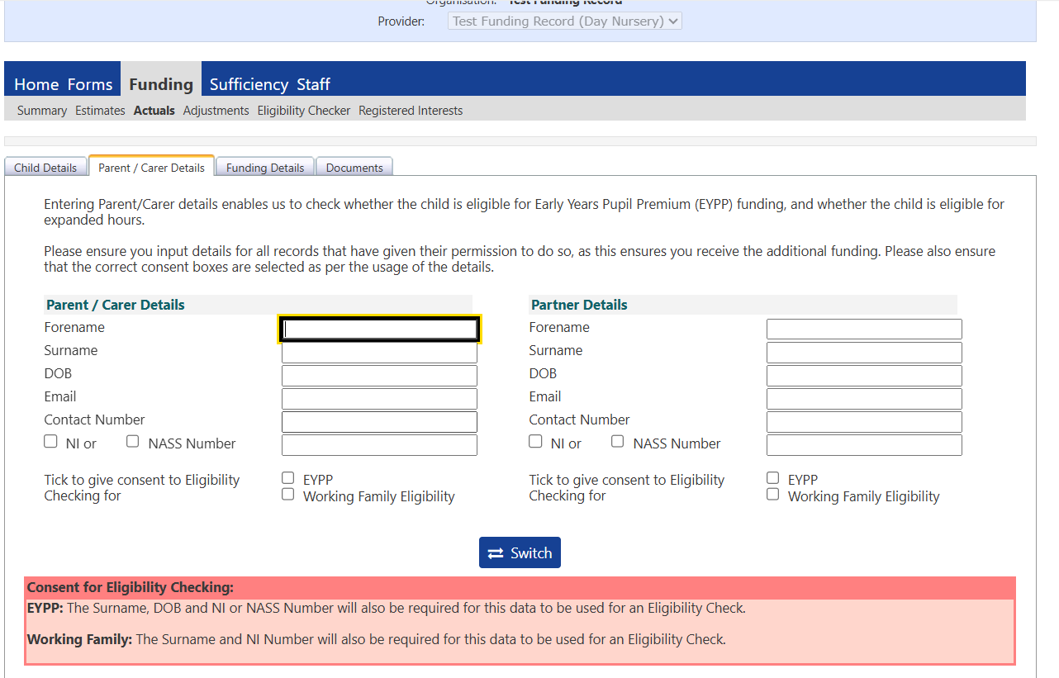

- If a parent has completed a ‘Parental Contract’ giving written consent to check eligiblity for Early Years Pupil Premium (EYPP) and/or Working Familiy Eligibility then please click on the ‘Parent/Carer Details’ tab.

- You will then need to enter the parents’s forename, surname, date of birth, National Insurance Number (2 letters, 6 numbers 1 letter) or National Asylum Support Service (NASS) Number (9 digits).

- FIS will undertake termly EYPP batch checks after the headcount deadline, once all data is in and processed and Working Family Eligiblity checks 6 times per year as stated in the FEEE Provider Agreement Guidance. Each term the child’s claims will carry forward into a new term, we will only check new children you add into the new term for EYPP and re-check any children that were not eligible in the previous term, all children that have been allocated EYPP will keep their EYPP status until they go upto School.

- EYPP checks will be updated and shown under the Actuals tab against the child data. If a child has been found eligible for EYPP ‘EYPP’ will be shown in the column titled ‘Child Weightings’

- Next click on the ‘Funding details’ tab, the screen should look as below:

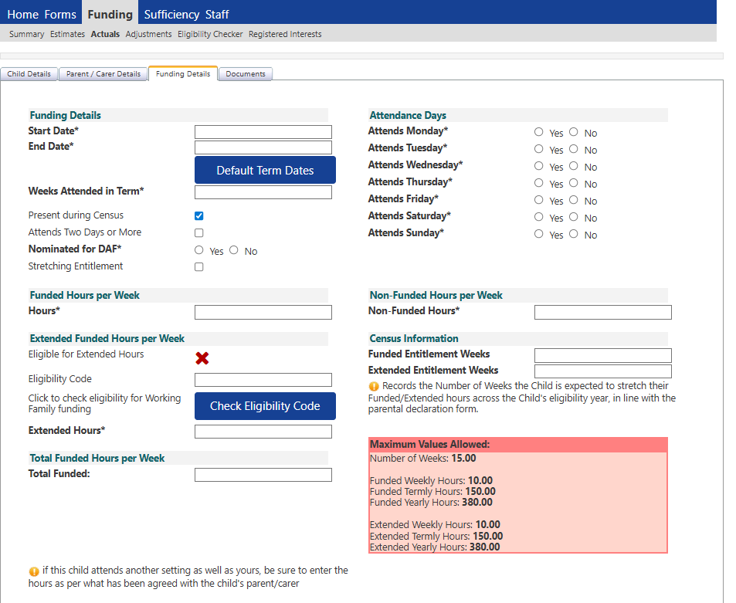

- Complete all fields as below:
Term start date and end dates will automatically be populated and will not reflect the actual term time dates as this section is also used for validating the stretched funding for upto 52 week year. Please adjust term start and end date to reflect what dates the child is actually attending.

Weeks attended in term – will be the number of weeks the child is attending for the term inline with the number of weeks on the term time funding timetable or your providers stretched declaration form.

The 'present during census' box should be ticked for all children on your ‘Actuals’ submission.

Attends Two Days or More box - should be ticked for all children claiming 15 hours; it is not possbile to claim more than 10 hours in one day and 15 hours must be taken over a minimum of 2 days. If you do not tick the ‘Attends Two Days or More' box and the claim is over 10 hours the system will give an error message.

Nominated for DAF – Please select ‘yes’ or ‘no’ to state if a child is in reciept of Disability Living Allowance. If ‘yes’ is selected you will need to submit evidence of the child’s DLA using the document tabs on the child’s record.

Stretching Entitlement – this box only needs to be ticked if you claiming stretched funding for the chid over more than 38 weeks of the year.

Attendance Days – state the days the child is signed up per the ‘Parental Contract’ to receive funded hours

Universal Hours - enter the number of weekly hours in the box maximum of 15 universal hours per week term time or maximum weekly hours funded on provider stretching declaration for children stretching funding over more than 38 weeks per year.

Non-funded hours per week – enter the number of hours paid for by the parent.

Funded Entitlement Weeks – This will be the number of yearly weeks the child is in attendance for example a child attending term-time will be 38 weeks, a child attending stretched funding will be 52 weeks or the number of yearly weeks stated in section 1 of your providers stretched declaration form.

Extended Entitlement Weeks – will be zero if the child is only attending funded universal hours. If you have entered extended hours this box will need completing the same as the funded entitlement weeks above.

Click ‘Save’ and ‘Send Claim’

Section 6: Working Parent Entitlement

The working parent entitlement will cover the 1140 hours per year for:

- 3&4 year old extended entitlement
- 2 year old expanded entitlement
- 9-23 months expanded entitlement

Parents must apply to confirm eligibility for the Working Parent Entitlements by making an online application through the HMRC website at https://www.childcarechoices.gov.uk/ or by ringing 0300 123 4097.
Parents that qualify will be issued with an 11 digit code. In order to take up a funded place for Extended or Expanded Entitlement, parents will have to present this code to childcare providers and the childcare provider in turn must verify that the code is a valid code by using the eligiblity checker functionality under the ‘FUNDING’ tab on the FIS portal, as detailed below:

6.1. Validating a Working Parent Voucher Code
Working parent codes must be validated on the portal before a funded place is offered, you can do this by following the instructions below:

- Go to FUNDING > Eligibility Checker and click on the Working Parent Voucher Code box shown on the printscreen below
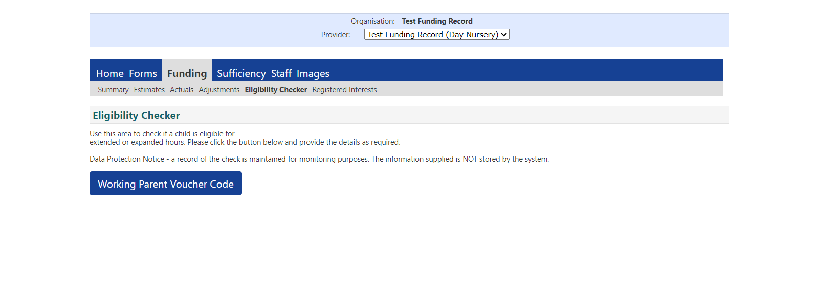

- Enter the * fields only, Eligibility Code, Child’s date of birth, Parent/Carer NI Number and tick the Consent box for eligiblity check to be performed.

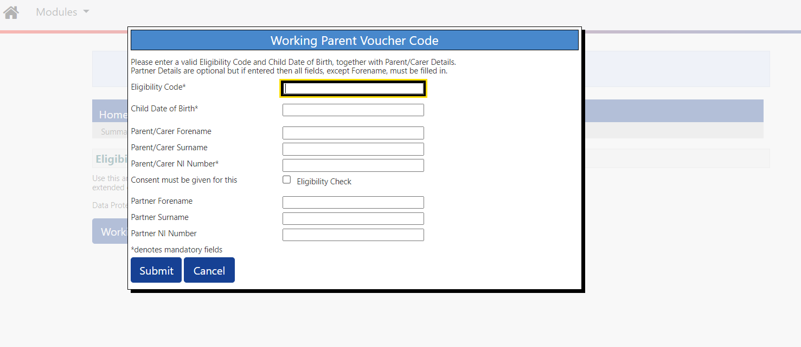

- Once the check is complete an amber box will appear at the top of the screen to state the details provided have been found. You must then check the code start and end date of the code to ensure it can be used in the term you will be claiming the working parent hours, please refer to the FEEE Provider Agreement Guidance for eligible dates for each term.

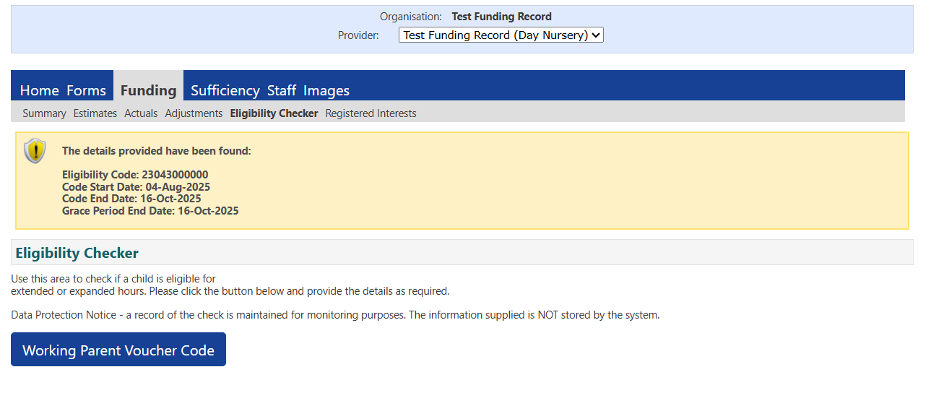
- If the code is not eligible or details have been incorrectly entered a red box will appear at the top of the screen with an error message, please check with the parent / carer that all details are correct, if they are and you still get the error message then the parent/carer will need to contact the HMRC gateway helpline on 0300 1234 097 to obtain proof of eligibility so the claim can go onto the portal.

Important points to consider:

- Codes are only valid from the start of the term after the one in which they are issued. For example, a parent issued with a code in September cannot use their working parent hours until January. Only 3- & 4-year-old children can access their universal entitlement based on date of birth as normal.

- Codes are only valid for 3 months. Parents must reconfirm their details with HMRC with the last month of their validity period. HMRC will remind parents by email and / or text message.

- Parents that do not reconfirm their details in time or whose details have changed enough to put them out of the eligibility range will become ineligible and will fall into the Grace Period. Funding will continue until the end of this period. The Grace Periods are set out in the table below.

- The local Authority will carry out Audit checks on codes at 6 points throughout the year as per the audit timetable below:

LA Audit | LA Audit date: | Validity end dates: | Grace Period End date:
Spring: Mid-term | 11 February | 1 Jan – 10 Feb | 31 March
Summer: Start of term | 1 April | 11 Feb – 31 March | 31 August
Summer: Mid-term | 27 May | 1 April – 26 May | 31 August
Autumn: Start of term | 1 September | 27 May – 31 August | 31 December
Autumn: Mid-term | 22 October | 1 September – 21 October | 31 December
Spring: Start of term | 1 January | 22 October – 31 December | 31 March

- Parents that have fallen into the Grace Period because they have forgotton to reconfirm their details can reapply through HMRC.
- As long as the same parent re-confirms or reapplies the code will remain the same but the code end date will change.

In order to claim correctly providers will need to understand how the parent wishes to take up their funding. This is particularly important where a child is claiming across multiple providers. Providers will need to know which hours are Universal and which hours are Extended for 3&4 year old funded children and which hours are Flying Start (additional support) and Expanded for a 2 year old funded children. Parents should confirm this information by completing the ‘Parental Contract’ and the provider’s ‘Actual’ headcount claim should reflect this by separating out the hours on the FIS Portal.

6.2. Claiming Extended Entitlement for 3&4 year olds

To claim for a child who is accessing the Extended Entitlement go to the ‘Actuals’ tab then select the required term.

- Complete the ‘Child Details’ tab as described earlier in this guidance (adding children – page 18-21)

- Next complete the ‘Parent/Carer Details’ as shown in the screen below you must ensure these details are complete with the eligiblity consent box for ‘Working Familiy Eligiblity’ ticked before peforming a check in the funding details tab:
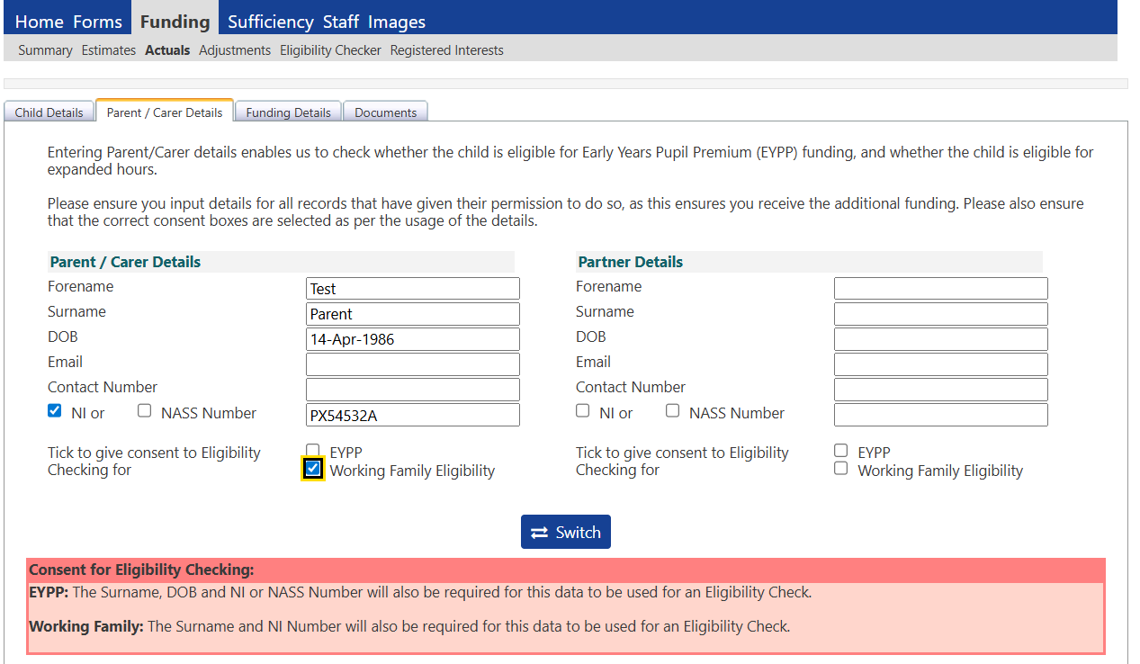

- Next complete the ‘Funding Details’ tab for extended hours please complete in the following order

Term start date and end dates will automatically be populated and will not reflect a child attending term time as this section is also used for validating stretched funding so the three terms have to conistently run across a 52 week year. Please adjust this to reflect what dates the child is actually attending.

Weeks attended in term – The number of weeks entered should be the number of weeks funded by the LA stated on the term time time timetable for a term time child, or the number of weeks you have signed up for on your provisions stretched offer declaration form if the child is taking a stretched offer. If the child is taking a reduced offer and you are offering less than 38 weeks for the year you should only claim the number of weeks the child is actually attending.

Complete the following boxes:
- Present during census (if applicable)
- Attends Two days or More (if applicable)
- Nominated for DAF (if applicable)
- Stretched Entitlement (if applicable)
- Attendance Days

Universal hours - enter the number of weekly hours in the box maximum of 15 hours per week term time or maximum weekly hours on provider stretching declaration for children stretching funding over more than 38 weeks per year. If a child is claiming Extended Entitlement only enter 0 in this box.

Before entering extended hours you must ensure the eligiblity code has been entered and you have performed an eligiblity check within the actuals by clicking on the ‘Check Eligibility Code’ button located underneath the box where you have entered the code. You should get a green box at the top of the page as shown below letting you know the eligiblity code has been found and eligibility for working family hours has been obtained’ now the portal will allow you to enter extended hours.

Extended hours –enter the number of weekly hours in the box maximum of 15 hours extended per week for a term time child or maximum weekly funded hours on provider stretching declaration for children stretching funding over more than 38 weeks per year.

Non-funded hours per week – enter the number of hours paid for by the parent.

Funded Entitlement Weeks – will need to be completed if funded weekly hours are present. This will be the number of yearly weeks the child is in attendance for example a child attending term-time will be 38 weeks, a child attending stretched funding will be 52 weeks or the number of yearly weeks stated in section 1 of your providers stretched declaration form.

Extended Entitlement Weeks – will need to be completed if extended weekly hours are present. Of not hours present will need to be completed with zero if the child is only attending funded universal hours. If you have entered extended hours this box will need completing the same as the funded entitlement weeks above.

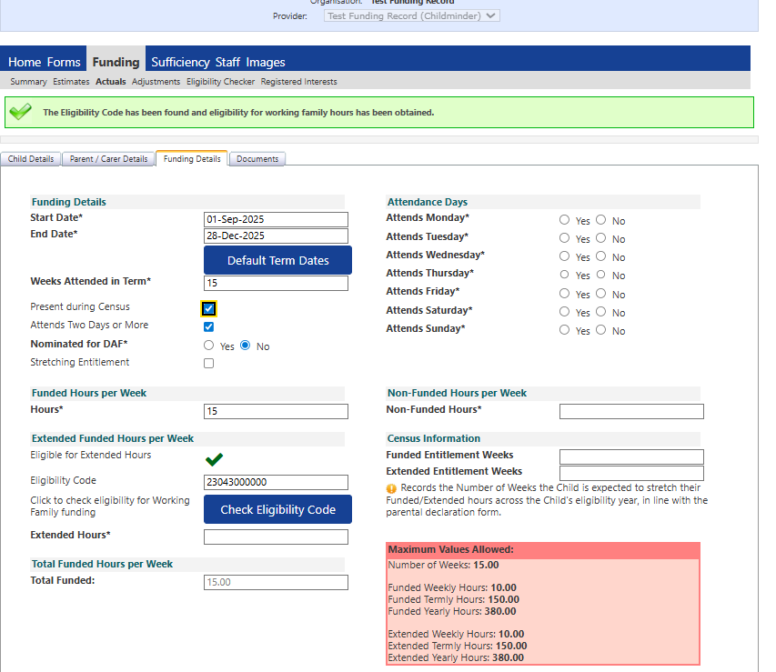

If the eligibility code is found and can be used in the term you are claiming a green tick will be shown under extended funded hours per week as shown in the pring screen above.
If the eligibility code cannot be found, an error message will be displayed at the top of the screen informing you of the reason for the error and you will only be able to submit ‘universal hours’. If you get an error message, firstly check the information has been entered correctly onto the portal. If the parent confirms all details are correct, the parent will need to either contact HMRC on 0300 124 097 to obtain confirmation of their applicaton to evidence the code is valid or provide you with a print screen of their application from their gateway account.

Please note: The Council has no jurisdiction over a child’s eligibility for Extended Entitlement. If a parent wishes to challenge the eligibility result they will have to contract HMRC directly.

Enter the ‘Non Funded Hours per week’

Click ‘Save’ and ‘Send Claim’

6.3. Claiming Expanded Entitlement for 2 year olds

Please Note: Some parents may meet the eligibility criteria for 2-year-old funding under the working parent entitlement (11-digit code) and the flying start for 2-year-old entitlement (6-digit code). In this instance providers must process the 6-digit code issued for Flying Start for 2-year-old funding to receive the first 570 hours per year and the working parent code to receive the remaining 570 hours per year.

- To claim for a child who is accessing the 2 year old Expanded Entitlement go to the ‘Actuals’ tab then select the required term and age group.

Complete the ‘Child Details’ tab as described earlier in this guidance (adding a new child record – page 18-21)

- Next complete the ‘Parent/Carer Details’ as shown in the screen below you must ensure these details are complete with the eligiblity consent box for ‘Working Familiy Eligiblity’ ticked before peforming a check in the funding details tab:

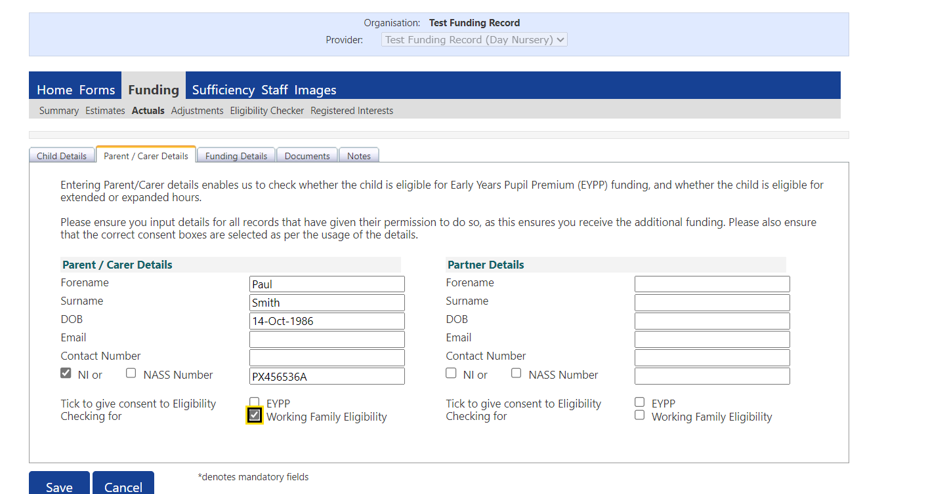

- Next go to the ‘Funding Details’ tab, shown below
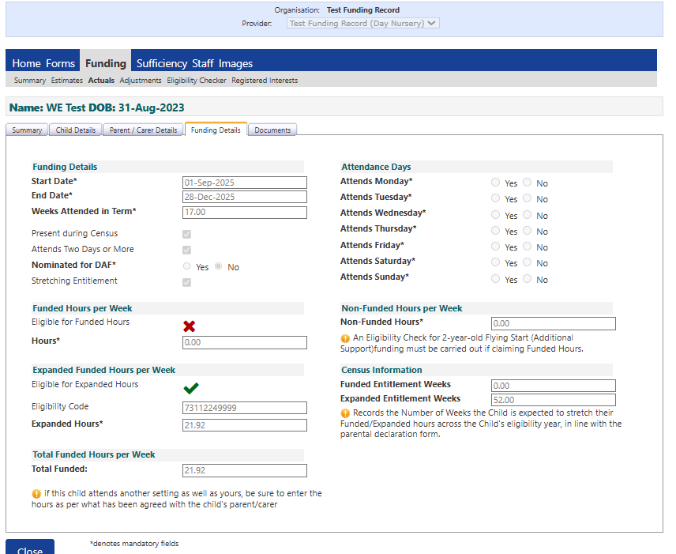

Complete the funding details in the following order:

Term start date and end dates will automatically be populated and will not reflect a child attending term time as this section is also used for validating stretched funding so the three terms have to conistently run across a 52 week year. Please adjust this to reflect what dates the child is actually attending.

Weeks attended in term – The number of weeks entered should be the number of weeks funded by the LA stated on the term time time timetable for a term time child, or the number of weeks you have signed up for on your provisions stretched offer declaration form if the child is taking a stretched offer. If the child is taking a reduced offer and you are offering less than 38 weeks for the year you should only claim the number of weeks the child is actually attending.

Complete the following boxes:
- Present during census
- Attends Two days or More (if applicable)
- Nominated for DAF (if applicable)
- Stretched Entitlement (if applicable)
- Attendance Days yes or no must be selected for all days including Saturday and Sunday

Funded Hours per week – should be recorded as 0 if the parent is only entitled to working parent hours, however if the parent has provided a 6 digit code for Flying Start (additional support) and an 11 digit working parent code, both codes should be entered on the funding details page and upto 30 weekly hours should be split between funded hours and expanded hours per week, up to 15 hours additional support hours should be claimed in funded hours per week (equating to 570 hours per year) and the remaining weekly hours should be claimed in the expanded funded hours per week (equating to 570 hours per year) if the child is eligible for 1140 hours per year.

Before entering expanded hours you must ensure the eligiblity code has been entered and you have performed an eligiblity check within the actuals by clicking on the ‘Check Eligibility Code’ button located underneath the box where you have entered the working parent code. You should get a green box at the top of the page letting you know the eligiblity code has been found and eligibility for working family hours has been obtained’ now the portal will allow you to enter expanded hours

Expanded Funded Hours Per week –upto a maximum of 30 hours per week needs to be entered (1140 hours per year) if parent is only eligible for working family entitlement, or upto 15 hours per week (570 hours per year) if flying start (additional support) funding is being claimed and child is entitled to 1140 hours.

Non-funded hours per week – enter the number of hours paid for by the parent.

Funded Entitlement Weeks – will be zero if the child is only attending expanded working parent hours with an 11 digit code only. If the child is eligible for flying start for 2 year old funding and working parent entitlement this box will need completing with the number of yearly weeks the child is in attendance for example a child attending term-time will be 38 weeks, a child attending stretched funding will be 52 weeks or the number of yearly weeks stated in section 1 of your providers stretched declaration form.

Expanded Entitlement Weeks – This will be the number of yearly weeks the child is in attendance for example a child attending term-time will be 38 weeks, a child attending stretched funding will be 52 weeks or the number of yearly weeks stated in section 1 of your providers stretched declaration form.

Click ‘Save’ and ‘Send Claim’

6.4. Claiming Expanded Entitlement for 9-23 months old

To claim for a child who is accessing the 9-23 months old Expanded Entitlement go to the ‘Actuals’ tab then select the required term and age group.

- Complete the ‘Child Details’ tab as described earlier in this guidance (adding a new child record – page 18-21)

- Next complete the ‘Parent/Carer Details’ as shown in the screen below you must ensure these details are complete with the eligiblity consent box for ‘Working Familiy Eligiblity’ ticked before peforming a check in the funding details tab:

- Next go to the ‘Funding Details’ tab, the page will look as below
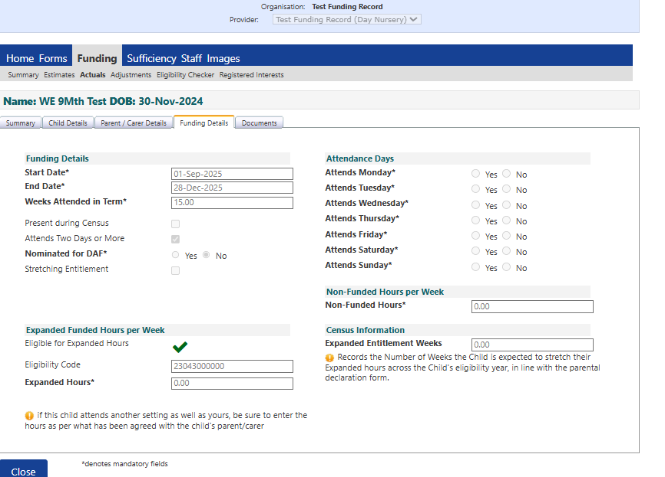

Complete the funding details in the following order:
Term start date and end dates will automatically be populated and will not reflect a child attending term time as this section is also used for validating stretched funding so the three terms have to conistently run across a 52 week year. Please adjust this to reflect what dates the child is actually attending.

Weeks attended in term – The number of weeks entered should be the number of weeks funded by the LA stated on the term time time timetable for a term time child, or the number of weeks you have signed up for on your provisions stretched offer declaration form if the child is taking a stretched offer. If the child is taking a reduced offer and you are offering less than 38 weeks for the year you should only claim the number of weeks the child is actually attending.

Complete the following boxes:
- Present during census
- Attends Two days or More (if applicable)
- Nominated for DAF (if applicable)
- Stretched Entitlement (if applicable)
- Attendance Days - yes or no must be selected for all days including Saturday and Sunday

Before entering expanded hours you must ensure the eligiblity code has been entered and you have performed an eligiblity check within the actuals by clicking on the ‘Check Eligibility Code’ button located underneath the box where you have entered the working parent code. You should get a green box at the top of the page as shown below letting you know the eligiblity code has been found and eligibility for working family hours has been obtained’ now the portal will allow you to enter expanded hours.

Expanded Hours – upto a maximum of 30 hours per week can be entered (1140 hours per year).

Non-funded hours per week – enter the number of hours paid for by the parent.

Expanded Entitlement Weeks – This will be the number of yearly weeks the child is in attendance for example a child attending term-time will be 38 weeks, a child attending stretched funding will be 52 weeks or the number of yearly weeks stated in section 1 of your providers stretched declaration form.

Click ‘Save’ and ‘Send Claim’

Section 7: Flying Start for 2-year-old Entitlement

An eligibility letter must be seen and retained by the provider before entering a flying start for 2-year-old child onto the FIS portal to claim additional support funded hours.

Parents living in Derby city can check if they are eligible for flying start for 2-year-old funding by ringing the Families Information Service on 01332 640758 or completing an online application on Derby City Council website Childcare and early years education - Derby City Council If a child is eligible for flying start for 2 year old funding they will be issued with a 6 digit code which will be a mix of numbers and letters.

7.1. Claiming for a child living in Derby City

If a child is living in Derby City, they should have received a voucher code from Derby City council.

To add a child claim onto the portal with a flying start for 2-year-old code issues by Derby City Council, please follow the instructions below:

- Go to ‘Funding’ > Actuals > Select the term and age group 2-year-old funding.

- Select ‘Enter EY Voucher Code’

- Enter the 2yr voucher code, child’s date of birth, and surname and click submit.

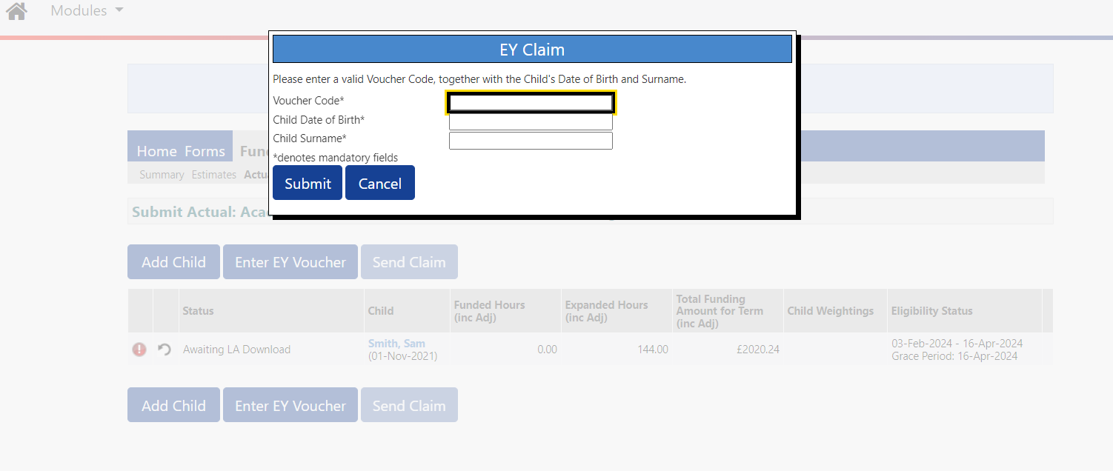

- The code is unique and will only work with the child’s surname and date of birth. Take care to enter the correct details. If the wrong details are added twice, or more, the system will lock this facility for a short period of time.

- After submitting the details, the system defaults to the fourth tab – funding details and the term dates are already shown. Providers must go back to the second tab– child’s details to check the names match the Birth Certificate (or other official documentation) and that the address matches the ‘Parental Contract’, any other fields on the child details will need completing and the third tab – parent / carer details will also need checking and updating where required and consent will need to be given for Flying Start 2 year old (additional support) check any EYPP check to be performed if applicable.

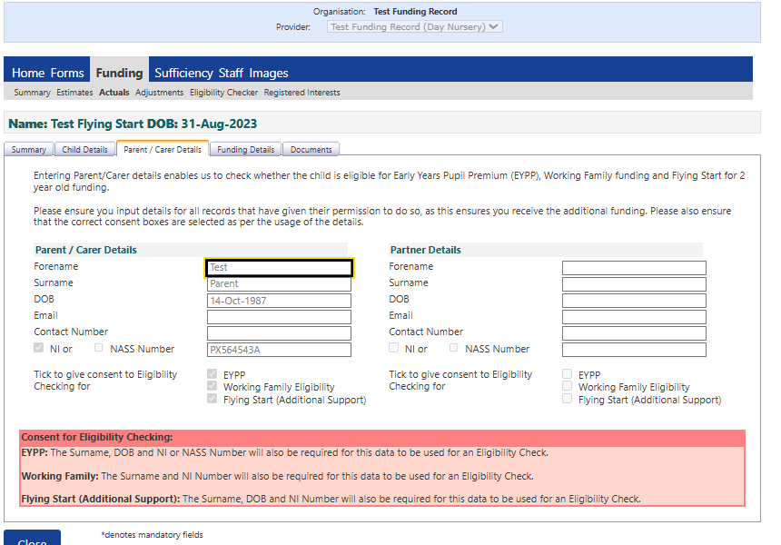

- Then go to the child’s funding details tab and complete the following:

Term start date and end dates will automatically be populated and will not reflect a child attending term time as this section is also used for validating stretched funding so the three terms have to conistently run across a 52 week year. Please adjust this to reflect what dates the child is actually attending.

Weeks attended in term – The number of weeks entered should be the number of weeks funded by the LA stated on the term time time timetable for a term time child, or the number of weeks you have signed up for on your provisions stretched offer declaration form if the child is taking a stretched offer. If the child is taking a reduced offer and you are offering less than 38 weeks for the year you should only claim the number of weeks the child is actually attending.

Complete the following boxes:

- Present during census (if applicable) – if child is in attendance headcount week
- Attends Two days or More (if applicable)
- Nominated for DAF (if applicable)
- Stretched Entitlement (if applicable)
- Attendance Days – yes or no must be selected for all days including Saturday and Sunday

Funded Hours – the weekly number of flying start (additional support funded hours the child is attending at your setting (maximum of 15 hours per week equating to 570 hours per year or maximum weekly hours on provider stretching declaration for children stretching funding over more than 38 weeks per year).

Funded Entitlement Weeks – This will be the number of yearly weeks the child is in attendance for example a child attending term-time will be 38 weeks, a child attending stretched funding will be 52 weeks or the number of yearly weeks stated in section 1 of your providers stretched declaration form.

Non-funded hours per week – enter the number of hours paid for by the parent.

Funded Entitlement Weeks – This will be the number of yearly weeks the child is in attendance for example a child attending term-time will be 38 weeks, a child attending stretched funding will be 52 weeks or the number of yearly weeks stated in section 1 of your providers stretched declaration form.

Expanded Entitlement Weeks – Only needs to be completed if expanded weekly hours are present. This will be the number of yearly weeks the child is in attendance for example a child attending term-time will be 38 weeks, a child attending stretched funding will be 52 weeks or the number of yearly weeks stated in section 1 of your providers stretched declaration form.

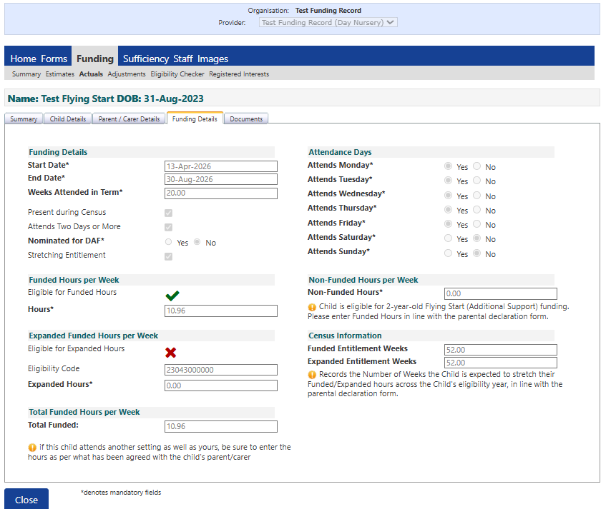

- Once you have completed the second, third and fourth tabs on the child’s record you can save and send claim.

  - Claiming for a Child Living Outside of Derby City

If a child is living outside of Derby City, the parents may come to your setting with a flying start for 2-year-old letter or code issued by another Local Authority. These children will not be on Derby’s FIS system as their eligibility has been checked elsewhere therefore, they will appear to FIS as ineligible for funding.

When submitting a claim for a 2-year-old given eligibility by another Local Authority please follow the instructions below to add these claims onto the FIS funding portal:

- Go to ‘Funding’ > Actuals > Select the term and age group 2-year-old funding.

- Select ‘Add Child’

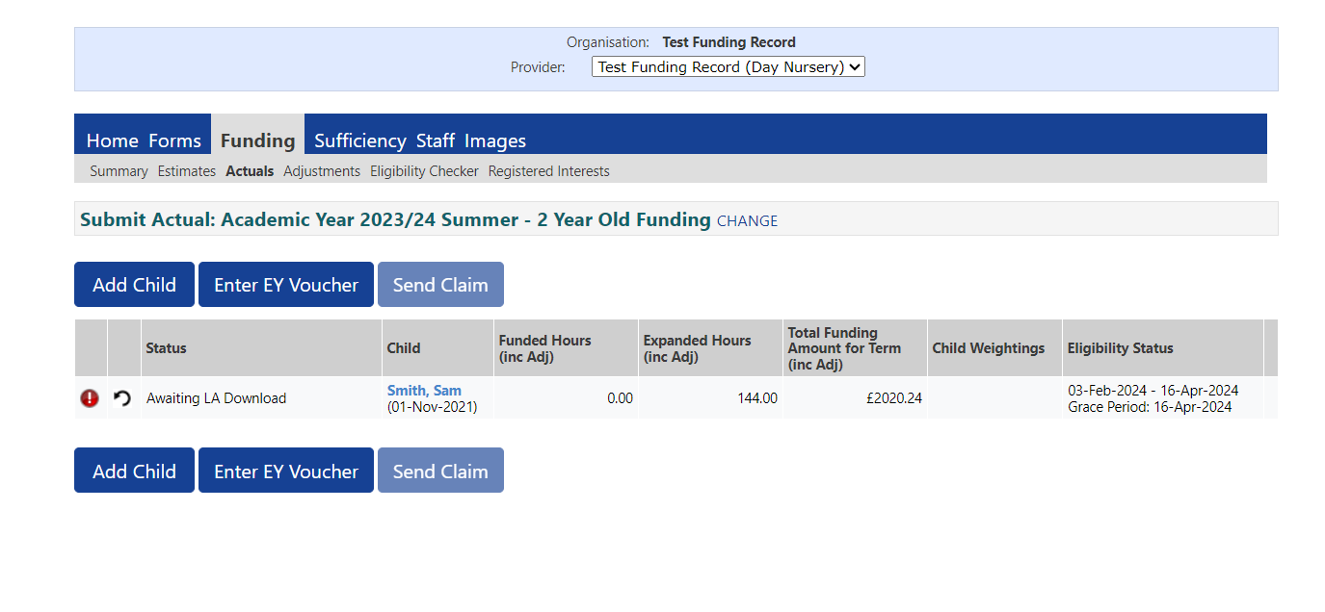
- Complete the child details and parent / carer details tabs.

- Then move over to the ‘funding details’ tab and complete:

Term start date and end dates will automatically be populated and will not reflect a child attending term time as this section is also used for validating stretched funding so the three terms have to conistently run across a 52 week year. Please adjust this to reflect what dates the child is actually attending.

Weeks attended in term – The number of weeks entered should be the number of weeks funded by the LA stated on the term time time timetable for a term time child, or the number of weeks you have signed up for on your provisions stretched offer declaration form if the child is taking a stretched offer. If the child is taking a reduced offer and you are offering less than 38 weeks for the year you should only claim the number of weeks the child is actually attending.

Complete the following boxes:

- Present during census
- Attends Two days or More (if applicable)
- Nominated for DAF (if applicable)
- Stretched Entitlement (if applicable)
- Attendance Days – days child is attending funded sessions

Funded Hours per week – enter the weekly number of funded hours the child is attending at your setting (maximum of 15 hours per week termt-time, or maximum weekly hours on provider stretching declaration for children stretching funding over more than 38 weeks per year)

- You will then need to upload supporting evidence from the Local Authority that has issued the voucher code into the childs ‘Documents’ tab by clicking on the ‘Upload a file’ shown in the print screen below and add too the description ‘voucher code evidence’ and save. You can than submit you’re the claim.

Non-funded hours per week – enter the number of hours paid for by the parent.

Funded Entitlement Weeks – This will be the number of yearly weeks the child is in attendance for example a child attending term-time will be 38 weeks, a child attending stretched funding will be 52 weeks or the number of yearly weeks stated in section 1 of your providers stretched declaration form.

Expanded Entitlement Weeks – Only needs to be completed if expanded weekly hours are present. This will be the number of yearly weeks the child is in attendance for example a child attending term-time will be 38 weeks, a child attending stretched funding will be 52 weeks or the number of yearly weeks stated in section 1 of your providers stretched declaration form.

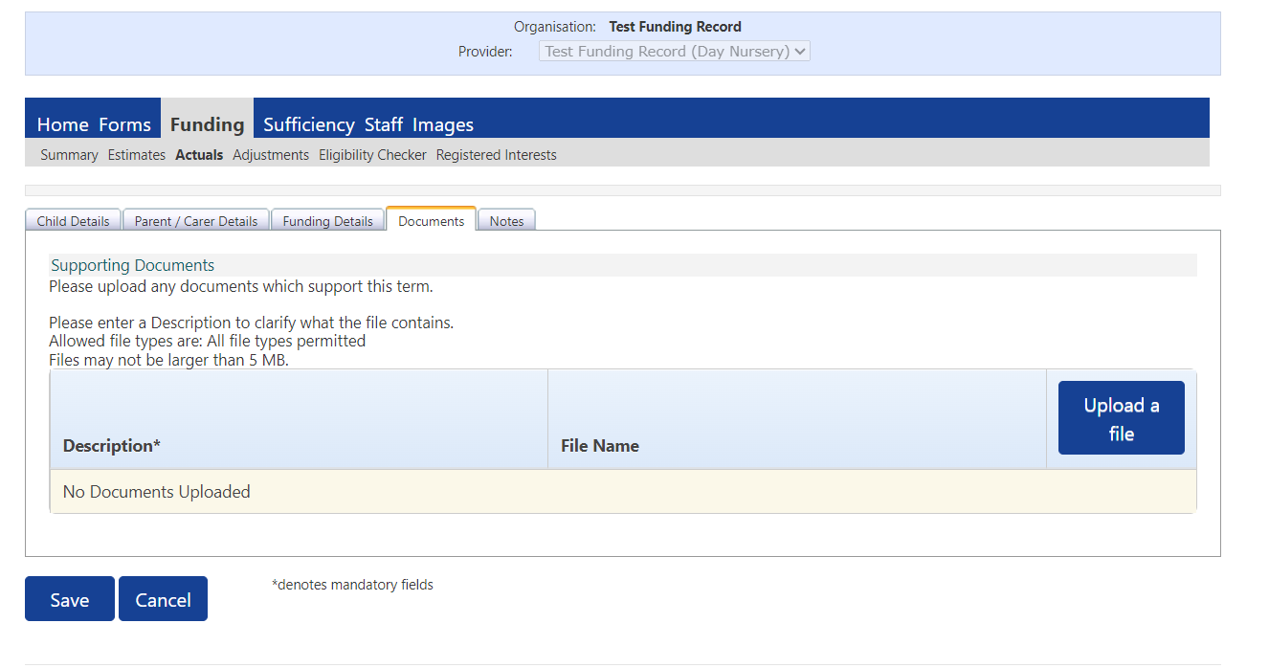

- Then save the record and send claim

Section 8: Early Years Pupil Premium (EYPP)

Early Years Pupil Premium (EYPP) is an additional sum of money paid to childcare providers for children in receipt of certain benefits, which are listed on the back of the child’s parental contract.

EYPP is only paid on children’s Actual claims and will not be processed on child Adjustment claims. Once a child is found eligible for EYPP they will keep this eligibility until the child takes up their school place.

Providers can receive EYPP for 9 months to 4-year-old funded children for up to 570 hours per year (equating to up to £570 per year):

- For 9-23 month and 2-year-olds receiving 1140 working family hours per year, EYPP applies to up to 570 hours per year only.
- For 2-year-olds receiving 570 hour per year Flying Start (additional support), EYPP applies to up to 570 hours per year only.
- For 2-year-olds receiving 570 hours Flying start (additional support) per year and 570 hours working family hours per year, for up to 1140 hours combined per year, EYPP applies to up to 570 hours per year Flying Start (additional support) hours only.
- For 3- & 4-year-olds receiving 570 universal hours per year, EYPP applies up to 570 universal hours per year.
- For 3- & 4-year-olds receiving 570 hours universal per year and 570 hours extended per year, for up to 1140 hours combined per year, EYPP applies to up to 570 universal hours per year only.

8.1. Submitting EYPP claims to be checked under Economic Criteria

To submit EYPP claims on the portal to be checked under economic criteria (checking the families household income with HMRC using parents NI/NASS number) providers must ensure parents have provided their details along with their National Insurance Number / NASS Number on the child’s parental contract and given consent on section 10 of the parental contract for Derby City Council to perform and EYPP check.

- Early Years Pupil Premium can be checked for 9 months to 4-year-old children under the economic criteria by fully completing the parent / Carer Details on the child’s actual claim and ticking the consent box for an EYPP check to be performed as shown below:

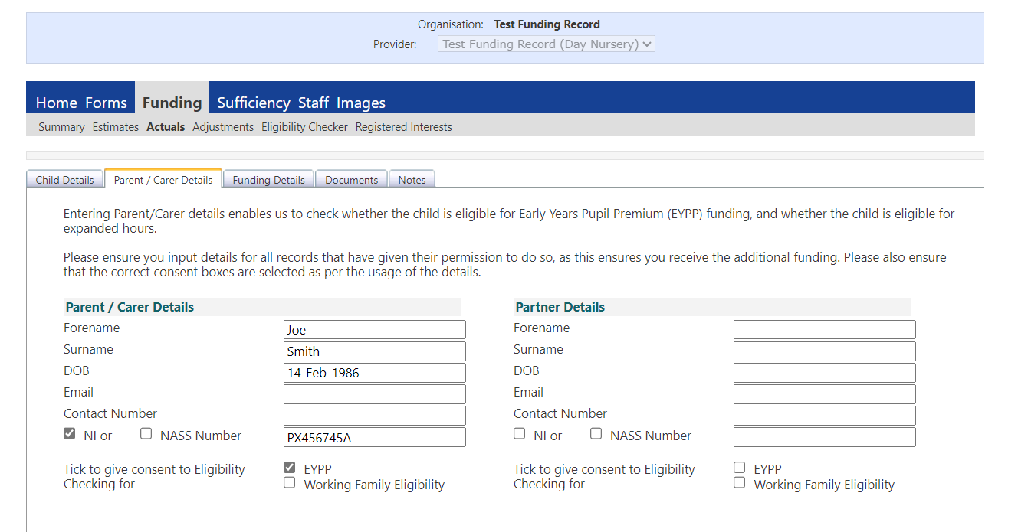

8.2. EYPP Claims checked under LAC or SEND

Early Years Pupil Premium can be checked for 9 months to 4-year-old children under the Looked After Child (LAC) or Special Educational Needs and Disabilities (SEND) criteria by fully completing the parent / Carer Details on the child’s Actual claim and ticking the consent box for an EYPP check to be performed as shown below:

A child will qualify for EYPP under LAC and or SEND if they are:

- In receipt of Disability Living Allowance (DLA)
- Are a Looked After Child (LAC)
- Or have Adoption, Special Guardianship or Residence Order

If this is the case, you can attach supporting evidence of one of the above under the child’s ‘Document’ tab on the portal with the child’s Actual claim as shown in the print screen below:

Section 9: Disability Access Funding (DAF)

9 months to 4 year old children who are in receipt of Disability Living Allowance (DLA) can receive an additional £9 per year. This is a one off payment, paid to the provider who the parent nominates as the main provider, it can only be paid once per rolling year. This funding does not move with the child. The parent must indicate on their child’s ‘Parental Contract’ which provider they wish the funding to go to, this is particually important if they are claiming funding across multiple providers.

Providers must upload evidence of the child’s DLA against the child’s Actual or Adjustment submission each term and a DAF payment will be generated for the year and paid with the adjustment payment for the term the DAF claim was made.

9.1 Claiming Disability Access Funding

- You must select either the ‘Yes’ or ‘No’ option for all children. You must only select the ‘Yes’ option if you have uploaded evidence of the child’s DLA in the child’s Documents tab on the portal and the parent has nominated you to receive the DAF on their child’s ‘Parental Contract’.

- You only need to select ‘Yes’ for DAF the first term you are putting in your claim for DAF, you then need to select ‘No’ for the following two terms of the year, and only select ‘Yes’ again on the third term if the child is still claiming DAF with you.

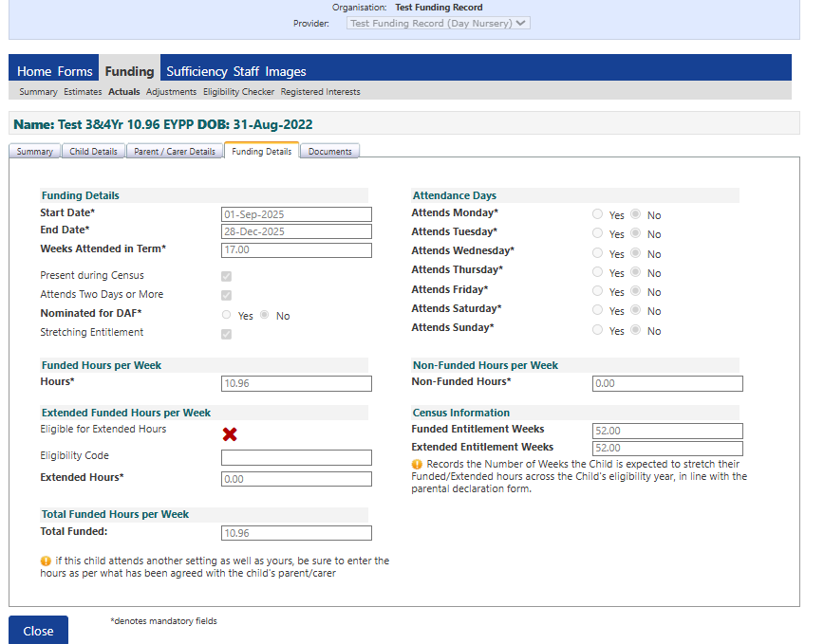

- If you have selected ‘Yes’ to nominate the child for DAF you must then upload evidence of the child’s Disability Living Allowance (DLA) Letter / Certificate in the Documents tab as shown below, with the description DAF Funding.

Section 10: Stretched Funding

Providers are not automatically set up to deliver the stretched funding on the FIS Portal, if you would like to deliver this, please contact FIS on 01332 640758 to inform us and we can go over the forms you need to complete to sign up to deliver stretched funding and discuss the possible stretched models with you.

Stretched Funding Attendance Dates can be found within the Document downloads - Derby City Council website, this will show you the maximum number of weeks you can stretch funding each term throughout the academic year. If you are delivering a stretched offer you will need to refer to the stretched offer attendance dates on the funding timetable.

Please Note: Stretched funding refers to the practice of a child attending more than 38 weeks per year and claiming for a reduced number of funded hours per week. For the - & 4-year-old universal or 2-year-old flying start offer this will reduce the funded hours to less than 15 hours a week or for the working entitlement offer for 9months to 4-year-olds this will reduce the funded hours to less than 30 hours per week. Any arrangements you have with parents/carers regarding spreading the cost of invoicing evenly over the year is not always stretched funding. If a child is attending and claiming for 15 universal hours or 30 extended hours, they can only be classed as a term time child regardless of your invoicing procedures.

10.1 Setting up to Deliver Stretched Funding

Providers will need to email earlyyearsfunding@derby.gov.uk with their stretched declaration form which can be found in the Document downloads - Derby City Council website. The declaration form will let us know how your setting will be delivering the stretched funding for the academic year and confirm that you understand how to pro rata hours if children start their funding in spring or summer to ensure there are not over or under claims of funding. The funded period is set on an academic year basis, so available hours are allocated pro-rata from September to the following August (autumn, spring, summer)

Please see some of the common stretched payment models below:

- 47.5 weeks 12 universal hours 24 extended hours
- 51 weeks 11.17 universal hours 22.34 extended hours
- 52 weeks 11 universal hours 11 extended hours

10.2 Claiming Stretched Funding

The FIS funding portal will allow a maximum of 12.95 weekly funded hours and 25.9 working parent hours to be submitted on the portal, the red box in the print screen below shows the termly maximums, however it is the childcare providers responsibility to submit claims in line with the stretched termly weeks and weekly hours stated on the provisions stretched declaration form.

The screen below shows an example of a child taking a 52-week stretched model, 52 weeks x 10.96 hours = 570 child’s yearly entitlement (17 weeks autumn, 15 weeks spring, 20 weeks summer):

Complete the following boxes:

- Present during census
- Attends Two days or More (if applicable)
- Nominated for DAF (if applicable)
Attendance Days – days child is attending funded sessions

Stretched Entitlement – tick the stretched entitlement box this will change the maximum termly and yearly values allowed which will show in a red box in the bottom right-hand corner of the screen.

Weeks Attended in Term
This will be the number of weeks you have stated on your provisions stretched declaration form.

Funded Hours per week This will be the number of weekly hours the child is attending in line on your provisions stretched declaration form.

Extended Hours per week This will be the number of weekly hours the child is attending in line with your provisions stretched declaration form.

Non-funded hours per week – enter the number of hours paid for by the parent.

Funded Entitlement weeks will need completing if funded weekly hours are present. This will be the number of yearly weeks the child is in attendance for example a child attending term-time will be 38 weeks, a child attending stretched funding will be 52 weeks or the number of yearly weeks stated in section 1 of your providers stretched declaration form.

Extended Entitlement weeks will need completing if extended weekly hours are present. This will be the number of yearly weeks the child is in attendance for example a child attending term-time will be 38 weeks, a child attending stretched funding will be 52 weeks or the number of yearly weeks stated in section 1 of your providers stretched declaration form.

Section 11: Submitting Adjustment Claims

Please Note: The online adjustment system is for 9 months to 4-year-old funded children starting, leaving, or increasing their universal and/or extended/expanded hours after headcount week and DAF claims for new or existing children.

- Click on the ‘Funding’ tab at the top of the screen, select ‘Adjustments’ and then select the funding term you wish to enter the child adjustment into, the screen should then look as below. Select the ‘funding type’ on the right-hand side of the screen to enter your adjustment into either the 9-23 months old funding, 2-year-old funding or 3- & 4-year-old funding

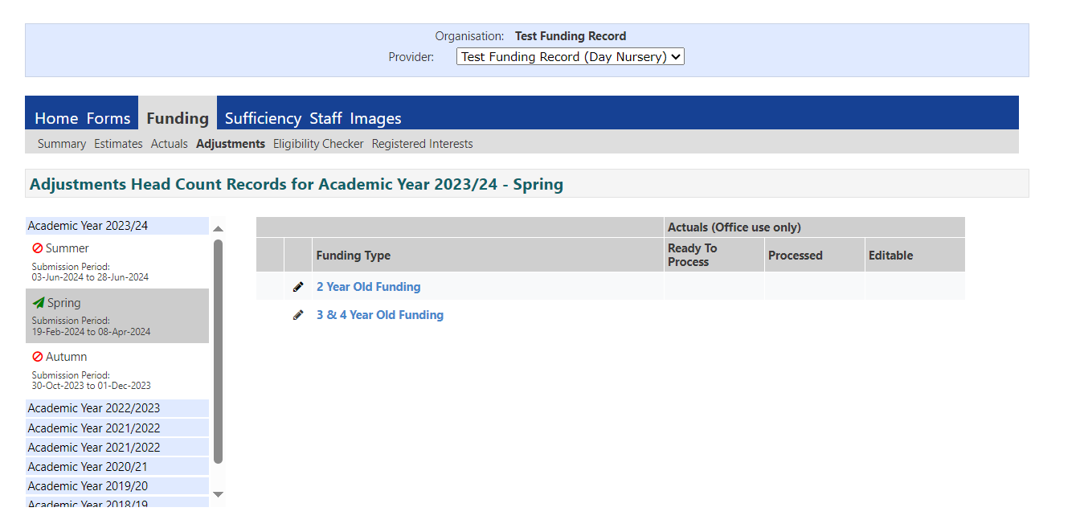

- To add a new child, click on ‘Add Child’ as shown below, if you are increasing or decreasing a child’s hours you need to click on the name of the child from the list of children.

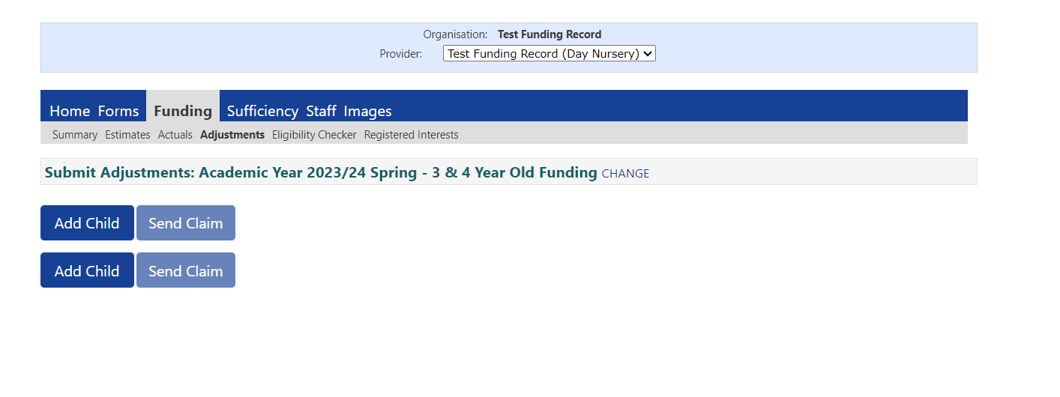

- The screen will open onto the first tab ‘child details’, complete all fields on this page.

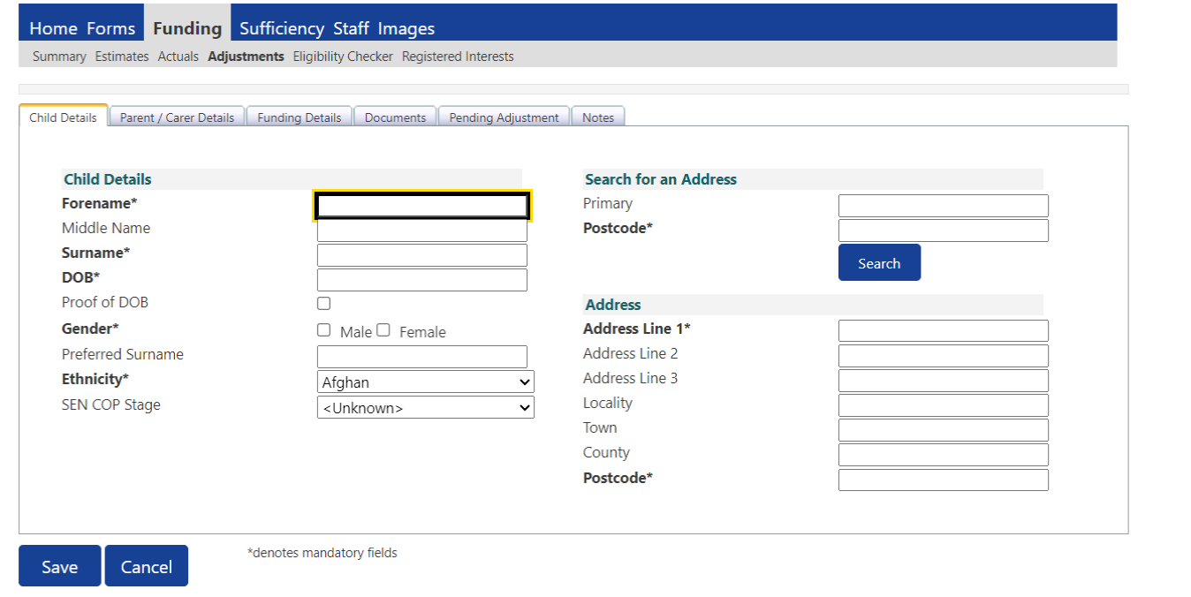

- Then move across to your second tab ‘Parent / Carer Details’ and complete this section if the parent has signed the child’s parental contract to give consent for an EYPP or Working Family check to be performed. Please remember to tick the relevant boxes for us to perform an EYPP or Working Family Eligibility Check.

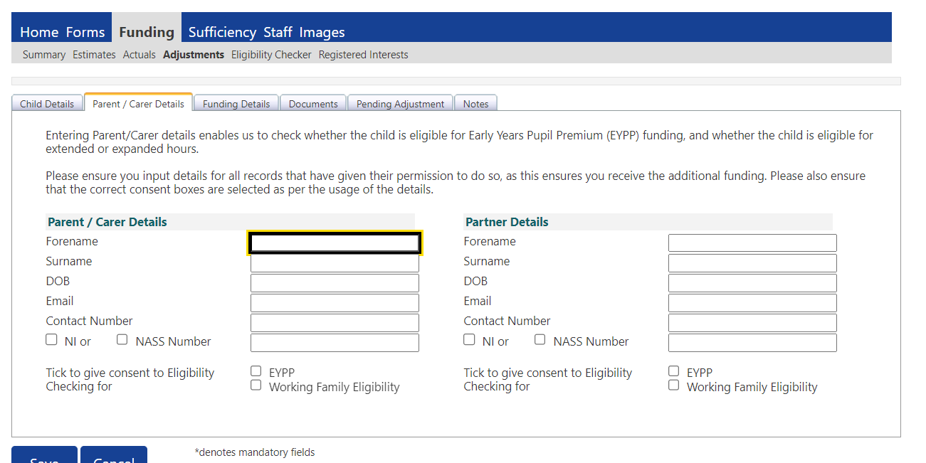

- Then move across to the third tab ‘Funding Details’ as shown in the print screen below:
• Enter the ‘Start Date’ this is the date you want the child’s funding to start from and this must be after headcount week.
• Enter the ‘End Date’ this is the date the child’s funding will end for the term.
• Tick the box ‘Attends Two Days or More’ if relevant.
• Select the relevant box to let us know if the child should be nominated for DAF if you have evidence to prove the child is in receipt of Disability Living Allowance (DLA).
• Tick the ’Stretching Entitlement’ box if the child is stretching their funding.
• If you would like to claim extended or expanded funded hours, you must enter the child’s ‘Working Family Eligibility’ code and click on the blue ‘Check Eligibility Code’ button located directly underneath the code to perform an eligibility check.
• Complete the ‘Attendance Days’ the child attends their funded sessions. You must click the ‘Save’ button at this point before going any further as it will determine what funding can be entered into the ‘Pending adjustment’ tab. By saving the child record you will now have a summary page for the child as the first tab to view the child’s overall funding once you have finalised the record.
Enter the funded and or extended/expanded entitlement weeks - This will be the number of yearly weeks the child is in attendance for example a child attending term-time will be 38 weeks, a child attending stretched funding will be 52 weeks or the number of yearly weeks stated in section 1 of your providers stretched declaration form.

Please Note: You cannot add ‘Weeks attended in Term’ or any ‘Funded Hours per week’ into the funding details tab for an adjustment claim.

- You will then need to click back into the child record. Select ‘Documents’ to give any supporting evidence, please see below instances where you will need to send supporting information:

Funding Claim | Evidence
DAF funding claim | - Copy of child's Disability Living Allowance (DLA) Letter / Certificate
2-year-old out of county children | - Copy of eligibility letter / code issued by Local Authority outside of Derby City
2-year-old Adopted or Looked After Child (LAC) | - Letter/Certificate of legal Adoption, Special Guardianship or Residence Order
EYPP Adopted or Looked After Child (LAC) | - Letter/Certificate of legal Adoption, Special Guardianship or Residence Order
EYPP (SEND) | - Copy of child’s Disability Living Allowance (DLA) Letter / Certificate.

Click on the ‘Upload a file’ button highlighted in the screen below to upload evidence from your computer or device and add the document. When you name the file, please put the type of funding it relates to and the evidence document for example DAF – DLA letter, 2YR – Out of County Letter. Once you have attached your evidence, you can click ‘Save’ to save your uploaded documents.

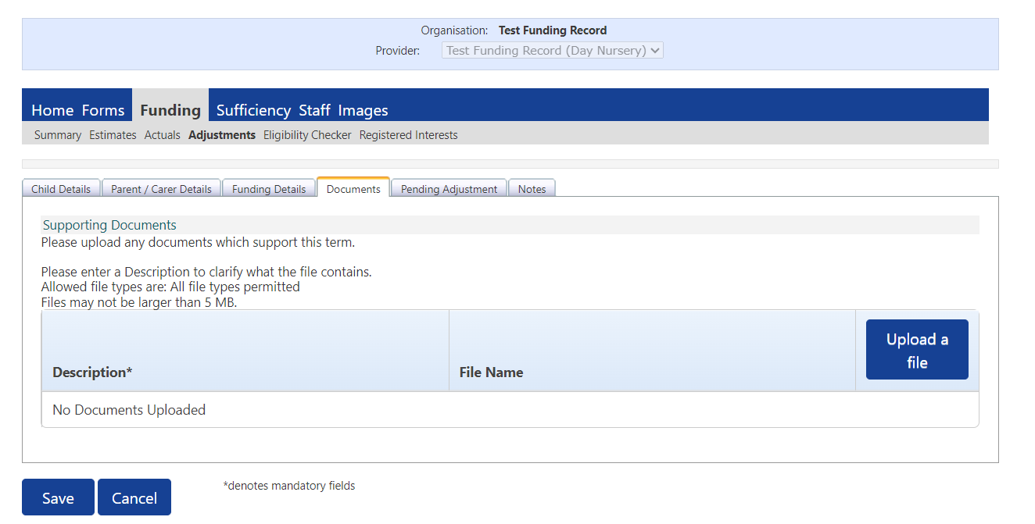

- Now move onto the ‘Pending Adjustment’ tab. If the child is starting at your provision or increasing hours, you must select the option ‘more hours’ and then enter the total number of hours you want to claim for the remainder of the term. If the child is leaving your provision, you must select the option 'less hours' to enter a minus total number of hours you want to claim for the remainder of the term. In the reason box you need to put the date you want the hours to be increased, decreased from, and give the number of weeks and weekly hours you want to claim so we can check the total hours you are entering are correct and match the attendance dates you have set. Then save claim.

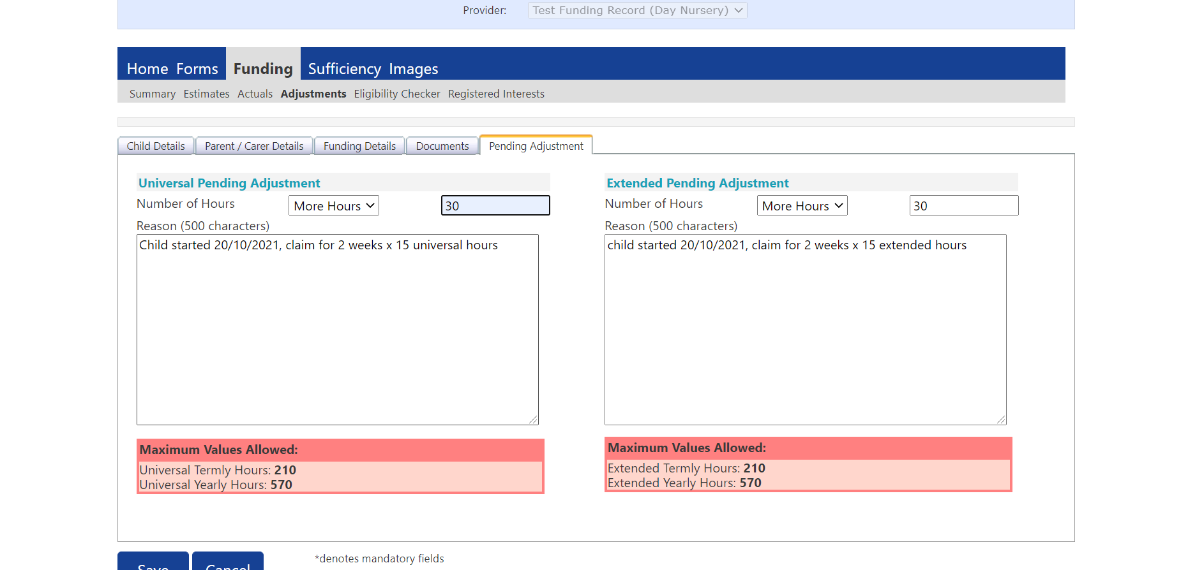

- The screen below will then show the overall funding due for the child including adjustments, and the status of the record will state ‘Unsubmitted Claim’. If the funding is correct you can click ‘Send Claim’.

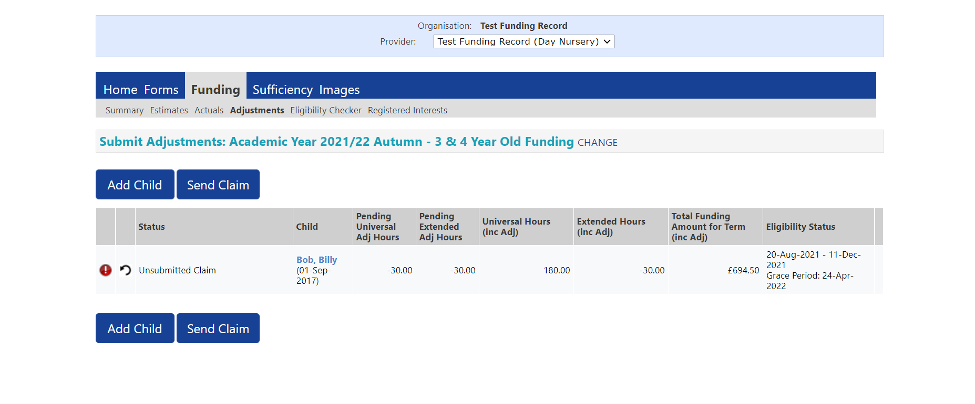

- A green box will appear at the top of the screen to indicate your submission has been successful and the status of the record will change to ‘Awaiting LA Download’.

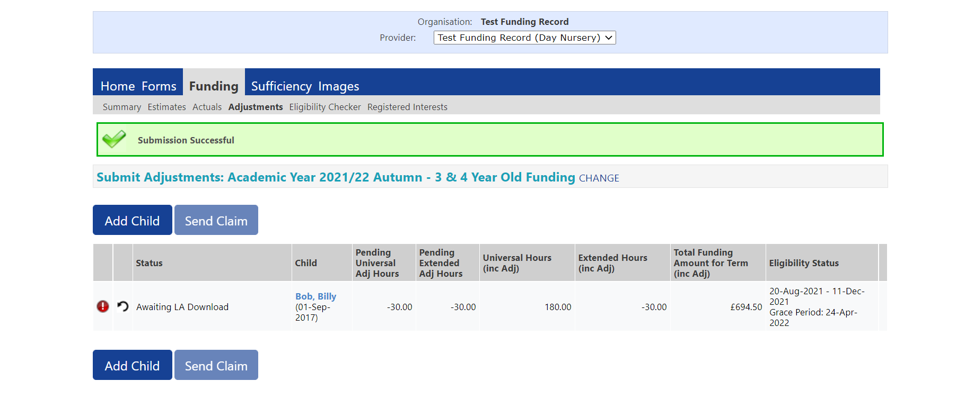

Section 12: Summary Page - Viewing Payments and Previous Claims

- Select ‘FUNDING’ tab, then ‘SUMMARY’.

- Select the year, term, and funding type you wish to view.

- The page will look as below showing a breakdown of the funding you have been allocated for the term.

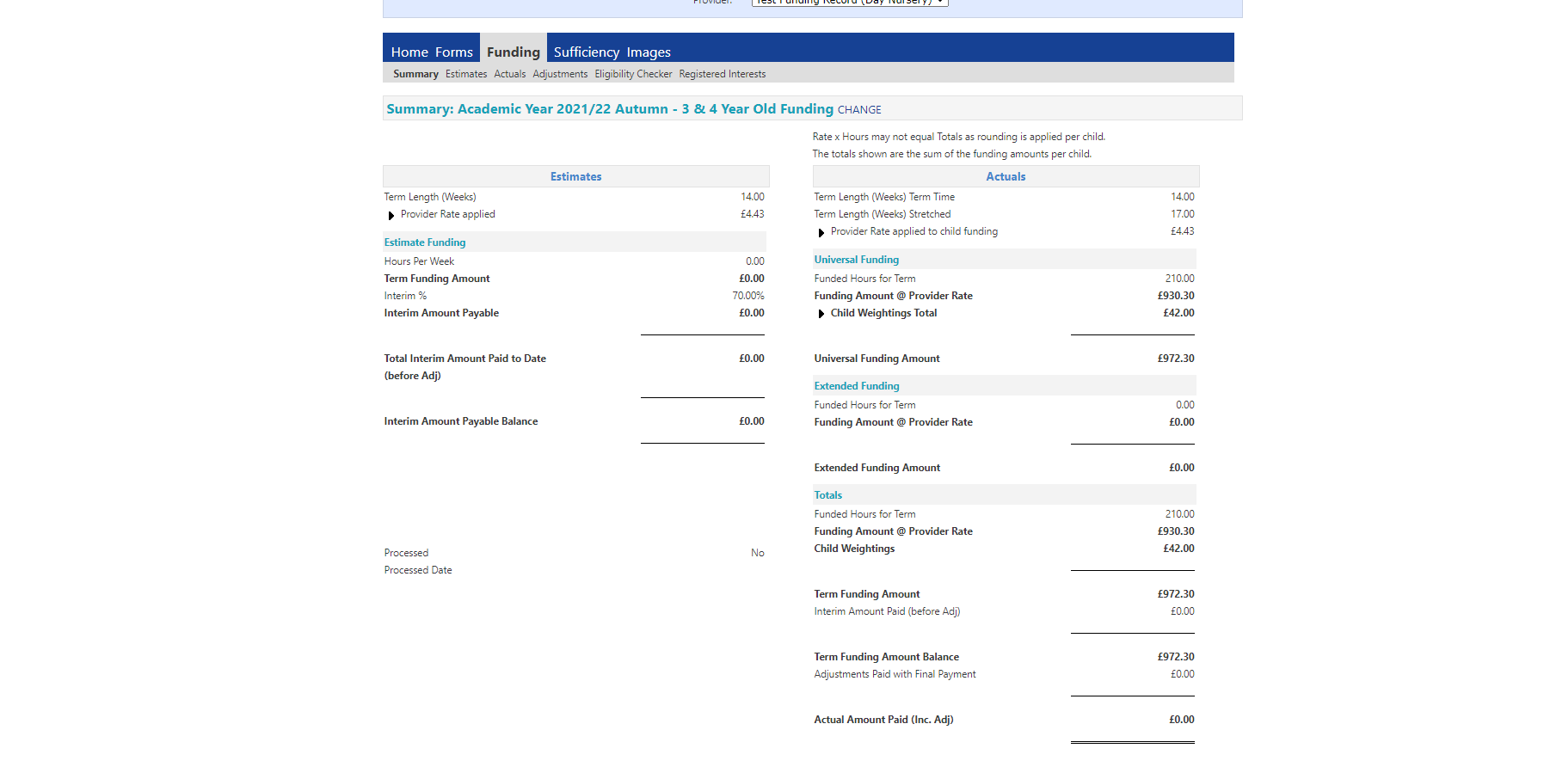

Section 13: Registered Interests

When parents visit Derby City Councils Website and use the FIS Childcare Directory to self-search for childcare in their local area, they can then register an interest and send their details directly to a childcare providers portal to be contacted back.

If a parent registers an interest on your portal, you should receive a generic email from the FISDirectory@Derby.gov.uk to notify you there is a registered interest on your portal.

1. Parents Registered Interest can be found on your portal under the ‘Funding’ tab and ‘Registered Interests’ as shown in the print screen below with a status of ‘New’. To view the registered interest, select ‘View Details’ under Actions.

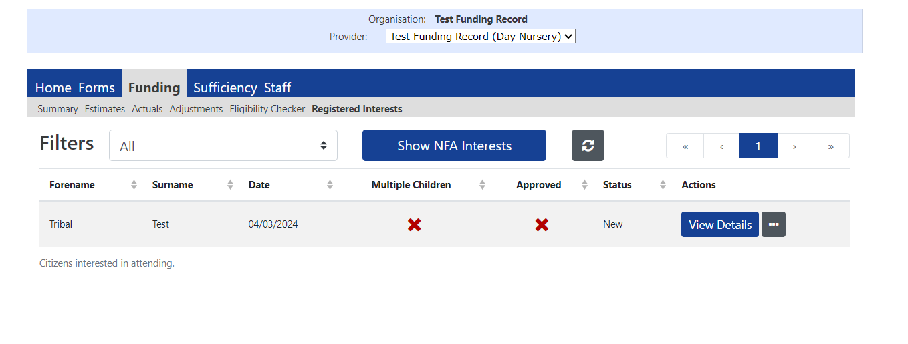

- The screen will then look as below, you can then select ‘Contacted’ or ‘Confirmed’ to action the registered interest – Please do not use ‘No Further Action’ this button is not currently set up.

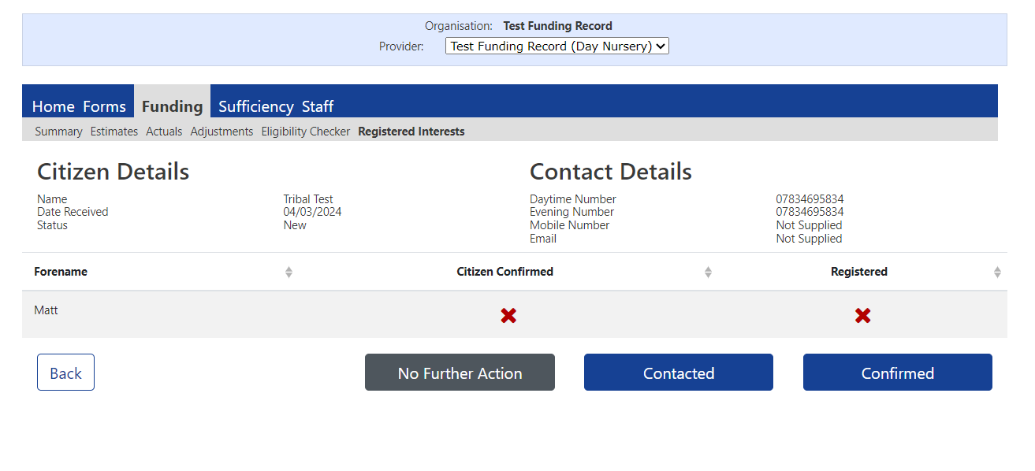

- Once you have actioned the registered interest the status of the record will change to ‘Contacted’ or ‘Provider Confirmed’ as shown in the print screens below:
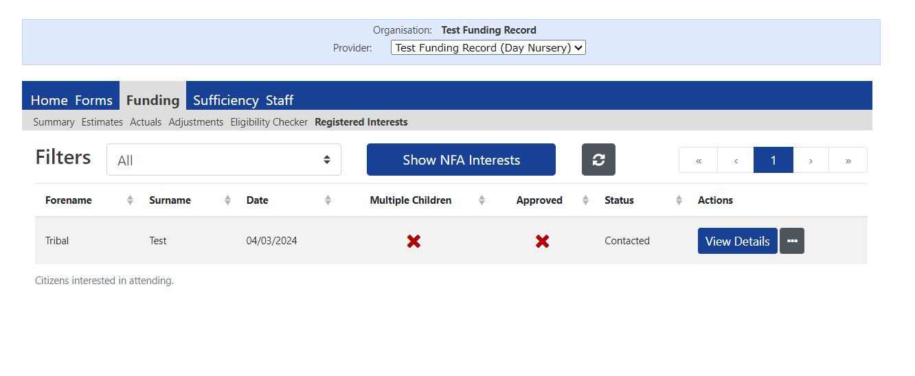

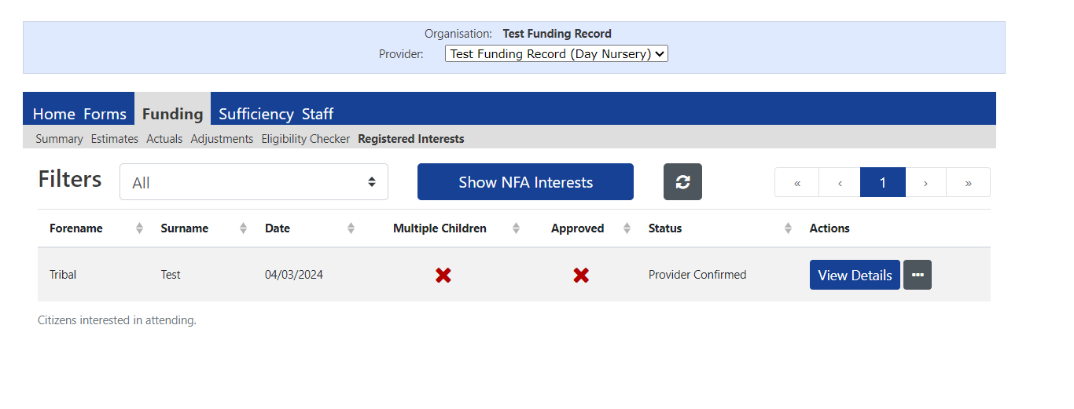

If you have any queries in relation to this guidance, please contact:

Families Information Service
The Council House
Corporation Street
Derby
DE1 2FS
Tel: 01332 640758
Email: Earlyearsfunding@derby.gov.uk

