Joined Up Care Derbyshire
Neurodevelopmental Programme
Do you want to receive adverts for coproduction opportunities?

Do you have lived experience of learning disabilities or are you autistic or neurodivergent?
Do you care for someone with learning disabilities or an autistic or neurodivergent person?
If so, would you like to receive adverts for coproduction opportunities?
We want to improve the care and support available for people with learning disabilities and autistic or neurodivergent people and their families. To do this, we need to hear from you.
If you would like to receive emails about any events or workshops we are holding you can sign up to a database of people who will receive adverts for upcoming opportunities. To do this, we need:
- Your full name – e.g. Mr John Smith

- Your email address – e.g. john.smith@email.co.uk

- Your consent to be included on the database and for us to send you emails containing the adverts from a dedicated email address.

By agreeing to be on the database you will be sent adverts for coproduction opportunities relating to services for people with learning disabilities and autistic and neurodivergent people. These emails will be from this email address: dhcft.ndservices.coproduction@nhs.net

You name and email address will not be shared. You will only be sent adverts.
For more details about data security and protection, visit: https://www.derbyshirehealthcareft.nhs.uk/about-us/data-security

Your name:

Your email address:

Your consent: By completing and returning this form, I give my consent to having my name and email address listed on the database so that I can receive emails about coproduction opportunities from Joined Up Care Derbyshire partners. I understand that I will receive these adverts from the email address dhcft.ndservices.coproduction@nhs.net. I understand that I can be removed from the database at any time by emailing dhcft.ndservices.coproduction@nhs.net

If you wish to have a nominated person receive the adverts for you, please complete this form with them and list their details above. We just ask what that person’s relationship is with you? For example, mum or social worker and so on. Relationship to you:

How to join the database:
Return this completed form to – dhcft.ndservices.coproduction@nhs.net. You will then be added to the database. If at any point you want to remove yourself from the database, please email dhcft.ndservices.coproduction@nhs.net asking to be removed and you will be. You can re-join again at any point.
Thank you!

Joined Up Care Derbyshire
Neurodevelopmental Programme
Do you want to receive adverts for coproduction opportunities?

 | Joined Up Care Derbyshire would like to hear your thoughts and opinions about the services you use.
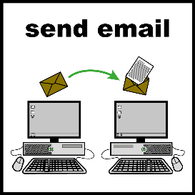 | To do this, we would like to send you adverts by email about events where we would like to hear from you. The adverts will come from this email address: dhcft.ndservices.coproduction@nhs.net
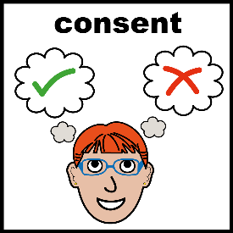 | If you want to have these adverts by email, please fill in your details and give your consent. If you would like to nominate someone else to get the emails, please fill this form in with them and put their details:  Your name or nominated person’s name:  Your email address or nominated person’s email address:  If you have nominated a person to receive emails for you, what is their relationship to you:  For example, mum or social worker.  Consent: By completing this form, I give my consent to having my name and email address listed on the database so that I can receive emails about coproduction opportunities from Joined Up Care Derbyshire. I understand that I will receive these adverts from the email address: dhcft.ndservices.coproduction@nhs.net. I understand that I can be removed from the database at any time, I just need to email dhcft.ndservices.coproduction@nhs.net asking to be removed. I can also re-join any time.  Return this completed form to dhcft.ndservices.coproduction@nhs.net
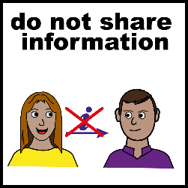 | We will not share your email address. You will only receive adverts from dhcft.ndservices.coproduction@nhs.net  You can stop having these adverts anytime, just email dhcft.ndservices.coproduction@nhs.net asking to leave the database. For more details about data security and protection, visit: https://www.derbyshirehealthcareft.nhs.uk/about-us/data-security
 | Thank you!

