Please do not feed pigeons
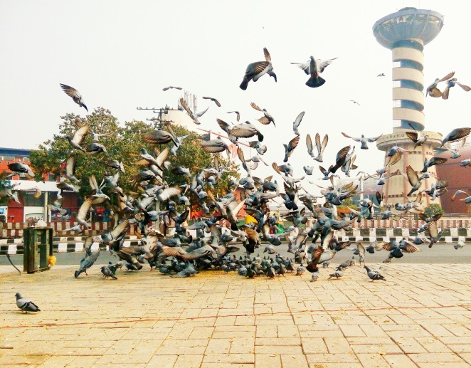
Every year we receive a large number of complaints about problems caused by pigeons. Pigeons are drawn to an area when people put out food for them.
Why are Pigeons causing problems?
- They carry insect pests.
- They leave droppings which carry disease,
- They create a smell and cause damage.
What can I do to help?
- Do not feed pigeons
- Dispose of food litter properly
If you don't feed them:
- They will find their own food naturally
- They will breed less often
- Flocks will become smaller
Pigeon Problems
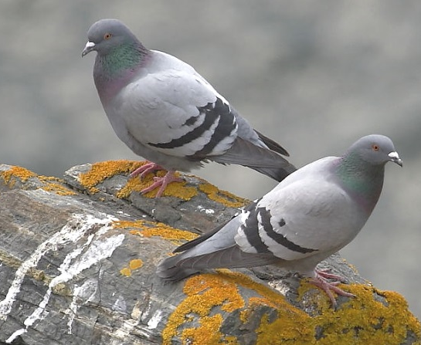
Some of us were encouraged to feed pigeons when we were children. However, people who own or live in buildings where the birds choose to roost and who have to clean up after them, may not like pigeons. Clearing up pigeon droppings can be very expensive; droppings can also damage property, block gutters and make pavements slippery. Pigeons can carry diseases, which puts our health and our children’s health at risk. They cause problems with insect pests and food put out for pigeons can attract vermin such as rats and mice. Pigeons are natural scavengers and will find their own food source. The size of a flock is determined by the amount of food available to them. The more we feed them the more the numbers will increase. However if the food supply is reduced, the flock will also reduce. They will not die of starvation; they will simply breed less often. Pigeons are wildlife. They are not domesticated and they are not dependant on us to feed them. Your act of kindness in feeding the pigeons may result in the birds becoming a problem for someone else. Birds that are fed too often can also become aggressive and may become a nuisance if they overpopulate a small area.

Tips for Feeding Ducks and other wildfowl
If you do choose to feed ducks and waterfowl at local ponds occasionally, the best tactic is to visit only rarely so the birds are not getting excess food that would be unhealthy for them or their environment.
Other tips for feeding ducks, geese, and swans include:
- Stop feeding if the birds appear uninterested or are leaving the food uneaten, since leftover food can quickly rot and attract unwanted pests.
- Avoid feeding the birds if other visitors are already offering treats, as too much food can lead to health problems and uneaten leftovers.
- No matter what foods you provide, only offer foods in bite-sized pieces the birds can easily consume without choking or struggling, since ducks do not chew.
- Be wary of birds that approach closely and remember that they can still be aggressive, particularly larger waterfowl such as swans and geese.
- Litter can hurt birds in many ways, so be sure to dispose of all waste properly,.
- Do not allow pets or children to chase or disturb the birds, particularly young birds or families that could become stressed or injured more easily.
Good Foods for Ducks
The best foods for ducks are those that provide the nutrients, minerals, and vitamins the birds need for healthy growth and development. Many of these foods are similar to the natural insects, seeds, grains, and plants the birds will forage for on their own. As omnivorous birds, ducks will eat many different foods, and the best foods to offer ducks include:
- Wheat, barley, or similar grains
- Oats (uncooked; rolled or quick)
- Rice (cooked or uncooked)
- Birdseed (any type or mix)
- Grapes (cut in half or quartered if very large)
- Nut hearts or pieces (any type but without salt, coatings, or flavoring)
- Frozen peas or corn (defrosted, no need to cook)
- Earthworms (fishing bait or dug from the garden)
- Mealworms (fresh or dried)

