

**TRAFFIC MANAGEMENT REPORT**

**CARLTON ROAD AND WHITAKER ROAD**

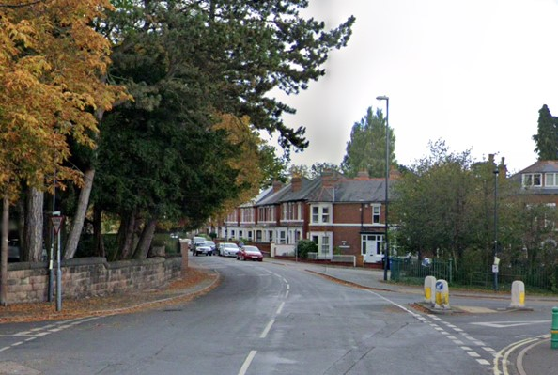

|  |  |  |  |
| --- | --- | --- | --- |
| Document Ref: | Author(s) | Checked | Date |
| TMT22 | DJ | AR | 07/24 |

|  |  |  |
| --- | --- | --- |
| **TABLE OF CONTENTS** | |  |
|  |  | **Page** |
|  |  |  |
| 1. | Purpose of Report | 3 |
|  |  |  |
|  |  |  |
| 2. | Introduction | 3 |
|  |  |  |
|  |  |  |
| 3. | Background | 3 |
|  |  |  |
|  |  |  |
| 4. | Road User Composition and Traffic Volume | 4 |
|  |  |  |
|  |  |  |
| 5. | Speed Review | 5 |
|  |  |  |
|  |  |  |
| 6. | Road Traffic Collisions | 7 |
|  |  |  |
|  |  |  |
| 7. | Consultation Results | 8 |
|  |  |  |
|  |  |  |
| 8. | Consultation - Feedback and Comments | 10 |
|  |  |  |
|  |  |  |
| 9. | Conclusion | 13 |
|  |  |  |
|  |  |  |
| 10. | Recommendation | 13 |
|  |  |  |
|  |  |  |
|  | Annex 1 – ATC Survey Locations | 16 |
|  | Annex 2 – Road Traffic Collisions | 17 |
|  | Annex 3 – Consultation Area | 18 |
|  | Annex 4 – Consultation Reply Slip | 19 |
|  | Annex 5 - Option Feasibility | 20 |
|  | Annex 6 – Traffic Calming Plan | 21 |

|  |
| --- |
| 1. **PURPOSE OF THE REPORT** |

* 1. The purpose of this report is to provide a review of the safety record along both Carlton Road and Whitaker Road to understand if there is sufficient evidence to support the introduction of road cushions.
  2. It is also to outline the results of a recent consultation on a proposal to introduce road cushions; undertaken to confirm if residents would support such a measure if it was formally recommended.

|  |
| --- |
| 1. **INTRODUCTION** |

2.1 Every year, local councillors, in discussion with their constituents, select certain priorities for the Council to help improve their local areas. This often involves concerns about traffic management and road safety.

2.2 As part of this process, Abbey Councillors decided to prioritise Carlton Road for further investigation. This was agreed and formed part of the 2022-23 Traffic and Transportation work programme.

2.3 The priority was to investigate if resident concerns about the use and safety of Carlton Road were supported by traffic data and, if so, what remedial solutions might be recommended.

|  |
| --- |
| 1. **BACKGROUND** |

3.1 Over the years, some residents of Carlton Road and Whitaker Road have expressed concern about traffic volume and speed.

3.2 Carlton Road and Whitaker Road represent a significant access point serving a large residential area that is located mostly within the Abbey ward. The area along the route includes access to a number of leisure and community facilities and both roads also provide an alternative route for local traffic between Burton Road and Warwick Avenue, including a bus route that links the area with the city centre.

|  |
| --- |
| 1. **ROAD USER COMPOSITION AND TRAFFIC VOLUME** |

4.1 In terms of the speed limit, both Carlton Road and Whitaker Road are defined as restricted roads, which are those roads with a speed limit of 30mph by virtue of the presence of street lighting.

4.2 When taken together, both roads cover just under 1 kilometre with a variable carriageway width that starts at approximately 7 metres at Whitaker Road and ends at approximately 8 metres near the junction with Warwick Avenue. Both minimum and maximum widths can be found between Arden Close and Fairfield Road, 6m and 11.2m respectively. There are footways on both sides of the road throughout the entire length with a general width of between 2 and 2.5 metres.

4.3 Average daily traffic (ADT) varies a little depending on the location of the traffic survey. The variance is between a high of 8533 vehicles travelling between St Chads Road and Buller Street (Site 4) and a low of 6242 vehicles travelling between Palmerston Street and Edale Avenue (Site 2) as shown in annex 1.

4.4 The evidence confirms traffic volumes have increased significantly over time, almost doubling since 2017 and are considerably higher than similar non-primary residential roads that offer similar local access and suburb links. The closest road for comparison is Boulton Lane, which has similar volumes to Site 2 (Palmerston to Edale) – see table 1.

**Table 1**: Average daily traffic (ADT) by location

|  |  |
| --- | --- |
| LOCATION | ADT |
| Slack Lane | 4785 |
| Max Road | 5800 |
| Upper Moor Road | 4362 |
| Boulton Lane | 6237 |
| Holbrook Road | 4382 |
| Western Road | 4623 |
| Allestree Lane | 4943 |
| Maine Drive | 3992 |
| St Albans Road | 3176 |

4.5 Approximately 85% of all traffic is car related with around 10% relating to LGVs and the remaining amounts covered by cyclists, motorbikes and HGVs. These traffic proportions are roughly similar for the type of roads mentioned in table 1.

|  |
| --- |
| 1. **SPEED REVIEW** |

5.1 For a period of two weeks in early to mid-July, four active traffic speed counts were conducted along Carlton Road and Whitaker Road (see annex 1). This was done to obtain a reasonable understanding of traffic speeds along the entire length of both roads. For comparative purposes, all counts were in the same place as the previous speed surveys, conducted in 2017. The intention was to compare data to understand if there has been any significant change that might corroborate resident complaints about speed.

5.2 Table 2 shows that despite the complaints, speeds have not changed significantly since 2017 and that vehicles are generally travelling below the speed limit with an average across all sites of 23.5mph. Also included for information is the 85th percentile results.

5.3 The 85th percentile, (the speed at or below which 85% of vehicles are travelling) is often used as part of any speed assessment to help understand the level of consistency with the mean. If a larger than normal difference exists between both measurements, this would normally suggest that drivers are having difficulty deciding on the appropriate speed for the road. In these circumstances, it might be necessary to consider remedial measures to remove the inconsistency. The results of all the surveys confirm the 85th percentile is consistent with the average with a difference of approximately 5mph, which is typical for a 30mph road.

**Table 2**: Mean and 85th Percentile Speeds by Site

|  |  |  |  |  |  |
| --- | --- | --- | --- | --- | --- |
|  | Carlton Road | Mean (mph) 2017 | Mean (mph) 2022 | 85th %tile (mph) 2017 | 85th %tile (mph) 2022 |
| Site 1 | Between Colwyn Ave & Leamington Close | 27 | 25 | 31 | 31 |
| Site 2 | Palmerston Road & Edale Ave | 23 | 22 | 26 | 27 |
| Site 3 | Fairfield Road & Arden Close | 24 | 23 | 28 | 28 |
| Site 4 | St Chad’s Road & Buller Street | 24 | 24 | 29 | 29 |

5.4 Further details of the distribution of speeds across all site locations is given in table 3 below. The data clearly supports the averages highlighted in table 2. However, the average speeds can sometimes mask the reason why some residents have expressed concern.

5.5 A review of all the speed data over a seven-day period shows several drivers travelling in excess of 40mph. There is also disturbing evidence of some drivers significantly exceeding the limit. However, the number of drivers this involves is very low. The survey results show those travelling at 40mph and above represent less than 2% of the total.

5.6 Comparatively, the propensity to speed is common across the network. Most speed surveys confirm similar results. For example, speed surveys were recently conducted on Boulton Lane where the average and 85th percentile speed are similar with less than 2% contraventions above 40mph (see table 5 & 6).

**Table 3**: Seven Day Summary – Total number

|  |  |  |  |  |  |  |  |  |  |  |
| --- | --- | --- | --- | --- | --- | --- | --- | --- | --- | --- |
| SPEED | **<10.0mph** | **10.0-20.0mph** | **20.0-30.0mph** | **30.0-40.0mph** | **40.0-50.0mph** | **50.0-60.0mph** | **60.0-70.0mph** | **70.0-80.0mph** | **80.0-90.0mph** | **90.0-100.0mph** |
| Site 1 | 189 | 6473 | 30121 | 11470 | 697 | 95 | 22 | 2 | 1 | 0 |
| Site 2 | 429 | 10204 | 30615 | 2300 | 139 | 8 | 1 | 0 | 0 | 0 |
| Site 3 | 328 | 11056 | 40290 | 5289 | 297 | 23 | 2 | 0 | 0 | 0 |
| Site 4 | 552 | 13559 | 38073 | 6939 | 504 | 91 | 14 | 2 | 0 | 0 |

**Table 4**: Seven Day Summary – As a percentage

|  |  |  |  |  |  |  |  |  |  |  |  |
| --- | --- | --- | --- | --- | --- | --- | --- | --- | --- | --- | --- |
| SPEED | **Total Flow** | **<10.0mph** | **10.0-20.0mph** | **20.0-30.0mph** | **30.0-40.0mph** | **40.0-50.0mph** | **50.0-60.0mph** | **60.0-70.0mph** | **70.0-80.0mph** | **80.0-90.0mph** | **90.0-100.0mph** |
| Site 1 | 49070 | 0.4 | 13.2 | 61.3 | 23.4 | 1.4 | 0.2 | 0.04 | 0 | 0 | 0 |
| Site 2 | 43696 | 1 | 23.4 | 70.1 | 5.3 | 0.3 | 0.02 | 0 | 0 | 0 | 0 |
| Site 3 | 57285 | 0.6 | 19.3 | 70.3 | 9.2 | 0.5 | 0.04 | 0 | 0 | 0 | 0 |
| Site 4 | 59734 | 0.9 | 22.7 | 63.7 | 11.6 | 0.8 | 0.2 | 0.02 | 0 | 0 | 0 |

**Table 5**: Boulton Lane Seven Day Summary – Total Number

|  |  |  |  |  |  |  |  |  |  |
| --- | --- | --- | --- | --- | --- | --- | --- | --- | --- |
| **<10.0mph** | **10.0-20.0mph** | **20.0-30.0mph** | **30.0-40.0mph** | **40.0-50.0mph** | **50.0-60.0mph** | **60.0-70.0mph** | **70.0-80.0mph** | **80.0-90.0mph** | **90.0-100.0mph** |
|  |
| 158 | 4034 | 41995 | 10457 | 368 | 27 | 5 | 2 | 0 | 1 |  |

**Table 6**: Boulton Lane Seven Day summary – As a percentage

|  |  |  |  |  |  |  |  |  |  |  |
| --- | --- | --- | --- | --- | --- | --- | --- | --- | --- | --- |
| **Total Flow** | **<10.0mph** | **10.0-20.0mph** | **20.0-30.0mph** | **30.0-40.0mph** | **40.0-50.0mph** | **50.0-60.0mph** | **60.0-70.0mph** | **70.0-80.0mph** | **80.0-90.0mph** | **90.0-100.0mph** |
|
| 57047 | 0.28 | 7.07 | 73.61 | 18.33 | 0.65 | 0.05 | 0.01 | 0.004 | 0.00 | 0.002 |

|  |
| --- |
| 1. **ROAD TRAFFIC COLLISIONS** |

6.1 Normally, to understand the safety record of a particular road, the Council will review the number of road traffic collisions involving injury over a period of three years. This is a statutory duty to identify those locations that have a comparatively poor safety record that might require an intervention. Importantly, previous reviews have not highlighted Carlton Road or Whitaker Road.

6.2 The reason why both Carlton Road and Whitaker Road have not been identified is because over the last 10 years, there have been no fatal or serious injury collisions reported. There have only been ten slight injury road traffic collisions and, importantly, only four during the normal reporting period (see table 7). Clearly, this suggests both roads are performing well when compared to other sites across the city.

**Table 7**: Carlton Road & Whitaker Road traffic collisions by injury and year.

|  |  |  |  |
| --- | --- | --- | --- |
|  | **Total** | | |
| **Year** | **Fatal** | **Serious** | **Slight** |
| 2023 | 0 | 0 | 1 |
| 2022 | 0 | 0 | 2 |
| 2021 | 0 | 0 | 1 |
| 2020 | 0 | 0 | 0 |
| 2019 | 0 | 0 | 0 |
| 2018 | 0 | 0 | 1 |
| 2017 | 0 | 0 | 0 |
| 2016 | 0 | 0 | 3 |
| 2015 | 0 | 0 | 1 |
| 2014 | 0 | 0 | 1 |
|  |  |  |  |
| Last 3 years | 0 | 0 | 4 |
| Last 5 years | 0 | 0 | 4 |
| Last 10 years | 0 | 0 | 10 |
|  |  |  |  |

6.3 A more detailed review of those incidents since 2020 confirm causation was either due to mechanical failure, driver error, or the failure of the driver to take the necessary due care and attention at junctions (see annex 2 for details).

|  |
| --- |
| 1. **COMMUNITY CONSULTATION** |

7.1 Two public consultations were conducted with residents living within the area of Carlton Road and Whitaker Road. The first consultation was held for a period of four weeks at the start of 2023 from Monday 9th of January to Friday 3rd of February. An additional week was added to the usual three week period to allow for postal strikes and the post-Christmas period. The second was conducted from Tuesday 5th of September to Friday the 29th of September 2023.

7.2 The reason for the second consultation was due to the poor level of response to the first consultation, with only 9% of residents responding. The Council normally require over 50% of all residents to engage as a basis for a decision on traffic calming. This is because on previous occasions traffic calming has been implemented and later withdrawn at significant public expense.

7.3 To confirm, the consultations were conducted to understand if the local community would support the implementation of speed cushions. The question was asked as part of the overall investigation to understand that if a proposal for speed cushions was recommended, and a formal process of stakeholder consultation was started, the Council would have the support of the local community.

7.4 The consultation area was devised to capture all those living along Carlton Road and Whitaker Road as well as those living locally and using the roads for residential access (see annex 3). Overall, this amounted to a total of 838 properties.

7.5 The consultation involved sending letters with an enclosed plan and reply slip. Residents could respond by either returning the reply slip for free or online by email. Contact details were provided to support any resident that required help or further information about the proposal (see annex 4). Also, local Councillors and Neighbourhood Officers engaged residents as part of a ‘door knocking exercise’ to help raise awareness and encourage people to respond.

7.6 In terms of both consultations, residents were asked a simple question as to whether they would support the implementation of speed cushions along Carlton Road and Whitaker Road. As previously mentioned, only 9% of residents responded to the first consultation, which was significantly below the 50% required to be confident of the result. It was therefore agreed, supported by local Councillors, to try again and provide another opportunity for residents to engage.

7.7 The second consultation increased the response rate to 29%, encouraging an additional 165 residents to engage. The results of both consultations showed, of those that responded, most residents were in favour (see Chart 1).

7.8 Importantly, on review of responses from residents of Carlton Road and Whitaker Road, the additional consultation encouraged an extra 47 responses. This increased the response rate for both locations to 94 out of 165 properties, an equivalent of 57%. Of those that responded, the results showed significant support for speed cushions (see Chart 2).

7.9 Clearly, for most of the residents living on Carlton Road and Whitaker Road, the additional traffic and subsequent increase in vehicles’ speeding, has significantly changed the character of the road and had a detrimental effect on their quality of life.

7.10 It is important, however, for the integrity of the process and the viability of any decision, to try and include the wider community, specifically those that use the road for residential access. Nevertheless, although two attempts to consult the wider community failed to raise sufficient interest, it did result in most residents of Carlton Road and Whitaker Road overwhelmingly supporting the proposal.

7.11 This is significant and must be treated seriously when deciding how to proceed. Residents of the wider community are not affected to the same extent by the changed traffic conditions as those living on both Carlton Road and Whitaker Road. It is worth confirming, however, the second consultation did improve the response rate from the wider community and did confirm most were in favour (see table 8).

**Table 8**: Consultation responses from the wider community - percentage in favour.

|  |  |  |  |  |  |
| --- | --- | --- | --- | --- | --- |
|  | **Responses received** | **Yes** | **No** | **Unclear** | **% Total in favour** |
| Consultation 1&2 | 147 | 104 | 35 | 8 | 71 |

|  |
| --- |
| 1. **CONSULTATION – FEEDBACK AND COMMENTS** |

8.1 As part of the consultation process, residents were given the opportunity to make additional comment. Any proposal to introduce road humps or speed cushions can generate strong opinions both for and against. On this occasion, although some typical concerns were raised, most residents who responded, including a majority of residents living on Carlton Road and Whitaker Road, supported the proposal with many highlighting safety, speed and the increase in through traffic. As expected, many of the more detailed comments in favour were from residents of Carlton Road and Whitaker Road (see table 9).

**Table 9**: Sample of responses in favour of the introduction of speed cushions

|  |
| --- |
| **Comment** |
| *I think it can be a great idea to slow things down as it can be a bit of a racetrack* |
| *Excellent proposal* |
| Please implement asap |
| *Please implement these traffic calming measures as soon as possible to stop reckless drivers speeding down our road at ridiculous speeds especially at night. Please do it before a major accident occurs.* |
| Speeding past while I try and get my baby out of the car |
| *Very fast traffic ….very dangerous for residents* |
| Help divert traffic to use other roads |
| *Cars speeding and rat running* |
| Too many vehicles driving too fast ….has made me feel unsafe when walking on the pavements on Whitaker Road |
| *Whitaker Road can get extremely busy when drivers are using it as a short cut. The speed that some drivers go when travelling along Carlton Rd is dangerous* |
| Cars regularly use Carlton Road as a cut through and high speeds. A number of cars also pass through late at night disturbing the peace. |
| *Regular speeding of young lads ‘racing’ in cars up and down Whitaker Rd / Carlton Rd* |
| Way too much traffic for such a road. Good proposal for safety and peace of local residents |
| *It’s a long time overdue – speeding cars are the main problem* |
| Heavy traffic especially between 4pm and 6pm with drivers using Carlton Rd as a short cut to the ring road from Burton Rd |
| *Cars speeding. Cars using Whitaker Road as a cut through to avoid Burton Rd in rush times* |
| Speeding traffic ….noise pollution at night due to speeding cars. |
| *Volume of traffic has increased significantly over the last 2-3 years.* |
| Boy racers being a danger and a nuisance to residents – good idea |
| *Extremely happy that this is going ahead. This should stop people speeding and driving erratic and from causing more accidents*. |
| I would like the speed cushions to be introduced as soon as possible as I feel really unsafe at the moment when crossing the road or taking my car out. I have experienced nearly having accidents with other cars which have been speeding. |
| *I am very pleased that this proposal is being considered. I have previously expressed my concerns about drivers speeding/not taking due care and attention to my local Councillor.* |
| I support any measure that reduces the speed of the fastest cars |

8.2 Conversely, of those against the proposal, the comments were focused on typical concerns such as inconvenience, vehicle damage and discomfort. Some residents also questioned the relevance suggesting speed was not a problem and that cushions would be a waste of public money (see table 10).

**T****able 10**: Sample of responses against the introduction of speed cushions

|  |
| --- |
| **Comment** |
| There are already too many speed bumps all over this area. I travel that route regularly and don't see the problem. |
| *I am strongly against the speed cushions. I think it doesn’t achieve anything. Those wanting to speed will do so. I see this frequently on roads where there are speed cushions. I suggest speed cameras which would also generate much needed revenue for the council.* |
| I do not agree with speed bumps, I feel it will cause more drivers to drive erratically between speed bumps. |
| *I’m not convinced that the humps will solve the amount of traffic. If there was the option to trial the humps then remove them if they don’t work then maybe. It also does not deal with some drivers giving way when they should.* |
| This won’t solve the problem. Drivers will just speed between the speed cushions. |
| *I use these roads frequently during the week and have rarely encountered any traffic problems. A couple of years ago an electronic light up sign was mounted on Carlton Road to warn drivers of excessive speed, probably at substantial cost to the Council. Two years on this sign has been disconnected. What a waste of money! I live on Warwick Avenue which is a far busier road and no action whatsoever has been taken by the Council to reduce speeds on this road. There are no speed cameras even though there are signs warning drivers of speed cameras. It’s just one big joke.* |
| There is no need for this proposal because it will damage the cars |
| *With the amount of car parked on the street, I think it would be redundant and a waste of money to install these speed cushions.* |
| You will appreciate that I do not want traffic calming measures of any description installed on Carlton/Whitaker Rds. Apart from the costs, which I am sure the council can ill afford with all its other financial commitments, the measures will not achieve anything positive and will merely contribute to the current damage to vehicles caused by poor road maintenance as well as needless discomfort to drivers & passengers, even at low speeds. The measures will also add to noise and air pollution, as vehicles will be constantly braking and accelerating. This will not help the aims of CO2 net zero aspirations! |

|  |
| --- |
| 1. **CONCLUSION** |

9.1 It is undoubtedly the case that the use of traffic calming offers an important and necessary road safety benefit to help control speeds and reduce collisions. The Council, as the Highway Authority, has the power to introduce such measures as and when deemed necessary and when supported by the appropriate data.

9.2 Collision history and speeds, however, are not the only consideration. Traffic volume is also relevant especially where an increase is unsuitable to the existing character of the road. Traffic levels through residential areas can be influenced by various factors and can fluctuate depending on the circumstance. However, residential roads that offer through routes with a perceived time benefit or are impacted by congestion along arterial roads, can be of significant detriment to the local area and damage the quality of life of residents. The evidence confirms that traffic volumes have significantly increased along Carlton Road and Whitaker Road since 2017 and is comparatively much higher than other similar locations.

9.3 Another important consideration when proposing traffic calming is consulting those affected. If schemes are introduced that are unpopular with the local community, they can soon become discredited. There are examples where traffic calming has been introduced and later removed due to pressure from local communities. This is a national experience but has also occurred locally where the Council has had to remove measures in the past. This is not cost-effective. So the Council must consult to estimate the level of public support. Clearly, in this case, the overwhelming majority of residents that responded were in favour. Importantly, this included most residents living on Carlton Road and Whitaker Road.

9.4 In terms of traffic speeds the evidence shows most are compliant, but this must be set against the increase in traffic. Many residents have complained about speeds and although it is normal across all speed surveys to find a percentage of drivers exceeding the limit, residents are clearly correct due to the increase in traffic.

9.5 In other words, because traffic volumes have almost doubled since 2017, the actual number of speeding drivers has increased in line with this change. This is not sustainable and provides some explanation for the level of complaint and support for traffic calming.

9.6 Derby City Council as the Highway Authority has a duty to ensure a transport system that not only supports economic growth, but is managed to protect, as far as possible, the vitality of local residential areas. This involves listening to local community concerns and, where evidence and reasonable public support exists, providing solutions. The Council is fully aware of the impact of traffic growth and speed on the wellbeing and the quality of life of residents. It is focused on improving the attractiveness of walking and cycling for local journeys and understands the importance of traffic management with that in mind.

|  |
| --- |
| 1. **RECOMMENDATION** |

10.1 Every year the Council receives many requests for traffic calming due to complaints about road safety and speeds. These requests, however, significantly outstrip the Council’s funding and capacity to deliver. As funds are limited, the Council must target locations deemed most serious. Schemes are therefore prioritised based on sites with clear evidence and a demonstrable level of support.

10.2 Overall, while the data relating to average speeds and injury collisions are of limited concern, the increased level of traffic has increased significantly. This confirms that Carlton Road and Whitaker Road have become a more attractive through route to avoid the signalised junction of Burton Road and Warwick Avenue.

10.3 Increased volumes of traffic have led to an increase in the number of drivers travelling over the speed limit, including those travelling far more than 30mph. This clearly has had a significant impact on residents, particularly those living and experiencing this on a daily basis. Essentially, those residents living along Carlton Road and Whitaker Road.

10.4 To conclude, following all the relevant investigations, resident consultation, and confirmation of support from stakeholders, the Council recommends proceeding with the implementation of speed cushions. National research confirms speed cushions reduce vehicle speeds and through traffic. The Council fully expect the proposal to be successful in achieving the same results. It is therefore recommended the Council progress with installation of the scheme as shown in plan TM T22 01 (see Annex 6).

**Annex 1:** ATC Survey Locations.

**Site 1**: Carlton Road (btwn Colwyn & Leamington) **Site 2**: Carlton Road (btwn Palmerston & Edale)

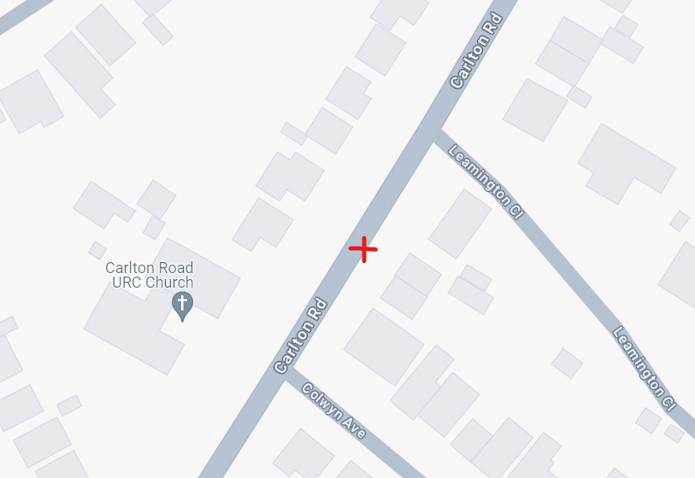

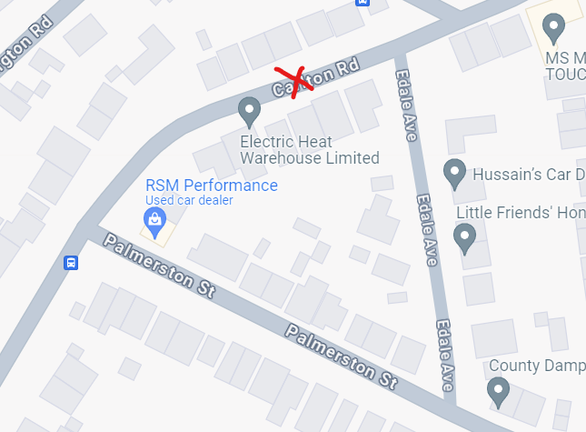

**Site 3**: Carlton Road (btwn Fairfield & Arden) **Site 4**: Carlton Road (btwn Buller & St Chad’s)

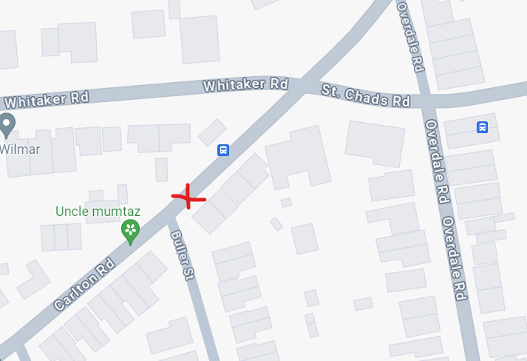

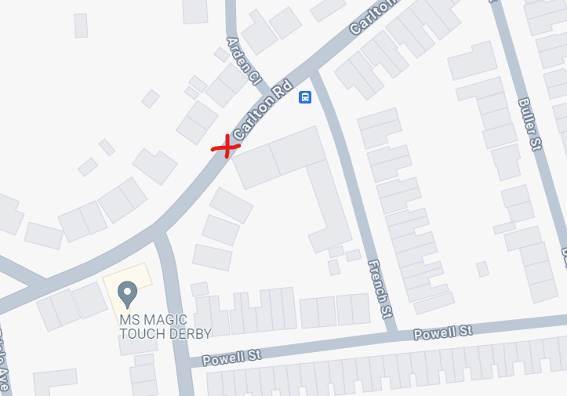

**Annex 2:** Road Traffic Collision Details

Collision 1 - 2021

**Date**: 07/06/2021 **Time**: 13:23

**Day**: Monday **Severity**: Slight **Vehicles**: 2

**Casualties**: 2 **Conditions**: fine, without high winds

**Location**: DERBY-CARLTON RD O/S NO 97

**Description** V1 SUFFERES ELECTRIC HANDBRAKE FAILURE AND ROLLS AND COLLIDES WITH V2 WHICH WAS PARKED AT THE TIME O/S NO 97

Causation: Defective brakes

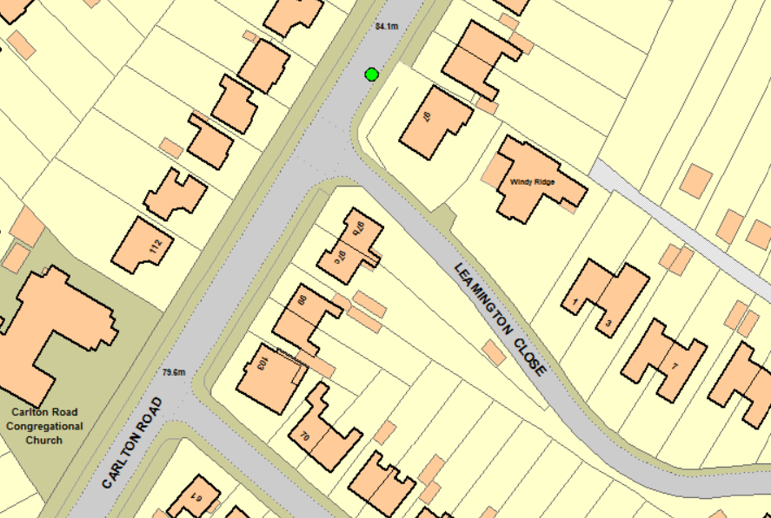

Collision 2 - 2022

**Date**: 11/03/2022 **Time**: 15:20

**Day**: Friday **Severity**: Slight Vehicles: 1

**Casualties**: 1 **Conditions**: Fine, without high winds

**Location**: WHITAKER ROAD O/S NO. 29

**Police Description**: V1 WHILST EXITING DRIVEWAY AND NOT CONFIDENT WITHBRAKES COLLIDES WITH IP BEFORE DAMAGING FENCE

Causation: Inexperience with type of vehicle/ loss of control

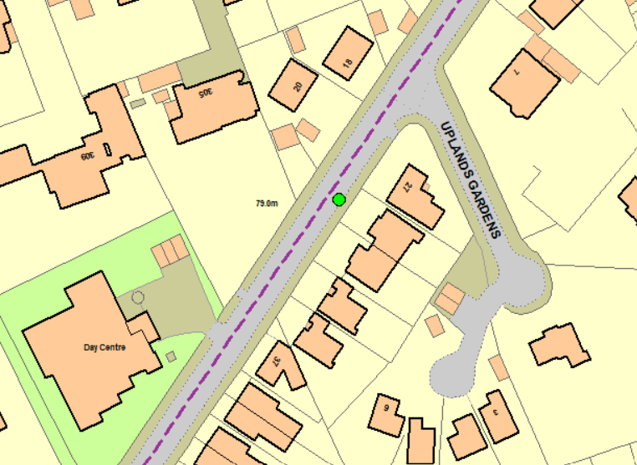

Collision 3 - 2022

**Date**: 04/10/2022 **Time**: 18:45

**Day**: Tuesday **Severity**: Slight **Vehicles**: 2

**Casualties**: 1 **Conditions**: Fine, without high winds

**Location**: CARLTON RD J/W WHITAKER RD

**Description**: V1 COLLIDED WITH V2 (P/CYCLIST CAUSING SLIGHT INJURIES

Causation: Unknown

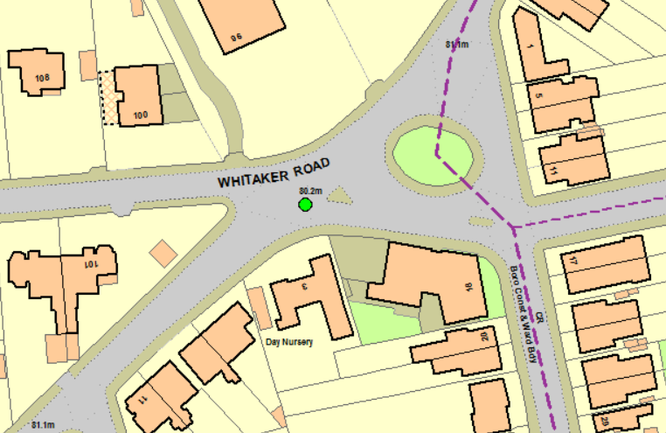

Collision 4 - 2023

**Date**: 27/10/2023 **Time**: 20:30

**Day**: Friday **Severity**: Slight **Vehicles**: 2

**Casualties**: 2 **Conditions**: Other

**Location**: CARLTON RD J/W FAIRFIELD RD O/S NO. 53

**Description**: V2 HAS COLLIDED WITH V1 WHEN V1 BRAKED SHARPLY CAUSING SLIGHT INJURIES

Causation: Slippery road (due to weather)

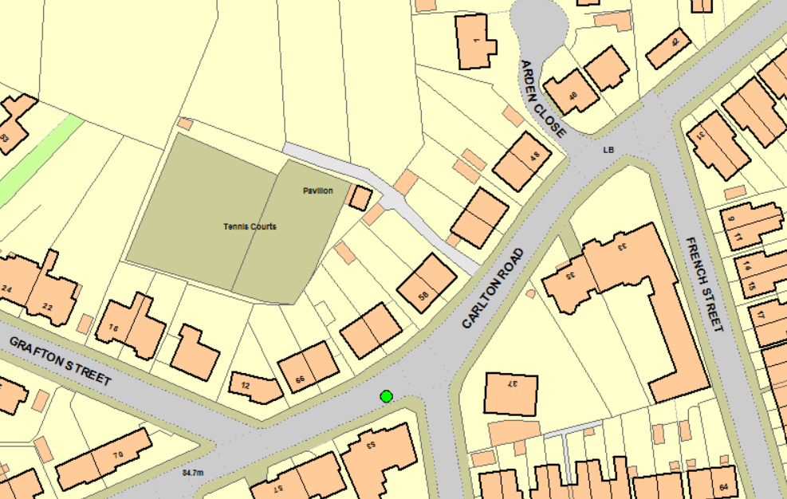

**Annex 3:** Consultation Area

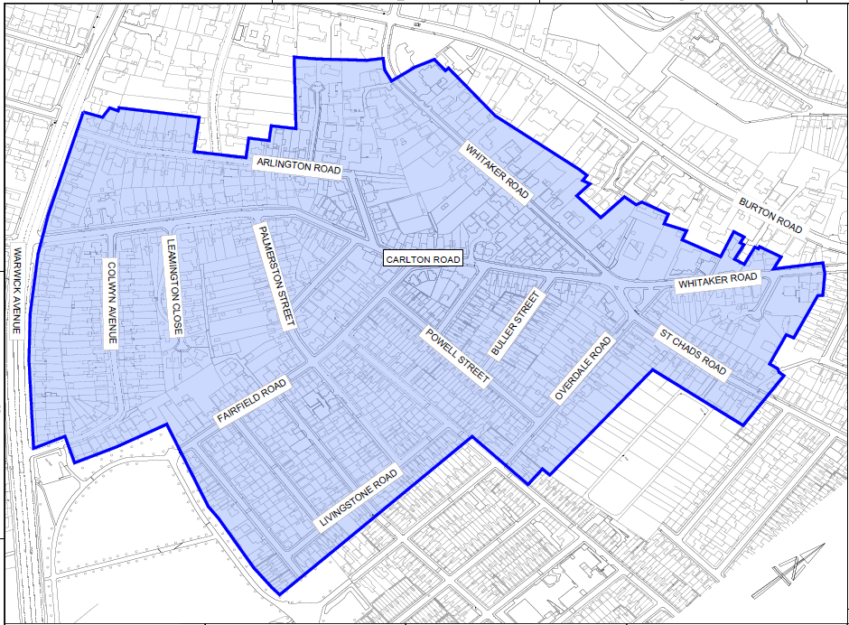

**Annex 4:** Consultation Reply Slip

**Carlton Road and Whitaker Road proposed Traffic Calming   
 Consultation ends 3rd October 2023**

**Name**

**Address, including post code – if this section is not completed your response will not be considered.**

1. **Have you experienced traffic problems on Carlton Road and/or Whitaker Road?**

Yes No

**If you ticked yes, please tell us what traffic problems have occurred**

1. **Are you in favour of the proposal to introduce speed cushions?**

YES NO

1. **Do you have any comments you would like to make regarding this proposal?**

**Annex 5:** Option Feasibility.

**Speed Cameras**

During the consultation, several residents expressed an interest in alternative options. Some were typical but not feasible. Speed cameras, for example, are expensive to procure and require significant police resource to manage. Consequently, they are only used to target those locations with a record of high speeds and serious and fatal road traffic collisions.

**20mph Limits**

Research indicates 20mph speed limits are most appropriate where 85th percentile speeds are already low (24mph or below). If this is not the case the introduction of a 20mph limit would not be supported by the Police. In these circumstances the Police would require the installation of expensive infrastructure such as cameras or traffic calming measures to reduce speeds to an appropriate level. This, however, would not be feasible due to the lack of supporting data and the fact the consultation results remain inconclusive.

**Road Narrowing / Chicanes / Buildouts**

The installation of ‘priority give-ways’ or ‘build-outs’ normally require opposing vehicle flows of approximately 400 vehicles per hour to be effective. Where vehicle flows are low, priority arrangements can cause safety concerns as drivers can sometimes speed up and choose a racing line through the feature. Also, for these features to be successful over larger areas it is normally necessary to include several or combine with other types of traffic calming. This can be expensive, reduce parking and create difficulties for property access.

**Annex 6:** Traffic Calming Plan.

