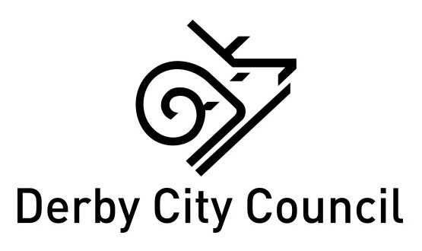

Highway Infrastructure Asset Management Policy
September 2018
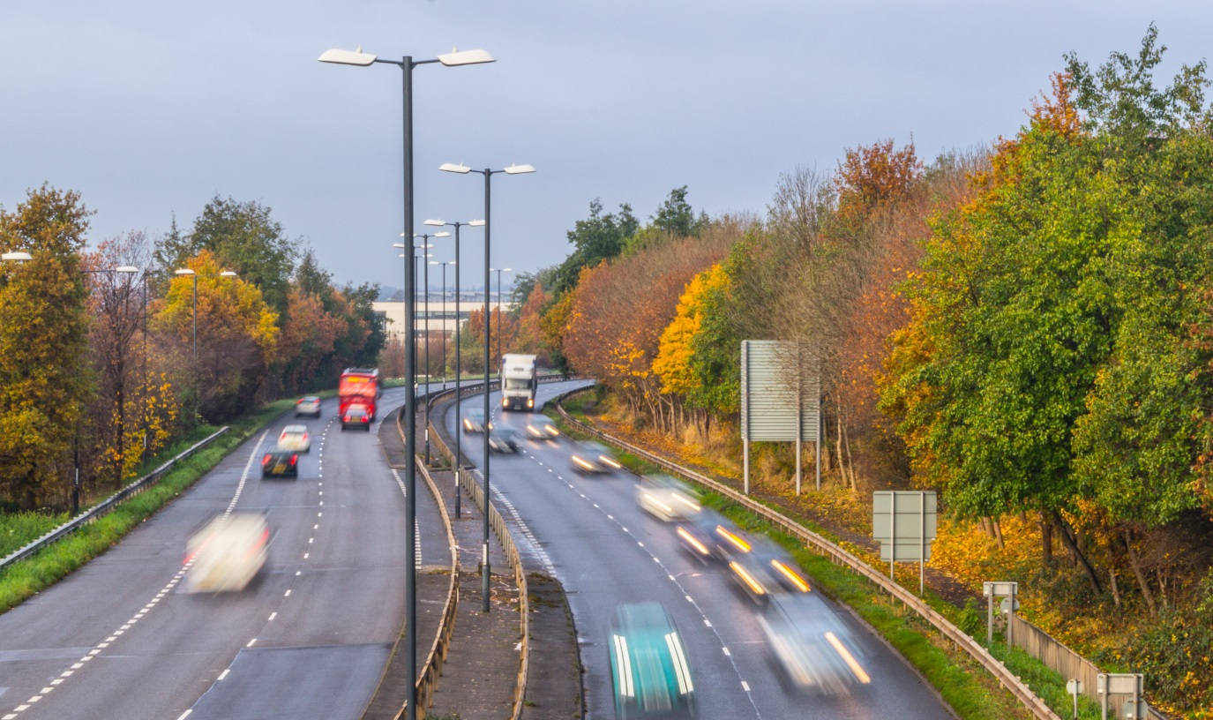

Purpose of this policy:

As a Highway Authority, we have a duty of care to maintain the safety and accessibility of highway infrastructure that is kept at public expense. As stewards and custodians of the highway infrastructure assets, in accordance with the Highways Act 1980, we must demonstrate that we have provided adequate provision for their upkeep and safety as can be reasonably expected. We shall maintain the highway infrastructure assets with consideration to whole life costs, associated risks and alignment with our corporate objectives. This policy defines the planned course of action for all highway asset owners

Control

Version control | AMF-001 v1.0
Author | Kully Boden –  Highway Asset Team Leader
Key stakeholders / contributors | - Highway Asset Owners  - XAIS Asset Management Ltd  - Midland Service Improvement Group  - Disability Hub  - Legal Services (Risk and Insurance)  - Communities Scrutiny Review Board  - Cabinet Member for Neighbourhoods and Streetpride
Lead Directorate | Communities and Place
Implementation due date | September 2018
Approving body | Council Cabinet
Approval date | 12 September 2018
Accountable Service Director | Richard Antcliff, Service Director for Public Protection and Streetpride

Supporting information

Policy or strategy type  (statutory/non statutory and/or internal or external) | Statutory and external
Equality impact assessment date completed | Wednesday 22 August 2018
Safeguarding implications / assessment date completed | N/A
Policy and Improvement review completed (Y/N) | N/A
Revised / updated date
Next Review date | September 2019
Reviewing officer | Kully Boden  Highway Asset Team Leader  kully.boden@derby.gov.uk  01332 642013

We can give you this information in any other way, style or language that will help you access it. Please contact us on 01332 642013 or Minicom 01332 640666

Foreword
The local highway network in Derby is the most valuable publicly owned asset, with a replacement value of approximately £2.8billion. It is used every day by residents, businesses and visitors to the city and provides a vital contribution towards the economic, social and environmental well-being of Derby.
This policy outlines what we need to do to meet our statutory requirements, to maintain the assets. By highway infrastructure assets, we mean any asset owned by the Derby City Council within the highway boundary, including carriageways, footways and cycleways, structures, drainage, street lighting, traffic signals and all street furniture.
Section 41 of the Highways Act 1980 states that ‘a highway authority is under a duty to ensure, so far as is reasonably practicable, that safe passage along a highway is not endangered….’
The ‘Well Managed Highway Infrastructure Code of Practice: October 2016’ is a document released by the UK Roads Liaison Group (UKRLG) and designed to promote the adoption of an integrated asset management approach to highway infrastructure. It is to be used as a guide for authorities to deliver a safe and well-maintained highway network.
Derby City Council is committed to this approach and developing best practice in how we inspect, programme and maintain key assets over their lifespan. It is key for stakeholders and the public that we make informed investment decisions which make the best use of their money.
This is reinforced through the Department for Transport Incentive Fund Self- Assessment process, in that future funding allocations will be linked to those authorities demonstrating value for money through effective and efficient delivery of highway maintenance activities. If Derby are not successful in maintaining a Band 3 optimum status by 2021, we stand to lose up to 10.4% of the monies allocated to the authority, effectively £186k per annum.
Asset management therefore is the backbone of this policy and should be read alongside the Highway Infrastructure Asset Management Strategy and Highway Infrastructure Asset Management Framework documents. All these documents are available on the authority’s website.

What we will do….
- We will create, manage and regularly update a Highway Infrastructure Asset Management Framework, which will set out the overarching principles and requirements of our approach to effectively managing the highway and its infrastructure assets. It will include all the documents and tools to support and implement our approach

- In line with the Well Managed Highway Infrastructure Code of Practice – October 2016, we will support a risk based approach to all aspects of highway infrastructure maintenance, including setting levels of service, lifecycle planning, risk management and scheme prioritisation

- We will work to maintain the authority’s optimum Band 3 status through the Department for Transport’s Incentive Funding Self-Assessment process, demonstrating a continual improvement in asset management processes and that clear outcomes have been achieved

- We will maintain, review and update our asset registers to ensure we hold sufficient accurate and current data, so as to continually improve our data integrity

- We will complete an annual regime of condition surveys and inspections of all highway assets, in line with the Code of Practice

- We will complete a regular review of current and future risks, associated with all assets at a strategic, tactical and operational level, using a robust and systematic approach, understanding their significance to users, stakeholders and the authority

- We will carry out lifecycle planning of all the highway asset groups to understand the level of funding we actually require to maintain them and seek to secure the required financial investment at the correct time

- In line with the Code of Practice, we will enhance current methods for prioritising highway maintenance and construction projects, to take account of whole life costs and risk management. We will assist internal stakeholders, the Police, the Derby and Derbyshire Road Safety Partnership and other agencies in their objective to reduce road collisions

- We will use cost effective planned maintenance treatments to preserve our assets. We will ensure they are carried out at the optimum time in the lifecycle of the asset to maximise the life of the asset, whilst delivering value for money

- We will develop long term rolling work programmes of between 5 and 10 years for each asset group. We will explore the potential to extend capital funding for longer than one year, with the aim to deliver longer term and sustainable preventative maintenance programmes

- In developing priorities and programmes, we will view the highway network as a whole, seeking to share and coordinate work across asset groups, as well as within them to minimise cost and disruption

- We will develop business cases to maximise opportunities for additional funding, including submitting bids and exploring avenues for funding streams

- We will ensure ongoing communication with our stakeholder groups and monitor our progress. We will engage them for key decision making and performance monitoring

- We will continue to benchmark our performance on all asset management activities with other similar authorities and learn from best practice

- We will maximise collaboration with neighbouring and national authorities to seek parity and strength in the approaches adopted

- We will communicate with the public on our levels of service and our long term plans for the management of our highway infrastructure assets

- We need to understand the levels of service we want to achieve, in line with the Code of Practice and regularly publish our performance against these targets on the Councils website

- We will research and embrace new technologies and innovative practices to maximise the performance and life of an asset and efficiencies in our services

- We will keep accurate records of historic projects, so we know when assets were repaired, what materials were used and to regularly monitor how the materials used are performing

- We will take opportunities to remove redundant assets off the highway to minimise clutter, remove unnecessary maintenance and simplify the street scene

- We will ensure all highway asset owners maintain a range of competencies, including necessary training and qualifications to deliver effective asset management. We will monitor our resources to check we have sufficient capabilities to meet our corporate objectives

- We need to proactively improve our approach through lessons learnt, introducing change and developing a mature approach to what is best for the asset

- We will have a proactive approach to managing the highway asset in line with climate change, to minimise disruption caused by flooding, snow and ice.

How we will know we have made a difference….

- Public opinion polls will show that residents are satisfied with the condition of Derby’s highway infrastructure assets, the repairs we carry out and the levels of service that are delivered

- The condition data and performance of the assets will show year on year improvements from the investments made. This will be benchmarked with neighbouring authorities and reported to key stakeholders

- We will have a long term, sustainable rolling programme of schemes from 5 to 10 years and a clear approach for prioritising our schemes, both within asset groups and across them, demonstrating an integrated cross asset approach.

- Highway Asset Owners will have complied with a robust risk management process, made evident by improved performance for the maintenance of all highway infrastructure assets

- The authority’s insurance claim repudiation rate will be maintained to a high level through a robust risk-based approach to safety inspections, defect identification with effective and timely repair

- Working to this policy, we will have increased confidence in the performance of our network and a clear indication of our maintenance need.

- Maximum levels of funding are secured each year, based on our self-assessment return to Department for Transport regarding our maturity in delivering asset management

- Retention of qualified and competent officers who have a clear vision and tools to deliver effective asset management

- Maintain a reputation locally, regionally and nationally of delivering successful infrastructure and maintenance projects

- Delivery of the Derby Local Transport Plan, LTP3: 2011-2026 priority of maintaining what we have and contributing to the priorities ‘managing traffic flows’ and ‘supporting and encouraging travel choice’

