

Local Highway Maintenance Transparency Report
September 2026

Highways Maintenance Transparency Reports Template

Contents
Contents 2
How we maintain local roads, pavements, and the wider highway network in Derby City Council 4
A1 – What we are responsible for maintaining 4
A2 – Road conditions in Derby City Council 5
A3 – What we are doing about potholes and other road defects 6
A4 – What we spend to maintain the highway network and where the funding is coming from 8
A5 – Our maintenance plans for this year 8
Transparency report – Technical Annex template 11
B1 - Highways maintenance funding and spending figures 11
B2 – Highway Maintenance Activity (Surface Treatments and Repairs) 13
B3 – Pothole repairs 14
B4 – Maintenance of highway structures 17
B5 – Asset Management 17
B6 - Maintaining footways and cycleways 23
B7 – Drainage 24
B8 – Skills and training 25
B9 – Adapting roads to withstand climate pressures 27
B10 – Innovation 29
B11 – Working with utility companies to reduce disruption to road users 30
B12 – Managing highways maintenance contracts effectively 31

Sign-Off Confirmation

This document has been approved by the appropriate level of authority as requested in the submission requirements

Role | Name | Date
Cabinet Member for Climate Change, Transport and Sustainability | Councillor Carmel Swan  Signature   | 3rd September 2026
Director of Finance  (S151 Officer) | Alison Parkin    Signature | 3rd September 2026

How we maintain local roads, pavements, and the wider highway network in Derby City Council

A1 – What we are responsible for maintaining
Ref | Asset | Quantity | Comment
 | Carriageways | 787 km | Based on recent road length statistics.
 | Footways | 1263 km
Additional Asset Types
1 | Vehicle Restraint Systems (VRS) | 28,764 m | Safety barriers (2024/25 survey)
2 | Structures: | 47 No. | Bridges
2 | Structures: | 97 No. | Retaining Walls
2 | Structures: | 10 No. | Pedestrian Subways
2 | Structures: | 21 No. | Footbridges
2 | Structures: | 9 No. | Gantries
2 | Structures: | 110 No. | Culverts
3 | Street Lighting | 29,589 No. | Street Light Columns
3 | Street Lighting | 1,552 No. | Signs (Illuminated)
3 | Street Lighting | 995 No. | Bollards (Illuminated)
3 | Street Lighting | 391 No. | Feeder Pillars
3 | Street Lighting | 191 No. | Subway Fittings
4 | Drainage | 125km. | Highway Drainage Pipes
4 | Drainage | 41,487 No | Highway Drainage Gullies.
4 | Drainage | 9 No. | Highway Drainage Pumping Stations
4 | Drainage | 58 No. | Petrol Interceptors.
5 | Traffic Signals | 214 No. | Traffic Signal Sites
5 | Traffic Signals | 1,987 No. | Traffic Signal Heads
5 | Traffic Signals | 214 No. | Feeder Pillars
5 | Traffic Signals | 1 No. | Urban Traffic Management and control system

Derby City Council also manage a number of other assets which include cycleways, highway trees, traffic data collection, CCTV, parking infrastructure and street furniture.
Managing these assets presents significant challenges due to their scale, ageing infrastructure and increasing demand. Many assets are approaching or exceeding their original design life, requiring investment to be carefully prioritised to maintain safety, reliability and value for money. The diversity of asset types, materials and technologies also increases the complexity of maintenance and lifecycle management.
Traffic growth resulting from new housing, infrastructure development and higher numbers of heavier vehicles continues to accelerate asset deterioration. Climate change is adding further pressure through more frequent and prolonged durations of flooding and temperature extremes, increasing maintenance demands and the need to further improve network resilience.
While the PFI programme has significantly improved the condition of the street lighting network, many other highway assets are reaching the point where increased investment is required to maintain serviceability. The expiry of the PFI contract in 2032, together with the growing obsolescence of existing traffic signal equipment, will require long-term planning and investment challenges. The Council continues to develop its asset management approach, using condition data, lifecycle planning and risk-based prioritisation to ensure available funding delivers the greatest long-term benefit for Derby's highway network.

A2 – Road conditions in Derby City Council
Councils use road condition surveys to assess the state of their roads. The results are grouped into three categories:
- Green – the road is in good condition and no further investigation or treatment is required
- Amber – the road may need maintenance soon
- Red – the road is in poor condition and should be considered for maintenance
The published official statistics for road condition include more detail about the methodology, timing and coverage of this data

A2.1. A roads
Year | Percentage of road in red category | Percentage of road in amber category | Percentage of road in green category
2023 | 8% | 58% | 34%
2024 | 9% | 61% | 30%
2025 | 9% | 61% | 30%
A2.2. B and C roads
Year | Percentage of road in red category | Percentage of road in amber category | Percentage of road in green category
2023 | 16% | 51% | 33%
2024 | 17% | 50% | 33%
2025 | 17% | 50% | 33%

A2.3. U roads
Year | Percentage of road in red category
2023 | 10%
2024 | 7%
2025  (2024/25) | 9%

A2.4. - Additional information on carriageway condition
Through the continuous collection and analysis of condition data, we aim to target the right treatments at the right locations and at the right time in an asset’s life. This evidence-led approach has enabled us to maintain a steady state across Derby's A, B and C road network, demonstrating that planned maintenance is effectively preserving condition and preventing significant deterioration on the city's most strategically important routes. Targeted investment in the unclassified (U) road network has also delivered an improvement in overall condition, demonstrating the value of risk-based, data-driven decision making. Note – the 2026 published figures are expected to show a 2% improvement).
Increased funding through the East Midlands Combined County Authority has enabled us to deliver an enhanced programme of preventative maintenance, targeting assets before significant deterioration occurs. It has also supported the use of innovative recycling techniques to repair problematic locations, extending asset life, reducing waste and delivering sustainable, cost-effective improvements across the network.

A3 – What we are doing about potholes and other road defects
A3.1. – What is a pothole?
In Derby, a pothole is defined by its depth rather than its surface area. Our intervention level for a pothole in the carriageway measures 40mm or greater in depth. This defect size is considered more likely to present a risk to road users or contribute to further deterioration of the carriageway.
Potholes typically develop when water penetrates cracks in the road surface, weakening the underlying layers. Traffic loading, combined with freeze-thaw cycles and prolonged periods of adverse winter weather, causes the surface to break apart, leading to rapid deterioration.
Response times are based on the road hierarchy and the level of risk. On higher-priority routes, potholes are made safe within one hour, while on lower-priority roads the response time is up to 36 hours. Making a pothole (or defect) safe may involve either an immediate permanent repair or a temporary repair until a permanent solution can be completed, ensuring the network remains safe and serviceable.
Appendix-2---AMF-009-Highway-Safety-Inspection-Manual-Final.pdf provides further information.
A3.2. – What we are doing to tackle potholes
Our approach to carriageway maintenance is increasingly focused on prevention rather than cure. While repairing potholes remains an essential part of our service, with 4,414 potholes repaired in 2025/26, our priority is to prevent defects from forming through targeted asset management. We invest in larger-scale planned patching and preventative maintenance programmes that address deterioration before it develops into more significant defects.
Using carriageway condition data alongside the expertise of our highway inspectors on asset performance and customer feedback, we identify locations where early intervention will have the greatest impact. This enables us to preserve the structural integrity of the carriageway, extend the life of the asset and reduce the need for reactive repairs. Success is not defined solely by the number of potholes repaired, but by the effectiveness of our preventative approach in reducing the number and severity of defects that develop.
Alongside our preventative programmes, we continue to trial innovative repair techniques that improve quality, efficiency and durability. One recent example is spray-injection patching, which uses a combination of bitumen emulsion and aggregate applied directly into a cleaned pothole. The material is compacted by the force of application, often removing the need for rolling equipment and reducing traffic disruption while providing a durable repair.
We continue to work closely with our supply chain partners to evaluate emerging materials and innovative repair techniques. By sharing knowledge, trialling new technologies and using evidence from condition data, we aim to adopt the most effective and sustainable solutions to address carriageway deterioration, improve repair quality and enhance the resilience and long-term condition of the highway network.
A3.3. How members of public can report potholes and other highway defects
Website - using the govService CRM platform, with myAccount as the public-facing portal, the public can report highway defects: https://myaccount.derby.gov.uk/MyServices. These are transferred directly into the Confirm asset management system via an API link for highway defects. Other assets, such as street lighting, traffic signals, drainage and structures are directed to the appropriate service area or inbox for action. The website also features Darcie, an AI-powered digital assistant that helps customers find the right service and complete their enquiry.
Telephone - the Derby Direct contact centre or specialists’ teams dedicated numbers. All services which may need to provide emergency response either provide a 24/7 service via their service number (e.g. street lighting/traffic signals) or a dedicated out of hours emergency response stand by number with a duty officer.
Enquiries can also be submitted by email to a dedicated address.
Enquiries received through councillors as part of their casework are also logged via the internal ‘councillor portal’ a part of the govService CRM platform and forwarded to the relevant team for action.
In person – Council House reception.
A3.4. What happens after a pothole is reported
The Confirm asset management system automatically assigns each enquiry to the highway inspector responsible for the area. The inspector visits the site, carries out a risk assessment, and determines whether a repair is required and its priority. Where safe, the defect is marked with paint; otherwise, the kerb is marked following a dynamic risk assessment. Using a handheld device, the inspector records the defect, including its location, dimensions, repair instructions and at least three photographs.
A technician reviews the repair before scheduling it for operations, except emergency repairs, which are automatically committed. Temporary emergency repairs are followed by permanent repairs where feasible. If a pothole is in a location that is due to be resurfaced, a temporary repair is completed.
Potholes that are deemed safe are monitored through cyclical safety inspections.

A4 – What we spend to maintain the highway network and where the funding is coming from

A4.1. – Spending on highways maintenance
 | 2024-25 | 2025-26 | 2026-27 (projected)
Total spend on highways maintenance | £41,218,300 | £27,537,033 | £36,555,254
Of which spent on:
Carriageways | £5,141,139 | £4,957,434 | £7,957,049
Footways | £870,567 | £780,445 | £614,059
Structures (for example bridges or tunnels) | £415,647 | £957,965 | £1,134,411
Drainage | £991,918 | £1,178,868 | £1,474,326
Street lighting | £8,825,006 | £8,143, 630 | £8,427,943
Traffic Signals | £1,242,742 | £1,028,905 | £1,752,466
Strategic Projects | £23,731,282 | £9,479,186 | £8,331,000
Strategic Projects (cw) | n/a | £1,010,601 | £6,864,000

A4.2 – Where our funding for highways maintenance comes from
Funding sources for highways maintenance | 2024-25 | 2025-26 | 2026-27 (projected)
Funding received through the Department for Transport / UK Government | £32,801,055 | £20,336,526 | £28,960,419
[if applicable]:  Additional highways maintenance funding provided by the Council or third parties | £8,417,244 | £7,200,507 | £7,594,835
Total | £41,218,300 | £27,537,033 | £36,555,254

A5 – Our maintenance plans for this year
A5.1 – Our plans for highways maintenance for 2026-27
Planned Carriageway Maintenance will include:
- 5.9 km of conventional resurfacing
- 0.8 km of reconstruction
- 1,552 m² of planned patching
- 0.75 km of In-Situ Recycling trial using calcined clay as a lower-carbon alternative to cement binder
Preventative Carriageway Maintenance will include:
- 5.1 km of Surface Dressing using a supreme enhanced binder
- 5.2 km of Micro Asphalt featuring a new fibrous material designed to better withstand adverse weather and heavy vehicle loads
- 1.2 km of Asphalt Preservation on the A52. One of the most sustainable maintenance methods designed to extend the life of the surface.
Footways
- 3.2 km of conventional resurfacing
- 8.1 km of Micro Surfacing
In addition
- 1km relining and refurbishment of a major city culvert
- Major upgrade of key city centre pumping stations
- Post tensioned structures detailed inspections and assessment programme
- Darley Abbey Mills Bridge demolition and development of Outline Business Case for replacement structure accommodating active travel, flood resilience and community connectivity
- Refurbishment of several signal assets and maximising on available developer led funding
- Pride Park Lantern Replacement (x300) - smart future-ready asset resilience and economic placemaking

A5.2 - Full list of planned carriageway and footway works
Derby City Council has published its 2026/27 works programme, and this can be viewed here Managing our highway assets - Derby City Council
This programme shows Carriageway works (CW) and Footway works (FW)
A5.3 – How decisions are made on our maintenance plans
Annual survey data is used to assess network condition against defined and weighted value management criteria and our adopted risk-based approach providing the evidence base for developing maintenance programmes.
The practical knowledge and on-site experience of our highway inspectors in assessing asset performance, in terms of an asset’s rate of deterioration and resilience help align maintenance plans, ensuring interventions are targeted, timely, and proportionate to the actual needs of the network and support informed investment decisions.
By intervening at the optimum time, we can apply the most appropriate preventative treatment, at a fraction of the cost of full depth resurfacing. Through lifecycle planning we seek to prevent further deterioration of the ‘Amber’ locations.
A percentage of resurfacing schemes are targeted at locations where the asset has deteriorated beyond the point where preventative/reactive maintenance is viable, however we will still attempt to complete in-situ recycling to techniques to reduce waste and lower carbon emissions.
Candidate locations are then assessed through cross-asset prioritisation with other asset groups and utilities to identify collaboration opportunities, enabling a whole-street approach to maintenance and repairs that maximise network benefits.

Transparency report – Technical Annex template
B1 - Highways maintenance funding

Spending figures
B1.1 – Capital funding allocation sources
Financial year | 2024-25 | 2025-26 | 2026-27 (projected)
Highways maintenance capital funding allocated through DfT ** | £3,046,358 | £6,615,629 | £19,682,648
Other DfT capital funding utilised by local authority for highways maintenance | £25,757,692 | £10,847,176 | £5,794,050
Other Government capital funding allocated by local authority to Highways Maintenance | N/A | N/A | £ 550,000
Other capital funding allocated to highways maintenance | £2,569,402 | £1,131,037 | £5,909,291
Total Capital funding allocated to highways maintenance | £32,373,452 | £18,593,842 | £26,935,989
** via East Midlands Combined Local Authority (EMCCA)
B1.1.2 - Additional information on funding figures
**Includes Highways Maintenance Block, Asset Resilience and Transport for City Regions funding. Funding for highways maintenance (asset resilience) is now passported to Derby City through the East Midlands Combined County Authority. Longer-term settlements enable greater certainty and stability in highway investment, enabling better prioritisation of investment based on whole-life asset management.

Other Government capital funding includes a contribution from the Environment Agency towards the relining of culverts within a busy shopping area. The investment will help protect properties and businesses from flood risk, improve the resilience of the local drainage infrastructure and reduce the potential for disruption to the area in the event of flooding. This also includes Funding received through the UK Government for PFI Credits.

The 2026-27 (projected) funding allocation sources is in line with quarter 1 forecast monitoring position approved by cabinet.

B1.2 - Spending
B1.2.1 – Total spending
The questions in this section (B1.2.1) relate to the spending condition set out in the 2026–27 local highways maintenance incentive funding requirements. Completion of this section forms part of the evidence required to meet this incentive funding condition.
Please confirm that you understand the answers provided in this section (B1.2.1) relate to your compliance under the 2026-27 local highways maintenance incentive funding requirements, as set out to your authority via letter to your chief executive in April and as published online. | Yes

Financial year | 2024-25 | 2025-26 | 2026-27 (projected)
Total highways maintenance capital spend | £32,373,452 | £18,593,842 | £26,935,989
Total highways maintenance  revenue spend | £8,844,848 | £8,943,191 | £9,619,265
Total spend | £41,218,300 | £27,537,033 | £36,555,254
B1.2.2 - Additional information on total spending figures
2026-27 (projected) funding allocation sources is in line with quarter 1 forecast monitoring position approved by cabinet.

B1.2.3 Spending on carriageways by type of spend in financial year 2025-26 and 2026-27 (projected)
Carriageway spend related maintenance type | Capital  2025-26 | Revenue 2025-26 | Capital 2026-27 (projected) | Revenue 2026-27 (projected)
Planned maintenance
Preventative carriageway maintenance | £721,232 | N/A | £1,725,000 | N/A
Structural carriageway maintenance | £2,750,436 | N/A | £3,660,821 | N/A
Planned carriageway repair / patching programmes | *£293,660 | N/A | *£237,843 | N/A
Reactive carriageway maintenance
Reactive carriageway repairs / patching (temporary repairs) | N/A | N/A | N/A | N/A
Reactive carriageway repairs / patching (permanent repairs) | N/A | N/A | N/A | N/A
Reactive carriageway repairs / patching (total) | N/A | N/A | N/A | N/A
Other carriageway-related spend | N/A | N/A | N/A | N/A
Total | £3,765,328 | N/A | £5,623,664 | N/A
B1.2.4 - Additional information on spending on carriageways by type of spend
*Includes planned pre-patching in preparation for Surface Dressing programme and other small scale resurfacing works

Our Structural and Preventative programmes are delivered via Capital funding, including any large scale planned patching works.

The figures set out in B.1.2.1 for ‘total highways maintenance revenue spend’ cover all aspects of the service. Each job we raised is logged through our Asset Management software and tracked through to completion. This includes the size of the repair and scope, however we don’t have an individual financial breakdown for maintenance delivered reactively via revenue.

B2 – Highway Maintenance Activity (Surface Treatments and Repairs)
B2.1 – Road resurfacing and surface treatments
Financial year | Road receiving preventative road surface treatments (length, km) | Road receiving planned structural maintenance (length, km) | Area receiving planned repair / patching programmes | Area receiving reactive repair / patching (permanent methods) | Area receiving reactive repairs/ patching (temporary methods)
2025-26 | 3.85km | 4.98km | 924.6m² | 14,221.2m² | n/a
2026-27 projected | 10.3km | 6.7km | 1552m² | n/a | n/a
B2.1.1 – additional information on surface treatments and repairs
Does table B2.1 reflect all your carriageway-related road surface treatments & repair activities (for example, including pothole repairs)? If no, please add further information on any other types of treatments (planned to be) delivered and their extent in the table below. | Yes

B2.1.2 – Further information and context
Additional funding from East Midlands Combined Authority has allowed us to significantly expand our preventative maintenance programmes delivering treatments at a much greater scale across key routes, including Uttoxeter New Road and the A6.  By continuing to work closely with our contractors during scheme development, we are identifying improved materials and treatment solutions that are better suited to the needs of our strategic routes. This collaborative approach supports more effective longer-term planning, delivers better value for money, and enables available funding to go further, helping us maintain and improve the overall condition of the highway network. | Yes

B3 – Pothole repairs
B3.1 – Pothole/Defect intervention criteria
Pothole/Defect category name (as used by your authority) | Minimum investigatory or definitional threshold (e.g. depth, area, width – include units) | Additional risk or contextual factors considered (e.g. road hierarchy, traffic levels, location in carriageway) | Target response time – make safe ** | Target response time – permanent repair **
Pothole – Carriageway | 40mm depth | Road Hierarchy | 1 hour or 36 hour | 14 day or  28 day
Pothole – Footway | 25mm depth | Road Hierarchy | 1 hour or 36 hour | 14 day or  28 day
Pothole City Centre – Footway | 15mm depth | Road Hierarchy | 1 hour | 14 day
** We have reviewed our current Highway Safety Inspection Manual, which is due to be adopted and implemented in the coming months. The new Manual will seek to adopt revised response criteria, with the 1 hour response being replaced by a 2 hour response, as benchmarked with other local authorities and the addition of a 12 week repair target, in response to KPI reporting trends.
B3.2 – Number of potholes filled
B3.2.1 - Number of potholes filled in 2025-26 (estimate) | 4,414*

B3.2.2 - Of these how many do you estimate were resolved using each of the following approaches?
Planned repair / patching programmes | Planned structural maintenance programmes | Reactive repair using temporary repair methods | Reactive repair using permanent repair methods
No data held | No data held | 1317* | 3097**
* This is the total number of jobs. One job can have multiple pothole repairs within it.
** This data also includes follow up permanent repairs carried out after initial temporary repairs.

B3.2.3 - Additional information on numbers of potholes resolved, by treatment type
The categorisation of temporary and permanent repairs is based on general assumptions, with emergency repairs typically classified as temporary and non-emergency repairs as permanent. However, this is not always the case, as permanent repairs may be completed during emergency work and temporary repairs may form part of non-emergency interventions.

The Council cannot readily extract data on potholes repaired through planned patching or structural maintenance programmes, however in practice, many potholes are temporarily repaired in advance of planned resurfacing or preventative maintenance schemes, such as those undertaken on Wragley Way, as a more cost-effective and efficient use of maintenance resources.
CAUTION FOR READERS – Authorities have different criteria for identifying potholes and different methodologies for counting how many they have filled or resolved. Summing the figures in the above table across authorities will therefore not provide a reliable estimate of the total number of potholes filled across England.
B3.3 - Prices of pothole interventions
Unit/average cost of a permanent pothole repair on your network (reactive) | £228.51 | Unit/average cost of a temporary pothole repair on your network (reactive) | £91.93
B3.3.1 - Additional information on pothole prices (optional)
The pothole repair costs shown above are based on a carriageway pothole measuring 2.5m² at a depth of 40mm. Actual repair costs may vary depending on factors such as road hierarchy, traffic sensitivity and material specifications, as different categories of road require prescribed treatment methods and materials.

Often, temporary repairs may address multiple nearby potholes, and where possible permanent repairs are often completed as part of larger scale patching, ahead of preventative maintenance. Costs can also be affected by site specific conditions, including the depth and extent of deterioration, additional preparatory works, traffic management requirements and health and safety considerations.

Accordingly, the figures provided should be regarded as indicative baseline estimates and not fixed prices.

B3.4 - Defect repair quality
ID | Question | Yes/no
3.4.1 | Do you set requirements to those delivering repairs about the longevity of both a) planned repairs/patching and b) reactive repairs using permanent methods? | Yes
3.4.2 | If yes, do you base your material and process specifications on these longevity requirements? | n/a
3.4.3 | Do you regularly monitor the appropriateness of the carriageway interventions chosen by your workforce or contractor and the quality of work delivered? | Yes
3.4.4 | If yes, do you systematically record information about expected and delivered longevity of repairs? | No
B3.4.5 - Evidence Summary

3.4.1 – Partially - Works orders specify whether a temporary “make safe” or permanent repair is required. Where a temporary repair is undertaken, a separate order is raised for the permanent repair, resulting in two orders for the same defect. This aligns with HAUC SROH S1.1.4, which requires permanent repairs following temporary/interim works within six months, and supports our asset management approach. Permanent repairs should last until the next planned lifecycle intervention.
3.4.2 – Our in-house contractor, working to these instructions, understands that permanent reinstatements must match the specification of the existing asset in accordance with HAUC SROH to ensure longevity of the repair and prevent revisits. For example, a carriageway with a high specification material must be reinstated like for like to the required depths.

3.4.3 – Inspectors monitor repairs through routine safety inspections and highlight any failures or quality of workmanship raised by customers. Instructions are also provided to ensure suitability of materials used for the defect e.g. using a carriageway specification material in the footway where vehicle override is an issue, so the existing specification is not suitable for the defect.

B3.4.6 - Additional information
The Council does not currently maintain a fully developed dataset comparing the expected and delivered longevity of individual pothole repairs, but repair quality and repeat defects are managed through inspections, warranty arrangements, contractor performance monitoring and operational reviews are discussed at operational board.

Our asset management approach seeks to maximise opportunities to complete large scale patching where practicable, prioritising these works ahead of preventative maintenance where this provides better value and supports the longer-term condition and performance of the highway network.

B3.5 - Public reporting system for defects and other issues
ID | Question | Answer
3.5.1 | Are defect reports from the public routinely used as an input into maintenance planning and inspection regimes? | Yes
3.5.2 | Do you inform users about the outcomes from their feedback, including when no action is to be taken? | Yes

B3.5.3 - Evidence Summary
Information submitted by residents helps validate and supplement existing highway condition data and safety inspections. It supports the identification of emerging trends, recurring issues and informed decision-making, contributing to a comprehensive understanding of network performance.
Public reports, including those received through councillor casework, are responded to with customers advised, where appropriate, of the Council’s adopted asset management approach and maintenance priorities. Public defect reports are not routinely used to determine inspection regimes, which operate according to established risk-based criteria and defined frequencies. However, reports provide valuable, real-time information on potholes developing between inspections, enabling prompt responses to safety-critical issues without altering scheduled inspections.
During periods of extreme weather, identified hotspots across the network are subject to enhanced monitoring, with information provided through customer reports helping to identify emerging issues and inform an appropriate and timely response.
B3.5.4 - Tools used for reporting
Website reporting using the govService CRM platform, with myAccount as the public-facing portal where the public can report highway defects: https://myaccount.derby.gov.uk/MyServices. These are transferred directly into the Confirm asset management system via an API link for highways defects.

B4 – Maintenance of highway structures
Please set out information about other highway structures and assets
B4.1 Highway Structures
ID | Question | Answer
4.1.1 | Number of highway structures on your highway network | 286
4.1.2 | Number of highway structures with interim measures in accordance with CS470 applied? | 5
4.1.3 | Number of structures due a General Inspection in 2025-26 in accordance with CS450 | 256
4.1.4 | Number of General Inspections carried out in 2025-26 | 37  (90*)
4.1.5 | Number of structures due a Principal Inspection in 2025-26 in accordance with CS450 | 253
4.1.6 | Number of Principal Inspections carried out in 2025-26 | 7

A total of 90 General Inspections (GIs) were undertaken, including inspections of retaining walls that, while not strictly part of the highway asset, have an impact on the highway. These inspections were prioritised where no existing data was held that could affect the public highway and/or where the assets were identified as being in poor condition.
Of the structures requiring Principal Inspections (PIs), 101 relate to bridges, footbridges and pedestrian subways. There are approximately 1,100 structural assets recorded within the asset database.

B5 – Asset Management
This section focuses on asset management practices that underpin how the authority plans, prioritises and delivers highways maintenance. It is intended to provide confidence that decisions are evidence led, risk based and aligned to whole life value, in line with the Code of Practice for Well Managed Highways Infrastructure.
B5.1 - Asset Management Strategy and Policy
The questions in this section (B5.1) relate to the asset management condition set out in the 2026–27 local highways maintenance incentive funding requirements. Completion of this section forms part of the evidence required to meet this incentive funding condition.
5.1.1 | Please confirm that you understand the answers provided in this section (B5.1) relate to your compliance under the 2026-27 local highways maintenance incentive funding requirements, as set out to your authority via letter to your chief executive in April and as published online. | Yes
5.1.2 | Please provide a link to your authority’s published highways asset management policy and strategy.  Link
5.1.2 | https://www.derby.gov.uk/transport-and-streets/managing-highway-assets
5.1.3 | Please provide the date it was last reviewed or updated | July 2026 - Ongoing
5.1.4 | Please provide proof of the review or update.
The Asset Management Policy and Strategy was adopted in September 2018. The documents were reviewed during Summer 2026 and are on the forward plan for Cabinet consideration in Quarter 4 of 2026/27 before September 2027, as well as the Highway Safety Inspection Manual v2.
The Forward Plan published for August 2026 at https://democracy.derby.gov.uk/Forwardplan.aspx shows the documents listed for review and approval by Council Cabinet.

5.1.5 | If your asset management policy or strategy has not been reviewed or updated since 1 August 2024, please confirm that it will be reviewed or updated by 30 September 2027 and provide a brief timetable for doing so. See 5.1.4 above.
Key aspects of highways asset management approach
To get a sense of how each local highway authority is implementing best practice for asset management, we ask that you provide the following information across a sample of key areas.
B5.2 - Asset data This section seeks to establish whether asset management decisions are supported by appropriate and up-to-date condition data.
Please complete the table below for your key highway assets.
Asset type | Asset inventory held? (None / partial / full) | Condition data held? (None / Partial / Full)
Carriageways | full | full
Footways and cycleways | full /  partial for cycleways | full /  partial for cycleways
Structures | full | full
Drainage assets | Mostly full / partial for underground assets | Mostly full / partial for underground assets
Street lighting | full | full
Traffic signals | full | full
5.2.1 - Further context (optional)
Carriageways are surveyed annually after winter using the PAS2161-accredited standard, covering the top four of nine road hierarchy groups. Lower hierarchy routes are surveyed on a 25% annual cycle, providing current data for scheme prioritisation and forward programmes.

Drainage data is continually collected to improve understanding of the underground network and support a proactive, risk-based approach.

The street lighting PFI Management Information System provides a comprehensive asset register, supporting maintenance, performance monitoring, contractual compliance and investment decisions.

Traffic signal sites receive annual inspections, or six-monthly inspections on the Resilient Network. Condition reports inform lifecycle planning, maintenance and investment priorities.

B.5.3 – Asset data integration and management
This section seeks to understand the maturity of how asset data is managed and integrated to support planning and investment decisions.
All traffic signal sites are visited once a year for a Periodic Inspection (PI). Resilient network sites are visited every 6 months. A PI includes condition reports that are used in the asset Lifecyle plan

B5.3.1 – Asset data integration
How is asset inventory and condition data for your key highway assets primarily managed? (please indicate one option with an X)
Discrete spreadsheets or documents held by individual teams
Multiple digital platforms with limited integration | x
A single digital platform or a set of connected platforms used across the highways service
Other (please set out in further context)
B5.3.2 - Further context (optional)
Highway asset inventory and condition data is primarily managed through a combination of specialist asset management systems, contractor management systems and corporate data platforms. Data is collected through routine inspections, condition surveys and maintenance activities, as well as public enquiries. Data underpins whole lifecycle planning which relies on accurate inspections and comprehensive asset inventories to forecast future condition and deterioration, which guides maintenance strategies, investment decisions and forward work programmes.

Through regular programme coordination and cross asset prioritisation processes, data is drawn from relevant systems to provide a consolidated view of upcoming locations for maintenance treatments and where possible, combining work across asset groups to maximise efficiencies and minimise disruption to road users.

Using BridgeStation, data collected for highway structures is associated to individual bridge components, supporting more accurate condition assessment and preventative maintenance interventions

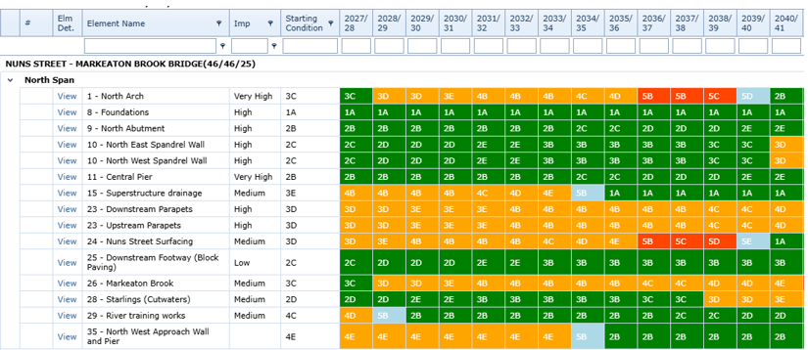

Traffic Signal Online System, is updated following each inspection with condition profile

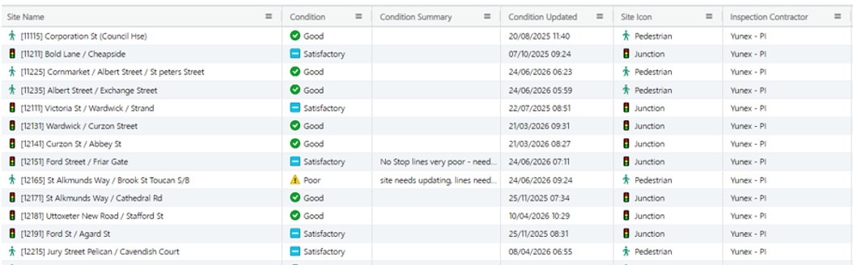

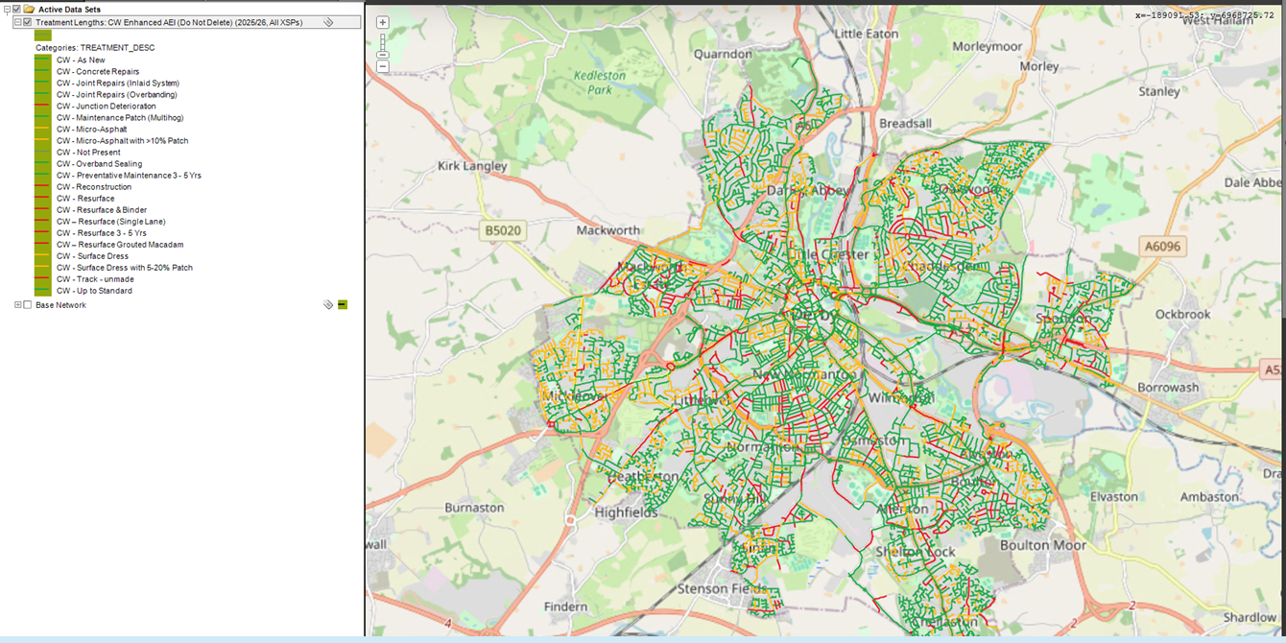
The Expert Assets (XA) system enables carriageway and footway network inventory data to be recorded, analysed and visualised as well as provide valuations and forward work programmes.

Mayrise, used for street lighting asset management also stores inventory by components, with full inspection, maintenance and electrical testing history.

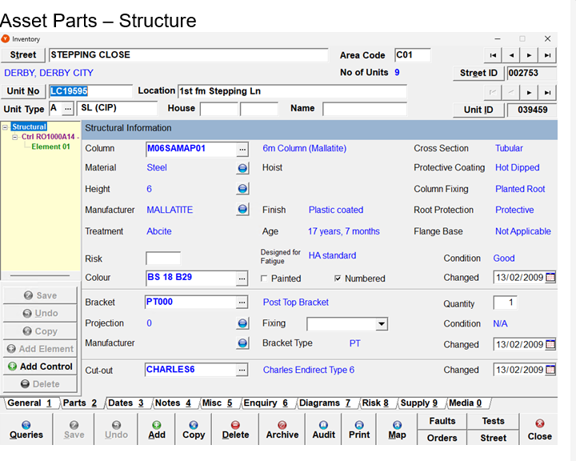

B5.4 – Lifecycle planning and investment decision-making
This section focuses on whether the authority uses lifecycle planning to inform maintenance investment decisions, rather than relying solely on reactive demand or short-term pressures.
ID | Question | Yes / No
5.4.1 | Do you use lifecycle plans for carriageways to support maintenance investment decisions? | Yes
5.4.2 | Do you use lifecycle plans for footways to support maintenance investment decisions? | Yes
5.4.3 | Do you use lifecycle plans for structures to support investment decisions? | Yes
B5.4.4 - Evidence Summary
Lifecycle planning helps us make informed decisions about how and when to maintain our roads and footways. It uses information about the condition of our network, how quickly different types of roads deteriorate, and how long different treatments are expected to last. This allows us to plan maintenance over the short, medium and long term, compare different investment options and understand the impact of different funding levels. By considering the whole life of an asset, rather than just its immediate condition, we can choose the most appropriate treatment at the right time, helping to extend asset life, manage costs and make the best use of available funding.

Using information also about the condition of each structure, its age, expected lifespan and the likely impact of different maintenance treatments allows us to plan inspections, maintenance, repairs and renewals over the short, medium and long term, while considering the risks and costs involved of each decision.

B5.5 – Performance monitoring and continuous improvement
This section focuses on whether the authority monitors the effectiveness of its asset management approach and uses performance information to inform ongoing investment and prioritisation decisions.
ID | Question | Answer
5.5.1 | Do you have a defined set of key performance indicators (KPIs) to monitor the outcomes of your highways asset management approach? | Yes
5.5.2 | Are these KPIs reviewed on a regular basis (at least annually)? | Yes
5.5.3 | Are KPI trends used to inform maintenance planning, prioritisation or changes to forward programmes or investment decisions? | Yes
5.5.4 | Have you conducted a value for money review or peer review of your service in the last 3 years | Yes
B5.5.5 - Evidence Summary
Data is collected and monitored for carriageway condition and skid resistance on the network, reported to Department for Transport annually. KPi’s are also measuring pothole response and repair times (monthly) and successfully funded third party claims (annually)

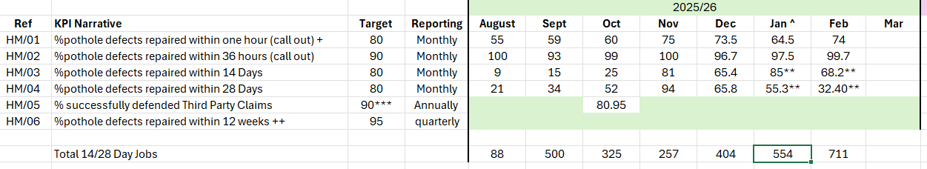

Through KPI monitoring, benchmarking with other local authorities and liaison with highway authorities, the inspection policy for managing potholes has been amended to reflect the need that while maintaining appropriate response times for safety-critical defects, more resource needed to be directed towards meeting permanent repairs response times.

To reduce repeat defects and reactive interventions, analysis of defect trends and repair performance has enabled greater emphasis to be placed on longer-term, preventative solutions, completing where possible larger scale patching ahead of preventative treatments which improve the durability of repairs and reduce the need for future reactive maintenance.

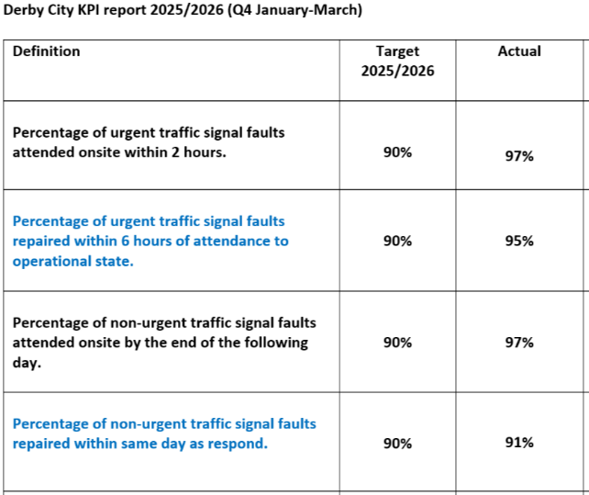
Our measurement of contractor performance in attending traffic signal faults within agreed response times is key to ensuring network reliability and safe highway operations.

Street lighting performance standards as part of the PFI are collected monthly with the contractor, measuring response times, fault rectification, lighting availability, and health and safety compliance.

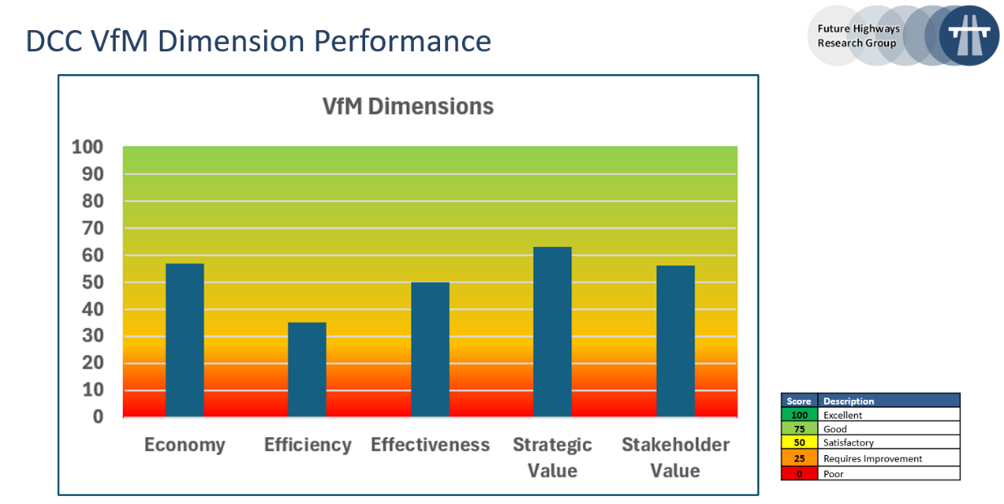
Derby City regularly complete peer reviews of the highway maintenance service, the most recent being June 2026. In partnership with EMCCA and the four constituent authorities, it identified opportunities for collaboration, service development and enhanced funding streams, particularly ahead of local government reorganisation.

B6 - Maintaining footways and cycleways
ID | Question | Answer
6.1.1 | Do you have a defined footway hierarchy (e.g. based on footway function and usage levels) that underpins a risk‑based approach to inspection frequencies and maintenance programmes? | Yes
6.1.2 | For 2026-27, please provide the length of footways that you have earmarked for structural maintenance / reconstruction / renewal | 3.2 km
6.1.3 | For 2026-27, please provide the length of footways that you have earmarked for preventative maintenance treatments | 8.1 km
6.1.4 | Are priority footways and cycleways included in your winter service (e.g. gritting or snow clearance), and in a routine programme for keeping them clear of overgrown vegetation and debris (e.g. sweeping, cutting back)? | Yes
6.1.5 | For 2026-27, are you planning to deliver structural or preventative maintenance to cycleways which is not yet covered as part of your carriageway maintenance programmes or footway maintenance programmes (e.g. segregated cycleways that are not shared with pedestrians or motorists). If yes, please set out the length of such cycleways that you have earmarked for: | No
 | - Structural maintenance / reconstruction (in km) | 0 km
 | - Preventative maintenance treatments (in km) | 0 km
B6.1.6 - Please provide any brief additional information you consider helpful in explaining your approach to maintaining footways and cycleways
We have six defined maintenance hierarchies for our footways, based on the current and anticipated levels of usage at each location across Derby. These hierarchies take account of local economic, social and accessibility factors to establish appropriate levels of service, inspection frequencies, maintenance treatments and response times. Maintenance priorities are determined using both condition data and a risk-based approach. We endeavour to include an annual footway preventative maintenance programme targeting routes and locations where early intervention can address emerging defects and slow deterioration. It also ensures that maintenance planning considers year-round service requirements, including winter service and routine cleansing and vegetation management whilst providing a positive customer experience.
B6.1.7 - Evidence Summary
Existing active travel routes across Derby are shown on the Active Travel Map Derby, 2021 https://www.cyclederby.co.uk/pages/cycle-routes-maps

We have started to review the existing active travel network and identify strategic improvements, which will be a refresh of the programme within the D2N2 Local Cycling and Walking Infrastructure Plan (LCWIP) key objectives being
- to increase walking and wheeled journeys, particularly walking journeys of up to 1km and cycling for journeys of up to 5km
- reduce congestion
- reduce carbon
- improve air quality
- enable healthier lifestyle and wellbeing
- better quality of life through improved accessibility to health and leisure.

B7 – Drainage
ID | Question | Answer
7.1.1 | Please provide an estimate of your drainage maintenance expenditure split (in percentages) between:
7.1.1 | - Reactive (incident- or failure-driven) maintenance | 85%
7.1.1 | - Planned maintenance (routine/cyclical and/or risk-based) | 15%
7.1.2 | Does your authority utilise a digital drainage management platform, covering asset inventory, inspection history, sensor data, and risk scoring? | Yes
7.1.3 | Do you maintain a record of locations where drainage issues are known to cause or contribute to carriageway deterioration or surface water ponding? | Yes
7.1.4 | Do you utilise smart sensors or other remote monitoring technologies to monitor performance of your drainage assets. If yes please provide some high level information in bullet points below | No
 | Guidance – This is space for additional information on sensors/technologies for remote monitoring – please list technologies used in bullet form, including approximate number of installations.
B7.1.5 - Evidence Summary
While around 85% of the drainage maintenance expenditure is reactive, we invest £0.2 million each year in drainage condition surveys. These surveys focus on key routes, with locations selected based on risk. As the drainage network is ageing, the surveys help us identify and address issues before they develop into flooding or more serious problems. This means that much of the drainage programme is driven by the findings of these surveys, allowing us to target investment where it is most needed and manage the condition of the network more effectively.
The Council does have a list of locations that are prone to flooding, and we use this to proactively undertake cyclical maintenance work on a frequent basis, and on ad hoc occasions before forecast severe weather.
B7.1.6 – Further context on approach to drainage asset management
Drainage asset management is focussed on improving safety and availability of the highway network. Condition surveys drive the investment programme, so we are making investment decisions based on current data and on a risk-based approach.

It is feasible to survey some asset types annually or more frequently (e.g. pumping stations, trash screens, flood defences, etc), some asset types on a planned cyclical basis (e.g. petrol interceptors on a three-year cycle) but some assets such as underground highway drains must be surveyed on a risk-based approach, according to defined criteria due to the size of that asset and the complexity of gathering condition data.

B8 – Skills and training
ID | Question | Answer
8.1.1 | Do you have an up-to-date training and development plan for those responsible for highways asset management in your authority? | Yes
8.1.2 | Do you or your main highways contractors support professional development through a recognised professional training scheme (e.g. Institution of Civil Engineers (ICE) or Institution of Highway Engineers (IHE))? | Yes
8.1.3 | Does your authority contribute towards the cost of professional membership or professional development required for relevant highways roles? | Yes
8.1.4 | Do you employ a professionally qualified engineer (e.g. Chartered Engineer (CEng) or equivalent competence) with responsibility for the management of highway structures (either in house or through a contracted arrangement)? | Yes
8.1.5 | Does your authority define competence requirements for key highways asset management roles and take steps to address any identified gaps (either directly or through contractual arrangements)? | Yes
8.1.6 | Do you or your main contractors support early career development in your local area, for example through apprentice schemes, traineeships or pre-apprenticeship programmes, sponsored qualifications (e.g. HNC/HND, degree, MSc), graduate schemes etc | Yes
B8.1.7 - Evidence Summary
Great Performance Conversations are held with all new employees and identifies initial training requirements. Our Technicians and Highway Inspectors have development action plans to ensure compliance and accreditation to manage our Highway Network through our cyclical inspection regime.

Individual competency records for all Highways colleagues are maintained and updated regularly and any skills gaps addressed.

Examples of specific training:

- IHE Winter Decision Making to enable interventions for treating ice and snow.
- Highway Safety Inspector Modular Training (LANTRA and IHE approved)
New Roads & Street Works Act Training (NRSWA).
- RSTA CPD courses for Surface Dressing and Micro Surfacing.
- Shadow condition surveys to understand the Engineer’s and Contractor’s judgement.
- IHE Traffic Signal Control course.

B8.1.8 – Further context on skills/training (optional)
We support university students by providing work placements that enable them to gain valuable practical experience alongside their academic studies. These placements give students the opportunity to apply their knowledge in a real-world setting, develop relevant skills, and contribute to research that can support their dissertations and wider academic work.
Equally, mentoring opportunities with contractors and professionals across the supply chain provide technicians with valuable insights, practical knowledge, and industry experience that can often be difficult to retain within a local government environment. These relationships help us develop a deeper understanding of how projects are delivered in practice, including the challenges, processes, commercial considerations, and collaborative opportunities available.

B9 – Adapting roads to withstand climate pressures
Climate and environmental factors, such as heavy rainfall, prolonged heat, and freeze-thaw cycles, are integral to effective highways asset management, as they influence asset performance, deterioration rates and long-term resilience. Understanding both the impacts of a changing climate and the carbon implications of maintenance activities supports better decision-making, helping authorities to optimise durability, manage risk and deliver best whole life value from their assets.
ID | Question | Yes/no
9.1.1 | Have you updated your asset management policy and strategy to reflect the increased probability of extreme-weather and/or geohazards now and in the future? | Yes
9.1.2 | Have you identified your resilient network and agree this with senior decision-makers | Yes
9.1.3 | If yes when did you last update this. | 2024  and due again autumn 2026
9.1.4 | Have you identified locations that are repeatedly affected by extreme weather (e.g. flooding, heat damage, storms)? | Yes
9.1.5 | Which climate-adaptation measures are currently implemented on your network?
 | - Targeted drainage upgrades or maintenance | Yes
 | - Natural flood management / SuDS | Yes
 | - targeted slope / ground stability / landslip mitigation | No
 | - Heat-resilient materials or surface treatments | Yes
 | - Tree planting / shading for heat management | Yes
 | - Other (please specify)  - Our City Our River (OCOR), Derby's flood alleviation project, led by Derby City Council in partnership with the Environment Agency @ £161m  https://www.derby.gov.uk/environment-and-planning/regeneration-and-economic-growth/our-city-our-river/our-city-our-river-project-overview/ | Yes
 | - None of the above | N/A
9.1.6 | Have you measured and benchmarked the greenhouse gas emissions from your highways maintenance service using a recognised industry standard? Or do you have arrangements in place to do this, such as by signing up to the DfT funded ADEPT Carbon Leadership Programme. | Yes
9.1.7 | Have you formally engaged with the DfT funded ADEPT live labs 2 Programme, to understand what lessons your authority can utilise to increase the efficiency of your operations and support decarbonisation efforts? | No
B9.1.8 - Evidence Summary
Through the introduction of a Network & Assets focus group data is collated to understand the most vulnerable parts of our network during severe weather events (eg Storm Babet). For example location subject to flooding are contained in the Flood Response Framework document on Resilience Direct.
Our Integrated Urban Drainage model has identified areas at risk of surface water flooding on the network. The model considers an additional intensity of storm event to assess for the impacts of climate change. This forms part of the risk-based assessment and prioritisation of works in the highway drainage programming, but it is only one of the criteria used to prioritise works.
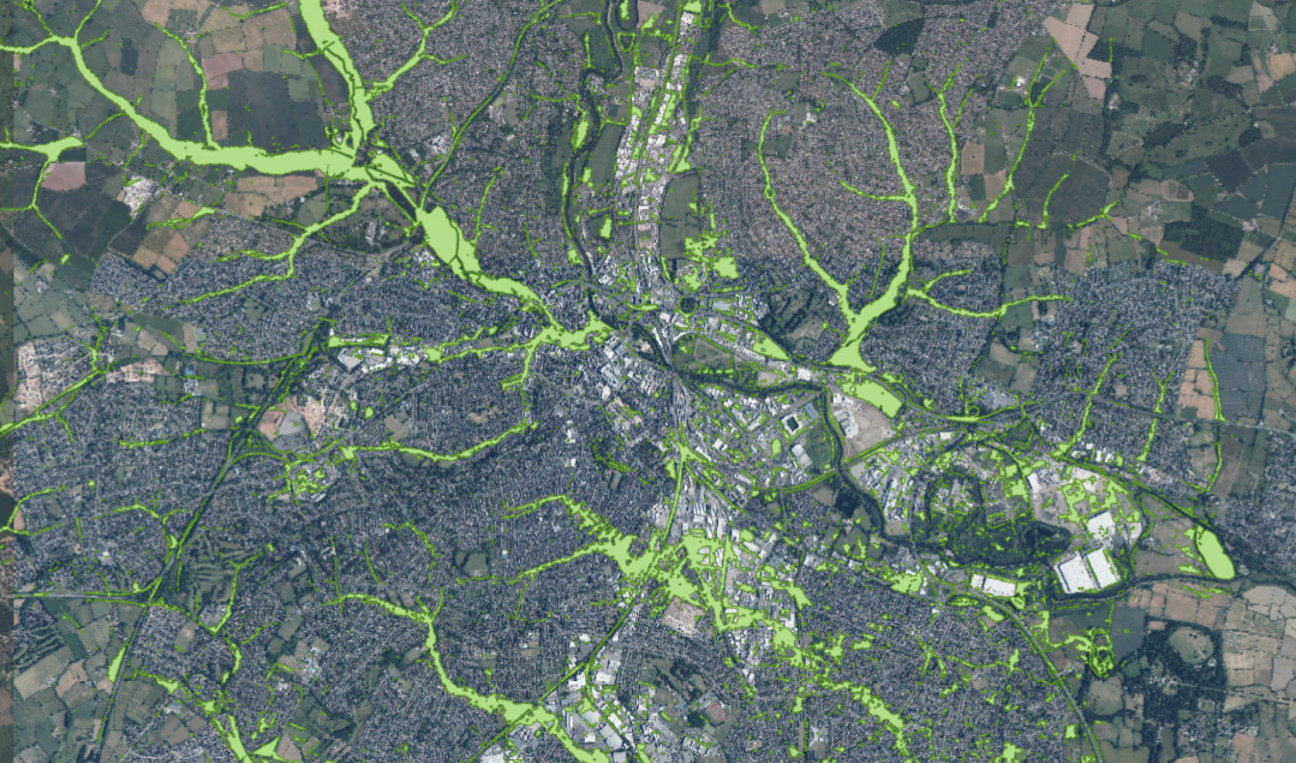
Extract from Derby City Council’s Integrated Urban Drainage model

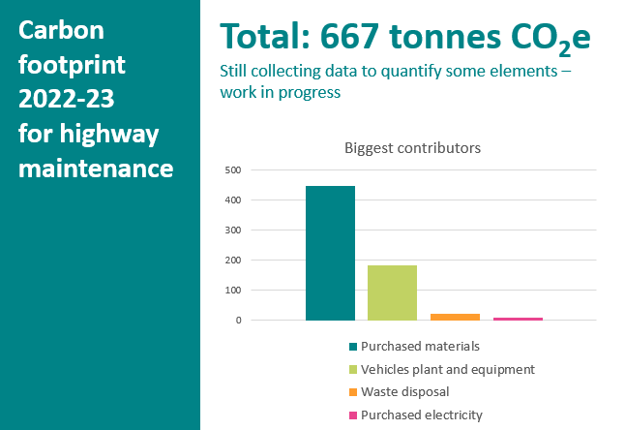
We completed an assessment of the highways maintenance service operational carbon based on the Greenhouse Gas Protocol and “Guidance for the Application of GHG Scope 1&2 in Local Authorities” (2022)
Guidance for the Application of GHG Scope 1 & 2 in Local Highways Authorities | ADEPT

A workshop followed with key supply chain partners to help understand their contribution and obligation towards reducing carbon emissions and to identify what products / processes they had that could help the authority.
B9.1.9 - Further context on your adaptation / resilience activities
Alongside physical adaptation, we are considering the environmental impacts of delivering highway services. The operational carbon assessment and subsequent engagement with supply chain partners are helping us identify opportunities to reduce emissions through changes to materials, construction methods, maintenance practices and procurement. This supports a combined approach to adaptation and mitigation, ensuring that investment in maintaining a resilient highway network also contributes to our wider carbon reduction objectives.

B10 – Innovation
ID | Question | Yes / No
10.1.1 | Do your procurement and contracting approaches encourage and reward innovative practice? | Yes
10.1.2 | Can you demonstrate that innovative materials and practices are regularly reviewed and, where appropriate, integrated into business as usual operations? | Yes
10.1.3 | If you have conducted innovation trials, have you shared the findings of these publicly or with professional networks? | Yes
10.1.4 - Evidence Summary
- When offering tender opportunities or establishing new frameworks, Derby City Council encourages suppliers to propose innovative solutions that meet the Council’s requirements. Where appropriate, innovation is recognised and rewarded through the evaluation process, with tender criteria designed to assess the added value, effectiveness and deliverability of proposed solutions.

- Derby City Council leads the LASR Approach, a risk-based methodology for prioritising skid resistance maintenance on local roads. https://www.lasr-approach.org/
Developed through research with 18 authorities from 2020–21, it uses local data and conditions to support proportionate decisions, focusing on those locations that present the greatest safety risk.

- It is now actively being used by several authorities alongside adopted approaches to illustrate a more risk-based approach to interventions. As part of the Road Safety Trust research grant requirements, the findings were widely disseminated at conferences, CPD events and through Highways Magazine etc. It is now being included in the revised Well Managed Highway Infrastructure Code of Practice 2026 as an example of best practice and innovation.

B10.1.5 - Further context on your innovation activities
- The LASR research and implementation draw on collision data as a key part of the risk assessment, but there are challenges associated with the sparse nature of this data. Crowdsourced data derived from braking events experienced by users of the road network is becoming increasingly available and practical to source and can be processed to support local authority skid resistance policies. strengthening the evidence base for decisions and reducing the need for subjective judgements of risk. This is an extension of the existing research and will be considered to further enhance the approach.

- Options for drone technology are now being considered for culverts and bridge inspections. Managing key structural assets, for example the Cathedral Swingbridge with remote sensors, will also allow a more in-depth understanding of thermal movement and deformation to ensure right intervention is completed at an optimum time.

10.2 – Examples of innovations that have been adopted
We have adopted in-situ recycling as a core element of our maintenance programme, recognising its ability to deliver significant environmental and operational benefits. Following the successful delivery of our first in-situ recycling scheme on Lime Lane in 2024 Derby City, Lime Lane - Deep in-situ recycling - Stabilised Pavements Ltd. A further scheme was completed in 2025, demonstrating the effectiveness of this approach in extending pavement life, while reducing material use, waste, and vehicle movements.

Building on this, our 2026/27 programme includes additional sites where we will trial an innovative design that replaces the traditional cement binder with calcined clay. This alternative binder has the potential to further reduce embodied carbon, while maintaining the required engineering performance, supporting our commitment to lower-carbon highway maintenance and continuous innovation.

The technique overall has been received favourably by local communities and elected members. Completed schemes from Derby are also being showcased by the contractor nationally, as best practice highlighting the quality and effectiveness of the Council’s asset management approach.

Through our ongoing engagement with our preventative maintenance contractors, we have regularly reviewed a range of products and treatments and assessed their effectiveness and suitability for our urban network.

We have recently adopted a specially designed Hybrid Microsurfacing treatment, which has been designed to provide an enhanced surface compared to traditional Micro Asphalt products on the market. https://kielybros.co.uk/services/carriageway-solutions/hybrid-micro/

Key benefits include an increased texture depth, increased resistance to delamination and fibre enhanced durability, that better withstands vehicle stress and extreme weather events increase skid resistance and overall durability. We will complete 36 locations in 2026, spanning three different maintenance hierarchy road types.

Our continued drive to improve our range of techniques strengthens our commitment to delivering sustainable programmes that perform more effectively against the challenges our network faces from climate change and increasing traffic levels.

B11 – Working with utility companies to reduce disruption to road users
ID | Question | Yes / No
11.1.1 | Do you routinely monitor and enforce utility works quality as part of your streetworks management? | Yes
11.1.2 | Have you undertaken a senior‑endorsed assessment of whether a lane rental scheme would be suitable for your area? | No
11.1.3 | Do you seek input from utility companies when determining your highways maintenance programme to help reduce disruption? | Yes
11.1.4 | Have you conducted and published a permit scheme evaluation within the last three years? | No
11.1.5 | Have you conducted a traffic sensitive review in the last three years? | Yes
11.1.6 - Evidence Summary
We aim to sample at least 20% of all utility works each quarter across categories A, B and C to ensure that reinstatements comply with the required standards and are completed in accordance with the relevant permit scheme requirements.
Inspections are carried out to assess the standard of workmanship, compliance with specification, and the long-term integrity of the reinstatement. Where defects or areas of non-compliance are identified, these are formally raised with the relevant utility company or contractor through the permit scheme process. Progress is then monitored to ensure that all remedial work is completed within the required timescales and to the appropriate standard.

We are exploring a standardised lane rental scheme across the region, including the potential benefits of a consistent approach for EMCCA and its member authorities.
Planned utility works form an integral part of our coordination process, enabling us to identify conflicts, opportunities for collaboration and align programmes where practicable. Having Streetworks and Highway Asset Management in one team provides greater visibility of planned works, supporting early engagement, strong relationships with utilities and reduced disruption for communities.
We have not published a permit scheme evaluation within the last three years. However, ongoing monitoring indicates that the scheme continues to meet its objectives. We report regularly to the local coordination group.
B11.1.7 - Further context
We hold regular coordination meetings and share long term programmes to identify opportunities for collaboration, the aim to prevent newly treated roads needing to be dug up in the near future. We meet with internal teams, National Highways, Derbyshire County Council, and all the main utilities.
A recent good example of coordination was identifying a major project Cadent Gas had on Kedleston Road, which also featured on our resurfacing programme. We coordinated their work in 2025 alongside National Grid, renewing the infrastructure and clearing the way for our resurfacing to take place in 2026. Discussions were also held with developers and other asset owners to ascertain possible work in the vicinity.

B12 – Managing highways maintenance contracts effectively
Only answer this sections if you utilise a contractor to deliver any of your carriageway maintenance operations, including: structural maintenance, planned repairs / patching, or reactive repairs / patching
ID | Question | Yes / No
12.1.1 | Does your authority retain in‑house technical capability to independently assess maintenance interventions proposed by contractors? | Yes  (please specify in further context)
12.1.2 | Do you routinely analyse actual unit costs (for example £/m² of road surface treatments, or £/pothole repair) for core highways maintenance activities delivered under contract and compare them against benchmarks or historic performance? | No
12.1.3 | Do you have defined KPIs for your highways maintenance contract(s), and are they actively monitored by your authority to manage performance? | Yes
12.1.4 | If reactive pothole repairs are delivered by a contractor, do your contracting arrangements incentivise single‑visit permanent repairs where it is safe and appropriate to do so? | No
12.1.5 - Evidence Summary
12.1.1
Derby City Council retains in-house technical capability through its Engineering Design Services team to independently assess and review maintenance interventions proposed by contractors. The team has appropriately qualified and experienced engineering staff with knowledge of highway design, construction, maintenance and asset management. This enables the Council to provide independent technical challenge, review proposed solutions, assess their suitability and consider alternative interventions where appropriate. Specialist external technical support may be commissioned where the required expertise or capacity is not available in-house. The level of independent assessment undertaken is proportionate to the nature, complexity and risk associated with the proposed intervention.

B12.1.6 - Further context
12.1.3
We maintain a comprehensive contract register, which captures key performance data, lessons learned, actions and outcomes from each individual contracts. This information is collated and analysed to identify recurring issues, successful approaches and opportunities for improvement.

We hold end-of-year performance meetings with all of our framework contractors to review delivery against the agreed Key Performance Indicators (KPIs), contractual requirements and wider service expectations. These meetings provide a structured opportunity to assess performance, recognise good practice and identify any areas requiring improvement or further intervention.

This forms part of our proactive approach to actively managing highways contracts throughout their lifecycle. Performance information is reviewed regularly, enabling emerging issues to be identified early and addressed through agreed corrective actions, rather than waiting until problems become embedded. Contractor performance is considered alongside programme, quality, health and safety, customer satisfaction, environmental performance and financial management to provide a balanced assessment of delivery.

