 | Team | Highways Maintenance
 | Contact | Highways Tech Support
 | Our ref
Name  Address | Email | maintenance.highways@derby.gov.uk
Name  Address | Tel | 01332 640676
Name  Address | Date

Dear

Vehicular Access Application – Construction by private contractor.

Thank you for your enquiry regarding the above. I enclose an information pack to help you.

The construction of the access must be to the enclosed standards and specification of the City Council (Appendix A). A £175.00 non-refundable approval charge is levied by the Authority.

The application process for constructing a vehicular access – what you need to do

Please read the enclosed application pack before completing the application.

The following will need to be completed as part of the application process:

- Obtain quotations from private contractors, who must have £5 million Public Liability Insurance in place, for your vehicular access to be constructed in accordance with the City Council standards. A copy of their Public Liability insurance must be sent alongside.

- Send us colour copies of all correspondence you receive from the utilities as a result of serving the 29 day notice of proposed work. Please note: these responses are only valid for three months. This means that the construction of the vehicular access once approved must be completed within a three month period.

- Send us a copy of your contractor’s accredited Street Work Qualifications Register (SWQR) card. We need to have a copy of both the front and back of the card(s) and the contractor needs to have both the ‘Supervisors’ and ‘Operatives’ Qualification. Please ensure that these cards are still valid as they do have an expiration date. The contractors whose cards are provided alongside this application must be of those carrying out the work. The Highway Inspector will inspect on the day of the construction of the access and
if contractors on site do not match SWQR cards provided with the application then Derby City Council reserve the right to stop any works within the Highway.

- Provide a detailed drawing of the proposed location of the vehicular access in relation to the driveway and property. The drawing must include length and width measurements. Do not attempt to carry out more works than proposed. Any approval received is for the proposed works only. If additional work is carried out then Derby City Council reserve the right to stop any works on the Highway.

- Provide proposed traffic management/pedestrian management plans for the work. As the work will obstruct the footway the contractor must make alternative provisions for pedestrians and the work area must be guarded with the use of barriers and cones. We need to see a plan of these proposed provisions. Please note: diverting pedestrians onto the opposite side of the road is not acceptable. An alternate walkway must be provided. If you do not feel this is achievable then please contact our roadworks team at roadworks@derby.gov.uk.

- Obtain and send us proof of any approval(s) required from other departments and organisations to complete the work i.e. planning, trees, street lighting etc.

- Proof of guarantee for the works (minimum of 2 years)

Once the above has been done, please return all documents alongside the completed and signed Appendix C - Application for a domestic vehicular crossing to be constructed by private contractors.

The approval charge of £175.00 (non-refundable) will need to be paid in advance by Credit or Debit Card. Please telephone 0333 200 6981 quoting the reference at the front of this pack. Alternatively, you can make payment on the Derby City Council website; please visit www.derby.gov.uk and search for ‘Pay it’ which will direct you to our online payment service. Please select the option for ‘Private Vehicle Crossing applications’.

Please note: no work is to take place until you have received written permission from Derby City Council.

Yours sincerely

Asset Management Team
Highways Maintenance

Domestic Vehicular Access Application Pack
Section 184 Agreement – Highways Act 1980

Important notice

To all developers planning to work within the highway.

Construction of Vehicular Access and similar works within the highway by developers.

Section 184: Highways Act 1980

Section 86: New Roads and Street Works Act 1991

Section 184 of the Highways Act allows the highway authority (i.e. Derby City Council) to give permission for works to be undertaken by a developer. This permission under Section 184 (9) places all the responsibilities of the highway authority on the developer. This not only means that the works must be insured, maintained in a safe condition and adequately signed and guarded, but the developer must comply with all the requirements of the New Roads and Street Works Act (NRSWA). Failure to comply with NRSWA can result in substantial damage being done and large financial claims against the developer.

It is the developers’ responsibility to make enquiries of all the Statutory Undertakers to determine the position of their apparatus and determine the need and cost of any diversion/protection works. For small domestic vehicular crossings, it is often not necessary for Undertakers apparatus, e.g. electricity, water, telephone, gas and cable communication, to be diverted or protected but for larger works, it could potentially be the case. Developers must tell the Undertakers that they will be working in the highways by virtue of permission given under Section 184(9) of the Highways Act 1980.

Appendix A

Derby City Council

City Sustainability - Highways Maintenance

Domestic vehicular crossings – Specifications

- General

  - Kerbing

Kerbs are to be of precast concrete, hydraulically pressed, from an approved maker, laid on a 150mm (6”) bed, 350mm (14”) wide and backed with 150mm (6”) concrete Class ST1.

Kerbs to the crossing are to be 125mm (5”) x 150mm (6”) drop kerbs with a single taper kerb (250mm 10”) to 150mm (6”) high) each side.

All existing kerbs together with the concrete backing are to be taken up and removed.

  - Edging

Precast concrete edging 50mm (2”) x 150mm (6”) to be provided to separate the vehicular crossing from the verge, if appropriate. The edging to be laid on a 50mm (2”) bed, 350mm (14”) wide and backed with 100mm (4”) of concrete Class ST1.

  - Dimensions

The dimensions of the crossing vary according to the width of the existing footway and must be as indicated on the construction drawing.

- New Construction

  - The existing materials are to be replaced with the following:

- Granular sub-base Type 1 laid to a consolidated thickness of 150mm (6”)
- Open graded base course macadam 20mm (7/8”) nominal size aggregate to BS4987:1993, Section 2.6.1 laid and rolled to a consolidated thickness of 45mm.
- Dense macadam wearing course, 6mm (¼”) nominal size aggregate (excluding limestone) to BS4987:1993, Section 2.7.4 laid and rolled to a consolidated minimum thickness of 20mm.

- General Conditions

3.1 Planning permission

There are two types of planning permission that may be required for constructing a driveway and vehicular access:

- Construction of the vehicle access on the highway
Other than for minor estate roads, planning permission may be required before vehicular accesses are constructed, and you should contact the Planning Development Control Team to obtain the necessary permission.

- Construction of hard standing/driveway
Planning permission will be required for the hard surfacing of any area exceeding five square metres that is proposed between the front elevation of the dwelling and the highway, if the proposed hard surfacing will be non-porous and the rainwater will not be directed into a permeable or porous soak-away within the curtilage of the property.

For further advice, please visit; www.planningportal.co.uk and search for ‘Paving your front garden’ or alternatively contact Derby City Council’s Planning Division via telephone on 01332 640795, or email at developmentcontrol@derby.gov.uk.

Planning permission must be obtained before submitting your application to us. Proof of planning permission approval must be supplied alongside your application.

3.2 Street Works Qualifications

A suitable qualified person, accredited via the Street Work Qualification Register (SWQR) in the type of work being undertaken, must always supervise the work and at least one operative who must be accredited via SWQR.

Please provide copy of Supervisors and Operatives accreditation with this application. The contractors whose cards are provided alongside this application must be of those carrying out the work.

The licensee shall ensure that he or any contractor employed by him shall comply with all relevant conditions of the NRSWA 1991 including the relevant Codes of Practice.

3.3 NRSWA 1991 – Road opening notices and permit applications.

All works carried on the highway must have a road opening notice, and all work carried out on permitted roads must also have a permit. Derby City Council will submit these on the behalf of all applicants. The following is therefore required as part of the application process:
- A traffic management/pedestrian management plan of the works area submitted alongside the application and other supporting documentation.
- A proposed start date.
- Estimated duration of works/proposed end date
- Once approval for the works to go ahead has been received from us, we require notification of the date that the works will commence, to be received in our office at least 7 days in advance of works start, to allow us to update the road opening notice. If the commencement date changes due to unforeseen circumstances, please let us know as soon as possible.
- Once work has finished, we require notification of works completion date as soon as possible so that the road opening notice can be closed.

3.4 Safety Precautions

All works will be properly signed and guarded in accordance with Chapter 8 of the Traffic Signal Manual, the Health and Safety at Work Act 1974, and all other Health and Safety legislation and Codes of Practice. The City Council shall be indemnified against all claims or accidents that may arise during the progress of the works, whether third party or otherwise.

3.5 Statutory Undertaker 29-day notice

You must serve 29-day notice on the Public Utilities, i.e., gas, water, electricity, telephone, and cable communications authorities to determine whether their apparatus could be affected and the cost of any diversion or protection works. Any responses received are only valid for three months so construction of the access once approved must commence within that three-month period. If this period is exceeded the 29-day notice must be served to the Statutory undertakers again. A list of all the companies you must contact, and their contact details are contained in the application pack enclosed with this letter (Appendix B). Please note: some utility companies charge for this service which they will notify you of at the time of contact. The notice must still be served, and proof supplied with your application.

3.6 Guarantees.

The applicant is responsible for guaranteeing the works for 2 (two) years and for any damage to the highway or utility apparatus, and any claims due to an incident caused by the works.

3.7 Construction of Hard standing including size, position and levels.

Please ensure that the hard standing driveway is constructed before the vehicular access. A newly constructed vehicle access can be damaged by building works during construction of the hard standing and also by vehicle override if not supported by a hard standing.

A car of any size should be able to fit onto the driveway, without the risk of overhanging onto the highway, the measurements of a hardstanding should be a minimum of 4.8m length and 2.4m width. If the parking space is in front of a door or garage, then the length increases to 6m for fire safety reasons.

The hardstanding should be positioned so that the car parks length ways, at a 90 degrees angle from the highway (see below diagram). We do not allow vehicle crossings for driveways that require the car to park parallel to the highway, unless the driveway is of a size that allows the vehicle to drive on and off at a 90 degrees angle, in a single, safe manoeuvre. Repetitive backwards and forwards manoeuvres on the footway to access a parallel parking position will not be acceptable.

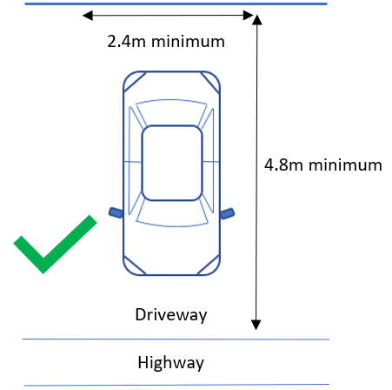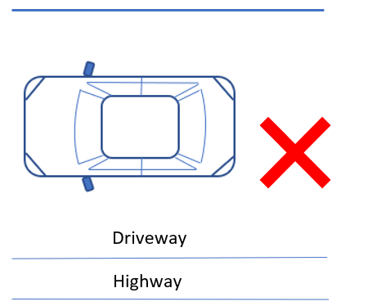

If the levels of the hardstanding change so that they no longer meet the level of the footway, then this is an issue that is to be rectified on the private boundary side. No adjustments are to be made to the highway levels. Ramps on the footway constitute a hazard to pedestrians and are therefore unacceptable.

Driveway gates are not permitted to open out onto the highway. They must open inwards towards the property.

We consider stone/gravel driveways to be unacceptable, due to the gravel dispersing onto the highway from vehicles entering and exiting the driveway. Stone gravel deposits are a hazard to highway users.
3.8 Damage to Highway.

When the construction is carried out by a contractor, any damage to the highway shall be rectified to the satisfaction of, and at no extra expense to, the City Council.

3.9 Highway Drainage.

When the construction is carried out by a contractor, any damage to the highway drainage shall be rectified to the satisfaction of, and at no extra expense to the City Council.

3.10 Crossing over Open Ditches.

Any ditch under the new crossing shall be piped with approved pipes of a suitable size and to approved levels and surrounded with 150mm (6”) of Class ST1 concrete. End of pipes must be incorporated into headwalls.

3.11 Street Lighting.

Construction of vehicular access must be a minimum of one metre away from any street lighting columns. If there is a street lighting column within close proximity of the proposed crossing, then this will have to be taken in to consideration as we must ensure the protection of the asset. This could lead to the request for a crossing being refused.

3.12 Highway trees.

If a highway tree is near the proposed vehicular access, advice must be sought from Derby City Council Arboricultural officers before submitting your application to us. This is to avoid causing damage to the tree and its root system by the construction of a vehicular access. This could lead to the request for a crossing being refused.
Any damage to highway trees shall result in costs of the asset being recovered by Derby City Council.

Please contact our Arboricultural team at trees@derby.gov.uk to seek advice or get approval.

3.13 Derby Homes properties.

To install a dropped kerb at a Derby Homes property, permission must be sought from Derby Homes before submitting this application.

Please contact Derby Homes at contactus@derbyhomes.org to get advice or approval before submitting this application to us.

4. Conservation Areas

In conservation areas, the applicant must inform the Planning Development Control Team of the proposal.

In conservation and similar areas, natural materials must always be used to match existing, for example, sandstone kerbs should be replaced by sandstone kerbs and not concrete or granite kerbs. Where natural materials exist then the applicant must contact the Planning Development Control Team for specific instructions.

For further advice please visit: www.derby.gov.uk and search ‘conservation’

Appendix B

List of Public Utilities - NB. By law 29 days written notice must be given to Public Utilities

Severn Trent Water LTD  Asset Protection East  Gorse Hill  Anstey  Leicester  LE7 7GU  Tel: 01162 343834  Email: net.dev.east@severntrent.co.uk  Web: https://utilities.digdat.co.uk/Account/register.aspx | Openreach  National Notice Handling Centre  Stoke Telecom House  Post Point 3WW18  Trinity Street, Hanley  Stoke on Trent ST1 5ND  Email: nnhc@openreach.co.uk  Web: https://www.openreach.com/building-developers-and-projects/locating-our-network/
Virgin Media  National Plant Enquiries  Unit12 Mayfair Business Park  Broad Lane  Bradford  BD4 8PW  Tel: 0870 888 3116 Option 2  Web: https://utilities.digdat.co.uk/Account/register.aspx | Vodafone  C/O Atkins OSM Plant Enquiry Team  The Hub  500 Park Avenue  Aztec West  Bristol BS32 4RZ  Tel: 01454 662881  Email: osm.enquiries@atkinsglobal.com
Cadent Gas  Hinckley Operations Centre  Brick Kiln Street  Hinckley  Leicestershire  LE10 0NA  Tel: 0800 688 588  Email: plantprotection@cadentgas.com | Balfour Beatty Living Places  Street Lighting PFI Division  Units 8-10 Sandown Industrial Park  Gosforth Road  Derby  DE24 8HU  Tel: 01332 715002  Email: lightingderby@bblivingplaces.com
National Grid Electricity Distribution  Mapping Centre  Toll End Road  Tipton  DY4 OHH  Tel: 0121 623 9780  Email: NGED.MapResponse@NationalGrid.co.uk  GTC  Synergy House  Woolpit Business Park  Woolpit  Bury St Edmunds, Suffolk  IP30 9UP  Web: www.gtc-uk.co.uk  Email: plantenquiries@gtc-uk.co.uk | K Com Group PLC  Network Engineering Centre  Vulcan Street  Hull, East Yorkshire  HU6 7PS  Tel: 01482 603479  E-mail: highwaysadmin@kcom.com  City Fibre  15 Bedford Street  London  WC2E 9HE  Tel: 0333 150 7282  E-mail: asset.team@cityfibre.com

Please Note: this list is not exhaustive. Derby City Council cannot be held liable for accuracy or completeness of this list.
Enquiry No.

Appendix C

Application for a domestic vehicular crossing to be constructed by private contractors.

I hereby apply for permission to construct a Domestic Vehicular Access at:

1) Contractor

This work will be undertaken by:

Contractor name:

Contractor address:

Telephone No:

The private contractor has £5 million Public Liability Insurance (copy of which is enclosed with application); all the work will be carried out to the dimensions and standards of the City Council’s requirements within a three-month period.

2) Planning Permission

- I have approached the Planning Division and they have confirmed that:

Planning permission IS required ☐ Complete question 2b)

Planning permission IS NOT required ☐ Continue to question 3)

- I have received planning permission for the vehicular access and the reference is:

3) 29-day notice to Public Utilities

I have served 29-day notice to all the Public Utilities listed in Appendix B of the application pack and they have confirmed that:

a) They have no objections ☐

b) Works will need to be undertaken prior to construction of the vehicular access ☐

Details of these works are as follows (Please include dates):

4) Information for Road Opening Notice and Permit application.

I have enclosed a traffic management/pedestrian management plan. ☐

The estimated start date of the works, pending road opening notice and permit approval:

The estimated duration of works (number of days):

5) Supporting information tick list.

I confirm that the following is enclosed herewith:

- Copy of private contractor’s public liability insurance (Minimum £5 million) | ☐
- Copy of Private contractors Streetworks Qualification card(s)  (Supervisors and Operatives qualification/ Front and back of card(s)).  Please note: The contractors whose cards are provided alongside this application must be of those carrying out the work. | ☐
- All correspondence (colour copies) received from Public Utilities in response to 29 day written notice. | ☐
- Detailed plan/drawing/sketch of the proposed location of the vehicular access, driveway and property (including measurements) | ☐
- Plan detailing the proposed traffic management/pedestrian management to be used during construction of the vehicular access (Please Note: Your contractor  being Streetworks qualified will be able to assist with this) | ☐
- Proof of guarantee for the works (minimum of two years) | ☐
- Proof of any necessary approvals, permissions required (trees, street lighting, Derby Homes, property owner etc.) | ☐

Please Note: Applications will not be processed until all the above supporting information has been received in our office.

6) Payment

I confirm I have made payment of approval charge £175.00. ☐

My payment reference is:

7) Applicant details and declaration

I will give one week’s written notice once permission has been granted to the City Council’s City Sustainability Directorate before I commence work and again written notice when the work is complete.

Signed

Name (Block capitals)

Address

Telephone Number Date

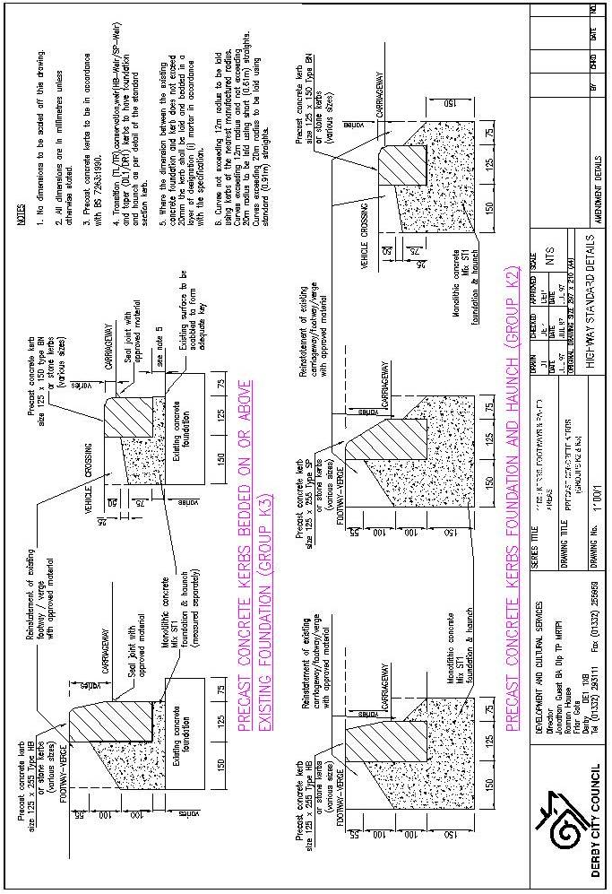
We can give you this information in any other way, style or language that will help you access it. Please contact us on 01332 641499 or derby.gov.uk/signing-service/

Punjabi
ਇਹ ਜਾਣਕਾਰੀ ਅਸੀਂ ਤੁਹਾਨੂੰ ਕਿਸੇ ਵੀ ਹੋਰ ਤਰੀਕੇ ਨਾਲ, ਕਿਸੇ ਵੀ ਹੋਰ ਰੂਪ ਜਾਂ ਬੋਲੀ ਵਿੱਚ ਦੇ ਸਕਦੇ ਹਾਂ, ਜਿਹੜੀ ਇਸ ਤੱਕ ਪਹੁੰਚ ਕਰਨ ਵਿੱਚ ਤੁਹਾਡੀ ਸਹਾਇਤਾ ਕਰ ਸਕਦੀ ਹੋਵੇ। ਕਿਰਪਾ ਕਰਕੇ ਸਾਡੇ ਨਾਲ ਇੱਥੇ ਸੰਪਰਕ ਕਰੋ: 01332 641499 ਜਾਂ derby.gov.uk/signing-service/

Polish
Aby ułatwić Państwu dostęp do tych informacji, możemy je Państwu przekazać w innym formacie, stylu lub języku. Prosimy o kontakt: 01332 641499 lub derby.gov.uk/signing-service/

Slovak
Túto informáciu vám môžeme poskytnúť iným spôsobom, štýlom alebo v inom jazyku, ktorý vám pomôže k jej sprístupneniu. Prosím, kontaktujte nás na tel. č.: 01332 641499 alebo na stránke derby.gov.uk/signing-service/

Urdu
یہ معلومات ہم آپ کو کسی دیگر ایسے طریقے، انداز اور زبان میں مہیا کر سکتے ہیں جو اس تک رسائی میں آپ کی مدد کرے۔ براہ کرم 641499 01332 یا derby.gov.uk/signing-service/ پر ہم سے رابطہ کریں


Derby City Council
The Council House Corporation Street Derby DE1 2FS
www.derby.gov.uk

