Derby Safeguarding Adults Board and
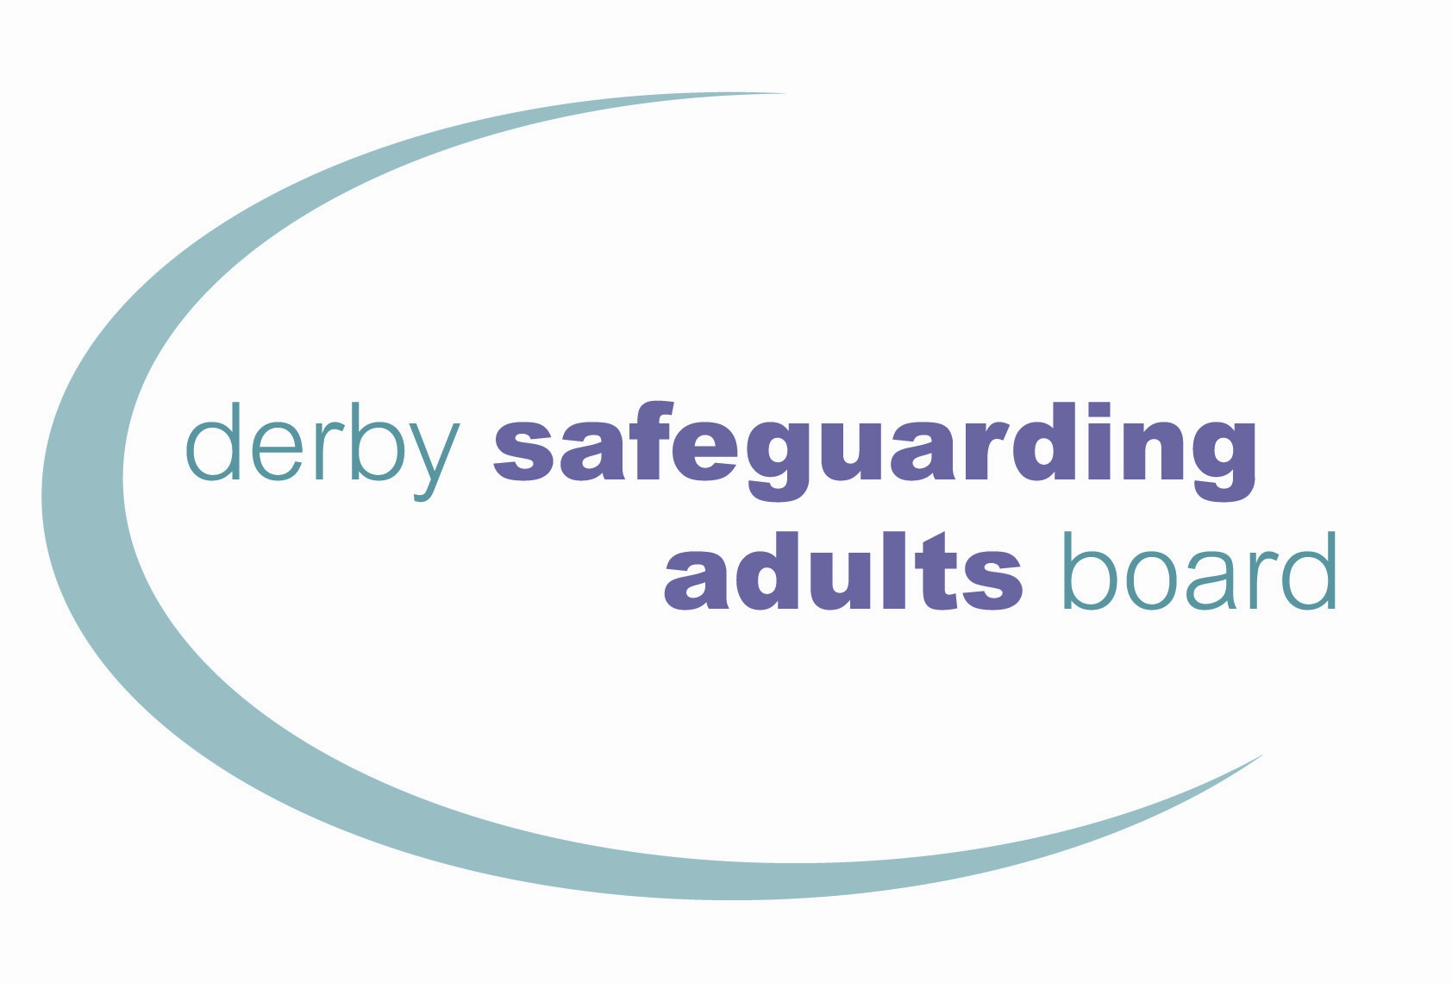
Derbyshire Safeguarding Adults Board
Referral Form

When completing the referral form please consult the Derby and Derbyshire Safeguarding Adults Procedures and also refer to the Derbyshire and Derby SABs Adults Safeguarding Decision-Making Guidance below:

Derbyshire and Derby SABs Adults Safeguarding Decision Making Guidance.

FOR ALL SAFEGUARDING REFERRALS PLEASE TELEPHONE the relevant local authority to make the referral before submitting this form.

For Derby City, please call 01332 642855 or 01332 956606 outside of office hours.

For Derbyshire County, please contact Call Derbyshire on 01629 533190 or 01629 532600 outside of office hours.

The email addresses below are secure. However, you should seek assurance from your IT team that you have the correct security to email securely to ‘gov.uk’ addresses. If in doubt, please send an encrypted email. Please note: these email inboxes are not monitored out of hours.

Derby City | AdultsMASH@derby.gov.uk
Amber Valley Area (Ripley, Alfreton, Belper) | ASCH.BSAmbervalley@derbyshire.gov.uk
Bolsover Area (Clowne, Whitwell) | ASCH.BSBolsover@derbyshire.gov.uk
Chesterfield Area | ASCH.BSChesterfield@derbyshire.gov.uk
Erewash (Long Eaton, Ilkeston) | ASCH.BSErewash@derbyshire.gov.uk
High Peak Area (Glossop, Buxton, Matlock) | ASCH.BSHighpeak@derbyshire.gov.uk
North East Area (Clay Cross, Dronfield, Eckington) | ASCH.BSNorthEast@derbyshire.gov.uk
South Dales Area (Ashbourne, Swadlincote, Shardlow, Willington, Hilton, Etwall) | ASCH.BSSouthDales@derbyshire.gov.uk

Please note: sending person identifiable information using the above email addresses may amount to a breach of Data Protection legislation if you do not send from a secure email address to a secure email address.

ALL QUESTIONS MUST BE COMPLETED IN FULL TO ALLOW ASSESSMENT OF RISK
Any incomplete forms will be reported to agency safeguarding leads for quality assurance.

- DETAILS OF THE ADULT
Name of relevant adult: Click or tap to enter text. |  | Date of birth: Click or tap to enter a date.
Gender: Choose an item. |  | If Other, please state: Click or tap to enter text.
Ethnicity: Choose an item. |  | If Other Ethnic Group, please state: Click or tap to enter text.
Address: Click or tap to enter text. |  | Telephone number: Click or tap to enter text.
Present location of the adult, if different from above: Click or tap to enter text.
Has the referral been discussed with the adult? Choose an item. | If ‘No’, why not?  Click or tap to enter text.
Have you assessed the adult’s capacity (Mental Capacity Act) to make a decision about the safeguarding referral? Choose an item.
If ‘Yes’, what was the outcome? Choose an item.
If ‘No’, why not? Click or tap to enter text.
Date of capacity assessment: Click or tap to enter a date.
Has the adult consented to the referral? Choose an item.
If ‘No’, why not? Click or tap to enter text.
Where the adult consents to the referral what do they want to happen as an outcome of the referral? Click or tap to enter text.

Where the adult has not consented to the referral, what legal grounds are there to override consent?  Consent should be sought by explaining to the customer the benefits of sharing information which is relevant and proportionate to the safeguarding concerns, and that sharing information will enable all agencies to work together with the adult to create a safety plan | ☐  ☐ | Not applicable  Lacks capacity to consent (MCA 2005)
 | ☐ | Prevention and Investigation of Crime (CDA 1998)
 | ☐ | Prevent serious harm/distress/threat to life (GDPR 2016)
 | ☐ | Risk to other people
 | ☐ | Risk to children (CA 1989)
 | ☐ | The adult is under duress or coercion
 | ☐ | Domestic abuse meets MARAC criteria
 | ☐ | Alleged abuser needs care and support/may be at risk
 | ☐ | Staff are implicated
 | ☐ | Court order/other legal authority
 | ☐ | Other: Click or tap to enter text.
Is the adult able to independently represent their views and wishes? |  |  | Choose an item.
Would the adult like someone to support or represent them? If so, please provide details: |  |  | Click or tap to enter text.
Where there is a representative supporting the adult, are they aware of the safeguarding concerns? |  |  | Choose an item.
Does the adult need referral to formal advocacy support or services? |  |  | Choose an item.

- STATUTORY SAFEGUARDING CRITERIA
What care and support needs does the adult have?  - For example, does the adult have any medical conditions or disabilities such as learning disability, dementia, physical disability, mental ill health etc. Please describe how these conditions impact the adult’s day-to-day life.  - Are there any conditions which impact on the person’s ability to make decisions for themselves? If you have completed a capacity assessment, please provide more information here?  - Please also explain whether the adult has experienced any trauma, do they have any leaving care status, previous experience of abuse, experiencing coercion or control, etc.  - Please also state if the adult is a carer. | Click or tap to enter text.
Reflecting on the care and support needs above, how do these needs prevent the adult keeping themself safe? | Click or tap to enter text.

- CATEGORY OF ALLEGED ABUSE/RISK OF ABUSE
☐ | Physical | ☐ | Sexual | ☐ | Psychological/emotional
☐ | Financial/material | ☐ | Discriminatory | ☐ | Domestic abuse
☐ | Sexual exploitation | ☐ | Neglect/acts of omission | ☐ | Modern slavery
☐ | Organisational | ☐ | Self-neglect

- DOES THE ABUSE/NEGLECT INVOLVE ANY OF THE FOLLOWING FACTORS?
☐ | Ageism | ☐ | Gender discrimination | ☐ | Sexual orientation/Homophobia
☐ | Religious intolerance | ☐ | Racism | ☐ | Disability
☐ | Pregnancy/maternity | ☐ | Hate crime | ☐ | Anti-social behaviour
☐ | Forced marriage | ☐ | Honour-based violence | ☐ | Radicalisation
☐ | Caring responsibilities | ☐ | Mate crime | ☐ | Criminal exploitation
☐ | Female Genital Mutilation | ☐ | Cuckooing | ☐ | Cross-border/county lines issues
☐ | Homelessness | ☐ | Substance misuse | ☐ | Rough sleeping
☐ | Cost of living | ☐ | Not Known

- DETAILS OF ALLEGED ABUSE/RISK OF ABUSE
Details of alleged abuse/risk of abuse/concerns  Please give as much detail as possible about what the concerns are, what has happened and what risk of future abuse/harm has been identified (who is involved, what has happened, how has it happened), are they at risk now? | Click or tap to enter text.
What immediate safeguarding action has been taken? | Click or tap to enter text.
If you suspect a crime has occurred, please contact the Police:
For emergency – call 999
For non-emergencies – call 101 or via the online portal link: Report a crime | Derbyshire Constabulary
Have the Police been informed?  If ‘Yes’, what is the incident or crime number? | Choose an item.  Click or tap to enter text.
Where has the alleged abuse occurred or is likely to occur?  If this is a regulated setting, please provide the full address and postcode. | Click or tap to enter text.
Date of suspected abuse: Click or tap to enter a date.
Time of suspected abuse: Click or tap to enter text.
If specific date/time is unknown, please provide details:
Click or tap here to enter text.
Has the adult died? Choose an item.
If yes, what was the date of death? Click or tap to enter a date.
Has the death been referred to HM Coroner? Choose an item.

Think Family: is anyone else at risk including other adults or children?  If you have concerns for the welfare or safety of a child, make a referral to children’s services. |  | Choose an item.
 |  | If ‘Yes’, please detail: Click or tap to enter text.
Derbyshire County Council Childrens Services
Derby City Council Childrens Services
Has the abuse or neglect been directly observed? | Choose an item.
 | If ‘Yes’, by whom? Click or tap to enter text.

- DETAILS OF THE PERSON WHO HAS ALLEGEDLY CAUSED HARM
Do not complete this section where self-neglect is identified  Name of person alleged to have caused harm:  Click or tap to enter text. |  |  | Date of birth:  Click or tap to enter a date.
Address: Click or tap to enter text.
Has the person who has allegedly caused harm/abuse got care and support needs? Choose an item.
If yes, please provide details of their care and support needs. For example, does the alleged source of risk have any disabilities, physical and/or mental health conditions, substance misuse, neurodiversity considerations, or are there any concerns about their decision-making ability?
Click or tap to enter text.
Is the person who has allegedly caused harm/abuse aware of the referral? Choose an item.
Is this person: | ☐ | A carer
 | ☐ | Family member
 | ☐ | Partner
 | ☐ | Professional
 | ☐ | Stranger
 | ☐ | Unknown/other
 | Details of relationship: Click or tap to enter text.

- DETAILS OF THE PERSON MAKING THIS REFERRAL
Name of referrer and referring agency: Click or tap to enter text.
Address: Click or tap to enter text.
Telephone: Click or tap to enter text. | Email: Click or tap to enter text.
Signature of referrer: Click or tap to enter text. |  |  | By typing your name, you are signing this electronic form.
Print name: Click or tap to enter text.
Date safeguarding concern raised in referring agency: Click or tap to enter a date.
Date form completed: Click or tap to enter a date. |  | Time: Click or tap to enter text.
Do you consent to the Local Authority disclosing to the adult that you have made this referral? |  | Choose an item.
Contact details for the Local Authority to send feedback about the outcome of the referral: |  | Click or tap here to enter text.

- ADDITIONAL INFORMATION
Please provide any relevant information about the adult’s circumstances e.g. mobility/sensory/communication needs; access to mobile/landline phone; best time for contact/visit; anyone who supports the adult.
It will help in the communication/contact with the adult and the safeguarding process.
Click or tap to enter text.

How is your information used?

The information we collect will be used so that we can assess the risk to your wellbeing in line with our Safeguarding Adults duties, to provide you with information, advice, and safety planning services to help you to maximise your independence and stay safe.

The information may also be used to carry out multi-agency case file audit for the purpose of assuring the quality of local systems and services in place to safeguard adults.

Who will your information be shared with?

If you are referred under safeguarding adults criteria, the information you provide may be shared with other professionals who may or may not be involved with you for similar purposes. We may also ask government departments and agencies to give us information they have about you.

The council may be legally obligated to share the referrer’s details with the adult subject to the referral.

If you live in Derby (excluding Derbyshire) and would like further information about how your personal information will be used, please see the full copy of our Privacy Notice. Alternatively, you can request a hard copy from the Contact Support Team, Business Support, Derby City Council, Council House, Derby DE1 2FS. Email: contact.support@derby.gov.uk, tel: 01332 640825.

If you live in the Derbyshire (excluding Derby) and would like further information about how your personal information will be used, please see the full copy of our Privacy Notice. Alternatively, you can request a hard copy by emailing adultcare.info@derbyshire.gov.uk or writing to the Adult Care Information Team, County Hall, Matlock, DE4 3AG.

